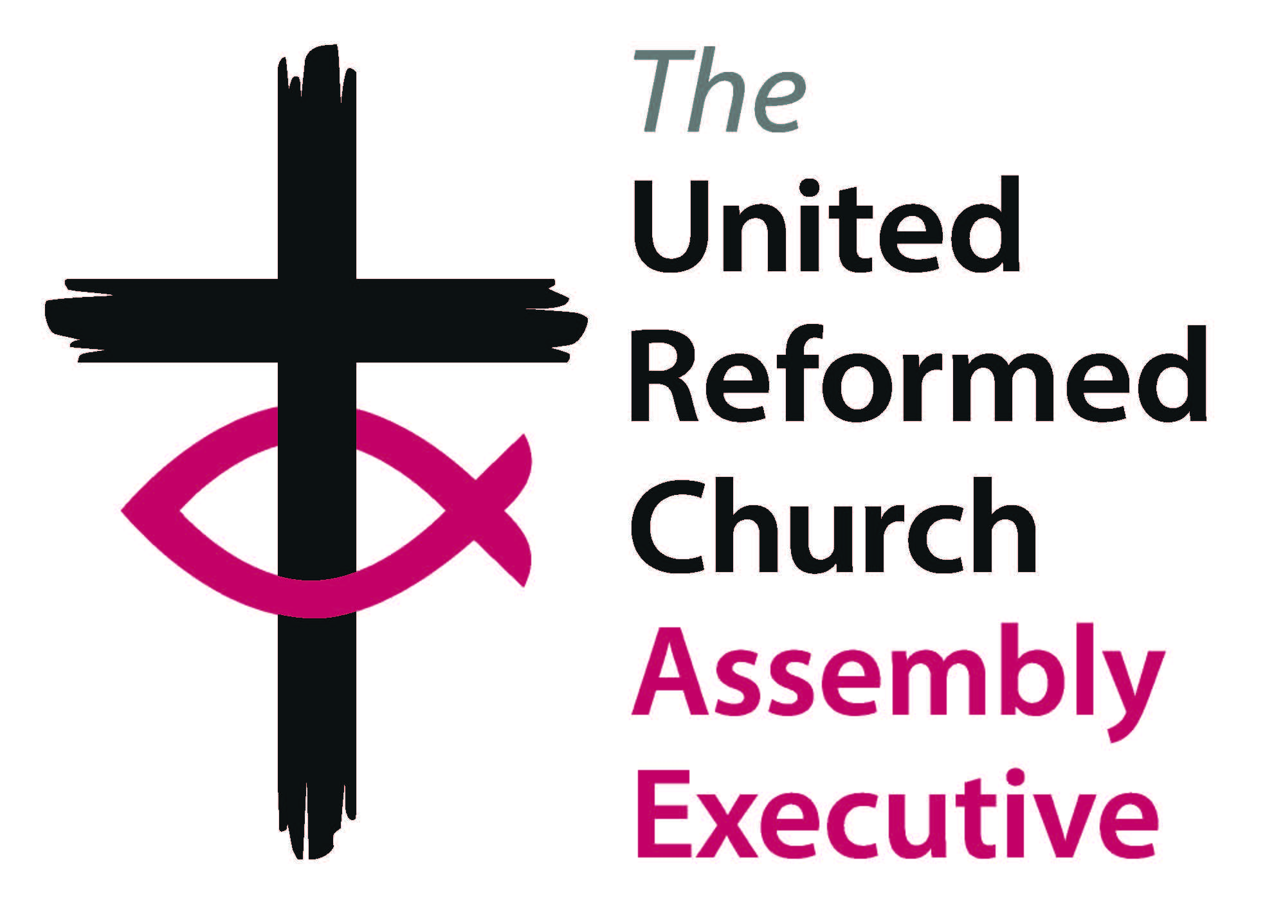

Assembly Executive
Monday 28 to Wednesday 30 November 2022

Agenda

Monday 28 November

12:00 to 13:00 Registration in reception

13:00 to 14:00 Lunch

Session one

14:00 to 15:30 Worship
Welcome and introduction
Minutes and matters arising

15:30 to 16:30 Check-in / access rooms
Tea / coffee break

Session two

16:30 to 18:00 R1 – MIND – lessons learned
Greenbelt feedback report
Roll of Ministers H1
Marks of Ministry of an Elder and Marks of H3
Ministry of an Elders Meeting

18:30 to 19:30 Dinner

Session three

19:45 to 20:30 Legacies of slavery report
Finance – Pensions update G5

20:30 Evening prayer

Tuesday 29 November

8:00 to 9:00 Breakfast

Session four

9:15 to 11:00 Worship
Finance – M&M Budget G3
Finance – Benevolent Fund and Energy Crisis Fund G2
CYW E&L Ministries – Call and Vocation – part 1 BDH1

11:00 to 11:30 Tea / coffee break

Session five

11:30 to 13:00 CYW E&L Ministries – Call and Vocation – part 2 BDH1

13:00 to 14:00 Lunch

Session six

14:00 to 14:30 Closed session business, then free time

16:00 Tea / coffee break

Session seven

16:30 to 18:00 Address by the Revd Dr Susan Durber, President of the European Region of the World Council of Churches

18:30 to 19:30 Dinner

Session eight

19:45 to 20:30 En Bloc
Items taken out of En Bloc
Remaindered business

20:30 Evening prayer

Wednesday 30 November

8:00 to 9:00 Breakfast

VACATE ROOMS AND RETURN KEY CARDS NO LATER THAN 9:30

Session nine

9:30 to 11:00 Morning Prayer
Church Life Review N1

11:00 to 11:30 Tea / coffee break

11:30 to 12:30 Worship with Holy Communion

12:30 to 13:30 Lunch and departures

13:30 to 15:00 Meeting of Committee Convenors and Staff Secretaries
in Mulberry Hall

