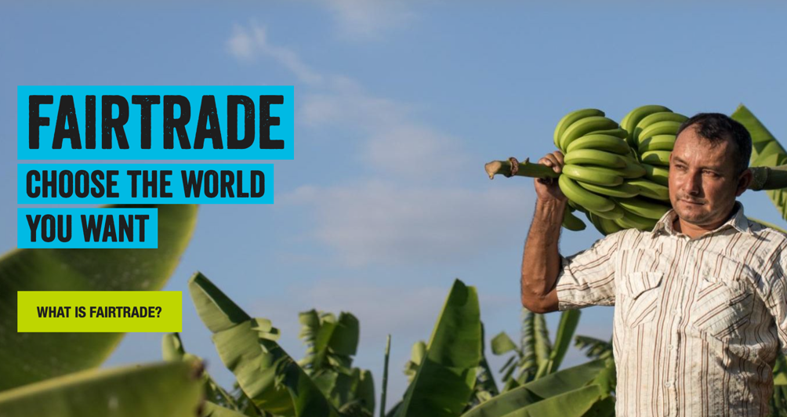
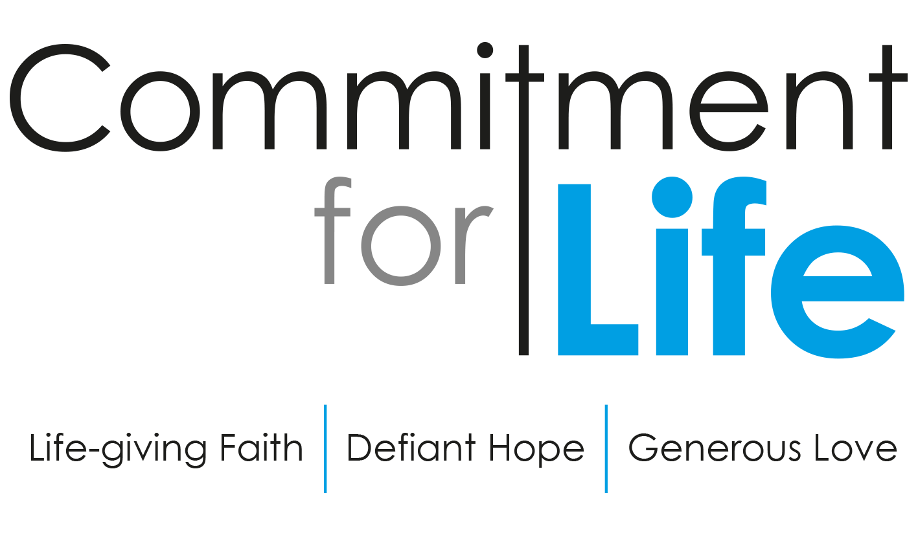
FAIRTRADE FORTNIGHT 27th Feb – 12th Mar 2023
https://www.fairtrade.org.uk/get-involved/Current-campaigns/Fairtrade-Fortnight-/
UK Retailers commit to Fairtrade
Commitment for Life supports The Fairtrade Foundation who work in partnership with 1.9 million farmers and workers globally to address the root causes of poverty. The good news is that more UK retailers are committed to Fairtrade. “It is inspiring to see that public trust in, and preference for, Fairtrade is at its highest ever,” says Michael Gidney, chief Executive of Fairtrade Foundation.
Lidl is the biggest buyer of Fairtrade cocoa. It rolled out its ‘Way 2 Go’ chocolate across 400 stores. Aldi launched the Choco Changer, a new chocolate bar that commits to Fairtrade’s Living Income Reference Price for cocoa. Aldi also provides opportunities for flower farm workers in Ethiopia to meet objectives on gender equity. Other Fairtrade cocoa conversions were made by SPAR. It introduced three new products on trial. Proper, building on their brand commitment as the ‘only Fairtrade sweet popcorn’ introduced two new Proper Chocolate Popcorn bars, while Asda launched a new FSI cocoa chocolate bar. 100 percent Fairtrade brand Tony’s Chocolonely also launched in major retailers in 2021.
Since 2005, Greggs has sourced Fairtrade coffee beans for all its coffee products. It has since added bananas, apple juice, orange juice, sugar sticks, sugar syrup, hot chocolate, black tea, mint tea, and green tea as part of its Fairtrade commitments. In August 2021, Greggs announced a switch to using only Fairtrade chocolate in its own products, which include Milk Chocolate Cookies, Caramel Shortbread and Chocolate Brownies.

MOVING STORIES
_________________________________________________________________________
Supporting | our global partners | FAIRTRADE EDITION

Facts ‘n Figures on Fairtrade
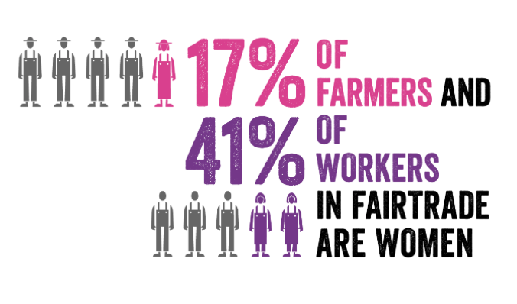

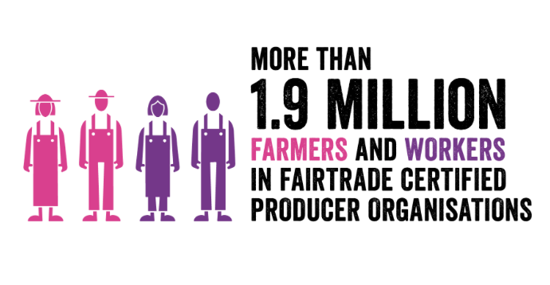

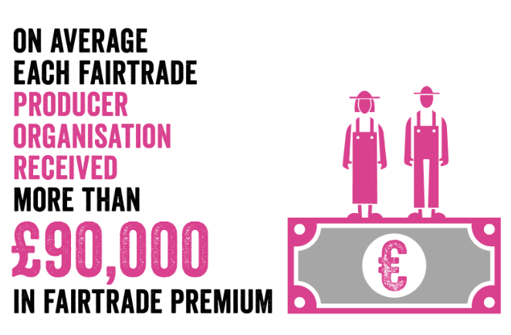

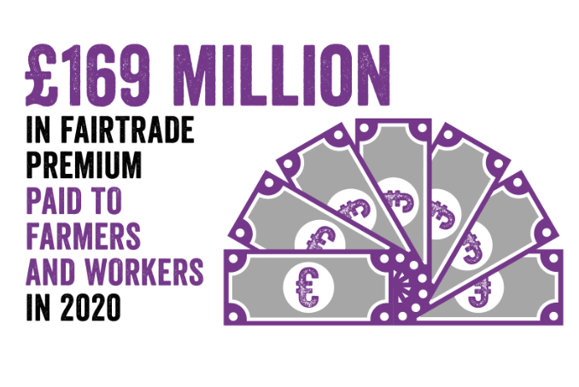

Prayer for Fairtrade
God of Abundance, help our church to support Fairtrade. Put into leadership business leaders with a conscience. Help them place people before profit.
We pray for Fairtrade across the world but especially in Zimbabwe, Bangladesh, and Israel and Palestine.
Amen.

