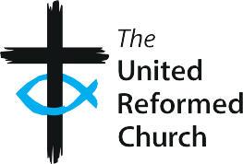
The United Reformed Church Local church safeguarding checklist

P5

 | Y/N/P1 | Notes/action needed/key dates
We have a Safeguarding Policy in place, covering both children and adults at risk, and it is being implemented.
Our Safeguarding Policy has been reviewed and updated in the last 12 months.
Safeguarding is a standing item on the agenda for Elders’/ Church meetings.
At least one Church Safeguarding Coordinator (CSC) has been appointed for our church.
Details of how to contact the CSC are displayed in church, and on our website/Facebook page.
All elders and church workers (paid and voluntary) working with children and adults at risk have an up-to-date Disclosure and Barring Service (DBS) check at the appropriate level for which they are eligible.
All church workers (paid and voluntary) working with children, young people and adults at risk have completed URC Safeguarding training at Foundation level as a minimum.
All those working with children or adults at risk have been given copies of the relevant Code of Conduct.

1 P = partial to indicate some progress made/some elements achieved

Good Practice 6 – Resource P5
1

The minister, CRCW, CSC, all group leaders, Elders and members of church leadership have completed all relevant levels of URC Safeguarding training.
All our workers (paid or voluntary) know the procedure to follow if harm or abuse is suspected, witnessed or reported to them.
We have contact information for local services able to provide specialist help (eg domestic abuse, mental health support) that we can link people with.
Any external organisations using our buildings comply with good safeguarding practices, in line with the Hirer’s agreement.

2 Good Practice 6 – Resource P5

