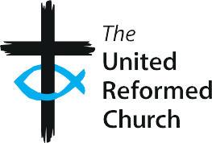
The United Reformed Church

SR1

Volunteer application form
This is a simple application form template for voluntary roles with children and/or adults at risk which can be used or amended as required.

Name of church/group:

Role/area of work:

Name: Date of birth:

Address:

Email: Phone number:

Previous experience of working with children or adults at risk and/or any relevant qualifications or
training (continue on a separate sheet if necessary).

Have you ever lived or worked abroad? If yes, please give details of dates and locations.

Please give details of two individuals who can provide references for you. This can include, for example, employers, tutors, staff in other voluntary organisations, leaders from a previous church. It cannot include people related to you, partners, people who reside at your home address or current members of your local church.

Name of referee:

How are they known to you?

Email: Phone number:

Name of referee:

How are they known to you?

Email: Phone number:

By signing this form, I confirm I understand that I will also need to:
- apply for a DBS check
- complete the confidential self-declaration form.

Signature: Date:

Good Practice 6 – Resource SR1
1

