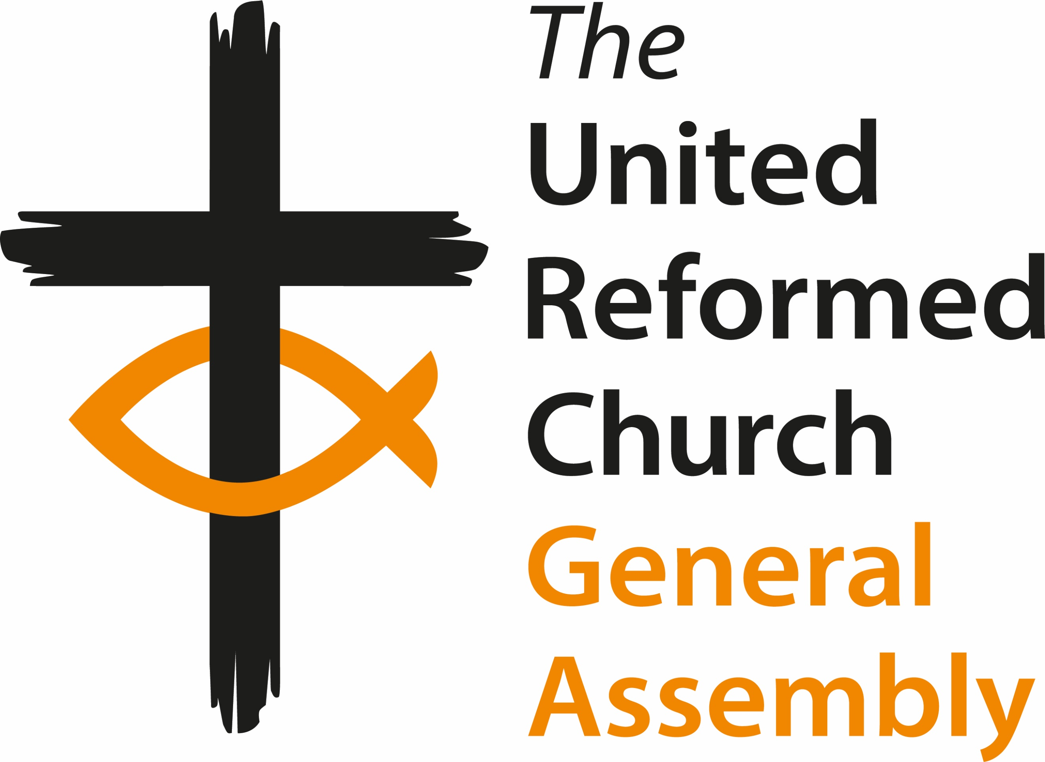
General Assembly
Friday 12 July to Monday 15 July 2024
Agenda

Friday 12 July

12:00 Arrivals and registration
13:00-14:00 Lunch (All attendees)
14:00 Welcome and constitution of Assembly
Opening Worship
16:00 Break (and access to rooms)
Session one
16:30 Introductions and Greeting of Ecumenical Guests
Mock Resolution
Synod Moderators’ Report
Closed Session Paper A11
18:30-20:00 Dinner
Session two
20:00 Ministries papers, H3, H5, H9, H11
21:00 Evening prayer

Saturday 13 July

7:45-9:00 Breakfast
9:00 Worship and Bible study
9:50 Presentation of candidates for GA Moderator 2024-2025 and vote
Session three
10:10 Mission I2, I3, I4
11:00 Coffee
Session four
11:30 Moderator’s Address
Faith Wills video (from Christian Aid)
12:30 Community Awards
13:00 Lunch
Session five
14:15 Place for Hope (presentation)
15:00 Finance G2, G3, G4, G5
16:00 Coffee
Session six
16:30 Ministries H7, H10
18.30 Dinner
20:00 Parallel Sessions
A. Business Committee – A1, A2 and Finance Committee – G1 and Mission Committee – I1
B. Worship Faith and Order Committee – F1 and
Ministries Committee – H1
C. Communications Committee – C1 and
Equalities Committee – E1
D. Education and Learning Committee – D1 and
Children’s and Youth Work Committee – B1, B2
21:00 Evening prayer

Sunday 14 July

7:45-9:00 Breakfast
9.00 Prayer with Bible study
Session seven
9:35 Church Life Review Group N1
10:00 Coffee
10:30 Worship
Session eight
12:00 North Western Synod X2
Thames North Synod X3
13:00 Lunch
Session nine
14:00 En Bloc:
Business Committee A3, A4, A5, A6, A7, A10
Ministries H2, H6, H8
Law and Polity Advisory Group P1
Nominations J1, J2
Safeguarding T1
Eastern Synod X1

Items removed from En Bloc
Celebrating Jubilee Ministers and greeting ministers new to their
URC roles
15:30 Coffee break
Session ten
16:00 Welcome to the new local church (assuming X1 agreed)
Business Committee A8, A9
Ministries paper H4
18:30-20:00 Dinner
Session eleven
20:00 Remaindered business
21:00 Evening prayer

Monday 15 July

7:45-9:00 Breakfast (check out of rooms by 9:00)
9:15 Worship and Bible Study
Session eleven
9:40 Moderator Elect 2024-2025 Acceptance Speech
Remaindered business
Miscellaneous Items
Address to the throne
10:45 Break
11:15 Closing worship:
Including induction of the Revd Tim Meadows
13:00 Lunch and departures
Leave by 2pm

