



United Reformed Church Commitment for Life Sept/Oct 2024
Storie
S

Moving

Committed to supporting our global partners IOPT

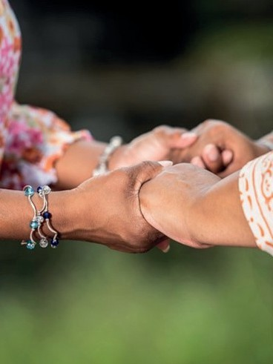
n the wake of the ongoing violence in the land we call holy, the 2024 General
A Prayer
We choose a world of justice, where resources are
not hoarded, but equally distributed; in which we work for a world made fit for future generations, caring for one another in peace.
We choose, we choose God, for God is justice.

We choose a world of peace, in which people no longer destroy one another, and
all are respected for their uniqueness.
We choose, we choose God, for God is peace.

We choose a world of love, in which God’s love for all is known, where each person is accepted and celebrated,
through whom God’s purpose for the world is fully revealed. We choose, we choose God, for God is love.

We choose a world of joy, where the joy of God in
all creation is fêted, where the goodness within all is gladly known.
Where we join creation’s song of praise.
We choose. We choose God. Amen.
I
Assembly of the United Reformed Church has asked local congregations actively to reach out in solidarity
Photo credit: AndPan 614 Pixabay
to both Jewish and Muslim neighbours.

The International Court of Justice has indicated that Palestinians are plausibly at risk of a genocide. The world court has offered an Advisory
Opinion indicating that the Israeli occupation of the West Bank, East Jerusalem and Gaza is illegal. Israeli civilian hostages are still being held illegally by Hamas. Our news and social media feeds are filled with horrifying images of death and brutality in Gaza. It is tempting to despair.

Nevertheless, General Assembly has made it clear that it is wrong and dangerous to hold Jews or Muslims in the UK responsible for the violence in Israel and in the occupied territory. Rather, we must ensure that every community here is loved, respected, and protected.

Whatever your views, are you able to reach out? Write a note of support? Invite people to a meal, shared activity or upcoming event? We must consciously choose the precious path of peace rather than the snaking highway of hate.

Please continue to pray and support our Commitment for Life Gaza Appeal.


Support Gaza here

commitmentforlife@urc.org.uk www.bit.ly/URCFL

