Commitment for Life Service for Harvest – Order of Service

THEME OF SERVICE: HARVEST AND HEALTH (Focus on Zimbabwe, but not exclusively!)

1. CALL TO WORSHIP
Psalm 41: 1-3 (NLT)

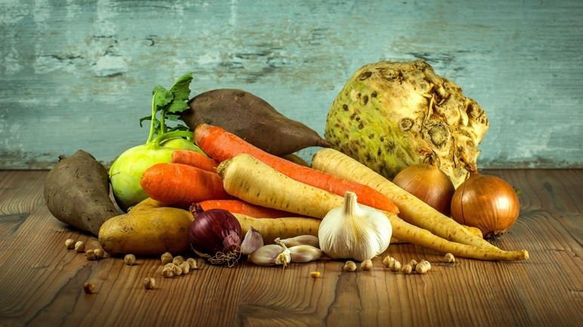
Oh, the joys of those who are kind to the poor!
The Lord rescues them when they are in trouble.
² The Lord protects them
and keeps them alive.
God gives them prosperity in the land
and rescues them from their enemies.
³ The Lord nurses them when they are sick
and restores them to health.
Photo credit: LubosHouska - Pixabay

2. OPENING HYMN (see selection below)

3. PRAYERS OF APPROACH

Jehovah Rapha, God of Healing, we praise you for your goodness and mercy. We thank you for our health and harvest. You created the earth and declared it good. You cause the rains to fall and the grains to grow. You have birthed us into goodness and have surrounded us with good things: family and community, fresh air and clean water, buzzing bees and laughing children. Your beauty is declared in and through all creation. As we draw close to you in this time of worship, may your Spirit of healing grace fall upon us and upon all, especially on those who are in need of your healing touch. In the name of the one who healed through love and grit and grace, Jesus the Christ, who taught us to pray:
Our Father…
Amen.

THEME

The idea is to explore how, creation, harvest and healing are intertwined. You will have your own experience of, for example, eating well and feeling well because of it. Think of how God creates things good, and that connecting to that goodness in nature can be a deeply healing experience, both physically and psychologically. You may wish to recount a personal experience of this – perhaps on a visit to Iona, or Holy Island ETC. You may know of a story where the environment was damaged, and people or animals were affected and fell ill AS A RESULT. Think, for example, of the raw sewage being pumped into oceans and rivers in the UK and the harm this has caused. Some further thoughts that you could explore on the theme could be:

- How food and health are closely connected (eating well).
- The connection between food insecurity and health (e.g. food banks in the UK).
- Climate chaos and its effect on food systems and production – why we need a healthy environment to produce food.
- Healthy eco-systems mean healthy people – we are not separate from the environment.
- Supporting the poorest people in our Commitment for Life regions to enjoy healthy harvests. You can find a few useful stories in the CFL Summer magazine that is attached to this Order of Service.
- See CFL video speaking to Giyani Siwela, speaking to us from a health clinic deep in the rural heart of Zimbabwe - https://youtu.be/Ux9hZp5_aWg
- See CFL video showcasing the work of ZELA, the Zimbabwe Environmental Law Association with Zanele Mpofu https://youtu.be/oHKQH7nL01k
- You may wish to show the Fairtrade video released this year -
- These videos could be shown in the service to expand on the theme of health and harvest, or harvesting health, if you like.

4. ALL AGE TALK

PROPS: Find a potato with eyes, cut an onion in half, get a pea pod and half open it

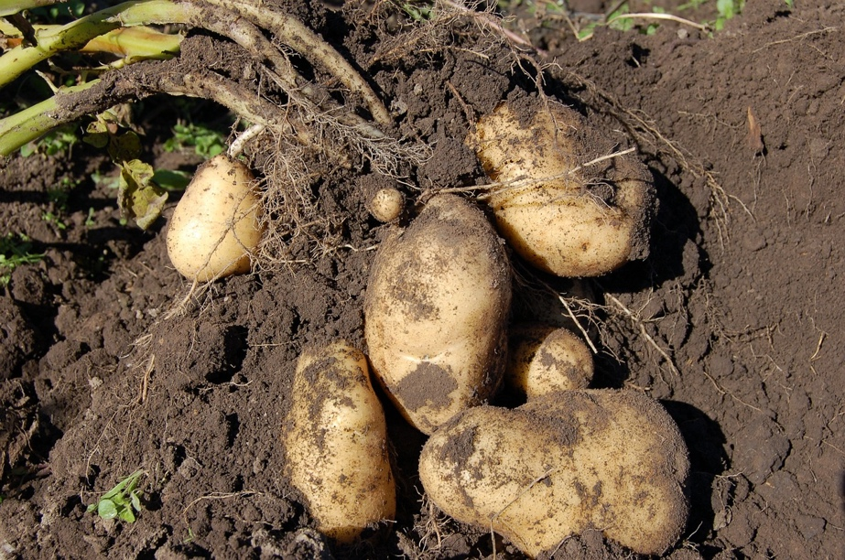
You talk can use these props to firstly teach the children that the potato has eyes to see, the onion can cause the eyes to weep, and that the peas are all in it together. Decide what story you wish to tell, for e.g. why healthy soil is vital. The potato is looking for healthy soil. Where do they find that soil? (farm, garden etc.) If the soil is not healthy, what might happen? (get answers – e.g. the vegetables are not healthy, so when we eat them, we are not healthy). What might also happen is that the onion becomes very sad and so cries (get children to pretend-cry. Maybe!) But all is not lost! They can all learn from the peas. What do peas do? They stand together like peas in a pod, to be stronger together. Together, they can work to make the soil healthy again. How can you make healthy soil? (composting, don’t use bad chemicals, rewilding, don’t cut the lawn so often etc. – get the children to hold hands or shoulders to stand together for healthy soil). Yes! We can make a difference. We can create a healthy environment.
Picture credit Alexey_Hulsov - Pixabay

This same theme (potato eyes, onion tears, peas in a pod) can be used for a variety of themes e.g. working for clean water, environmental justice, or helping people grow healthy food in Zimbabwe, Bangladesh, and Palestine.

PRAYER: God. Thank you for all the things that make us healthy: fresh food, healthy crops, for potatoes, and onions, and peas, and maybe even Brussels Sprouts. Thank you for making us stronger and healthier together, so that we can be more like Jesus. Help us make the world a healthy, beautiful place once again. Amen.

5. HYMN (see selection)

6. SCRIPTURE

There are so many scripture verses with health themes – two to choose from might be:

Jeremiah 17:12-17a

¹² “This is what the Lord says:
“‘Your wound is incurable,
your injury beyond healing.
¹³ There is no one to plead your cause,
no remedy for your sore,
no healing for you.
¹⁴ All your allies have forgotten you;
they care nothing for you.
I have struck you as an enemy would
and punished you as would the cruel,
because your guilt is so great
and your sins so many.
¹⁵ Why do you cry out over your wound,
your pain that has no cure?
Because of your great guilt and many sins
I have done these things to you.
¹⁶ “‘But all who devour you will be devoured;
all your enemies will go into exile.
Those who plunder you will be plundered;
all who make spoil of you I will despoil.
¹⁷ But I will restore you to health
and heal your wounds,’
declares the Lord,

TEXT NOTES

Credit: Pixabay artisansandvines

A difficult reading, to be sure. The author in line with many of the Hebrew prophets links the healing or wholeness of the people with their obedience to God. The author suggests that once the people obey God’s commands, then wholeness and healing will follow. Affliction and disease are not limited to the physical body, but affect everyone emotionally, psychologically, communally, and spiritually.

Disobedience comes at a high cost. Beware the consequences of disobeying God’s laws. Even the enemies of God’s people will eventually be affected. It does not pay to plunder God’s people, declares the author.

One needs I think to be quite careful with the exegesis of this text. Correlation is not causation. One really ought to interpret ‘God’s people’ and ‘obedience to God’ in an expansive, inclusive way. One may interpret God’s people as all whom God loves, and think of “disobeying God’ as a refusal to love one’s neighbour. Disobedience encompasses things like hoarding wealth, oppressing others, refusing to act justly, and uncaringly or unthinkingly to destroy God’s creation.

Obedience to God is to love one’s neighbour and even enemies as oneself. This is how Jesus, I think, would frame the question of obedience. Also, try to widen the scope of the interpretation. ‘Do not plunder God’s people’ could be widened to encompassing the whole earth or all creation: do not plunder the environment, otherwise we risk our wholeness and healing. Use an example of a corporation or a farmer exploiting a river, or forest, dumping sewage from factory farming into a river, or the danger that comes from a corporation or government exploiting a healthcare system like the NHS for private profit, and look at the result…

If you watch the provided video, you might also ask why so many people living in Zimbabwe seem stuck in such grinding poverty. Why are so many desperately sick and poor? It is vital to avoid the ‘easy’ answer! “Oh, that’s because the government is corrupt…’ Mmm. Well, OK, but corrupted by whom? Corrupted by what? Surely those controlling massive resources with a view to increasing profits are the one’s doing the bribing. Is it not the global financial economic system that benefits the wealthy, and is corrupt and corrupting? Jesus would have named the system ‘Mammon’ but you will need to decide if your congregation would be OK with this language. Be that as it may, you may wish to bring this home, and connect with the way that the system probably is benefitting your congregation. Our pension funds rely on the profits generated by the system. Is it beyond imagining that we (by which I mean comparatively wealthy people in the global north) are the beneficiaries of a system that exploits farmers and workers? If we are benefitting from an unfair system, what ought our response be?

I think this exegesis makes for a reasonably good analysis of the text, and opens up the possibility of action, such as sharing, generosity, a commitment to change the system, and come up with a more God-centred way of living. Of course, this may be too much for some congregations. Please be wise around how deep you take your analysis. Sometimes, keeping the questions a bit more generalised is the right way to go.

Matthew 10: 1-11

¹And he called to him his twelve disciples and gave them authority over unclean spirits, to cast them out, and to heal every disease and every affliction. ² The names of the twelve apostles are these: first, Simon, who is called Peter, and Andrew his brother; James the son of Zebedee, and John his brother; ³ Philip and Bartholomew; Thomas and Matthew the tax collector; James the son of Alphaeus, and Thaddaeus;^{[a]4} Simon the Zealot,^{[b]} and Judas Iscariot, who betrayed him.

Jesus Sends Out the Twelve Apostles

⁵ These twelve Jesus sent out, instructing them, “Go nowhere among the Gentiles and enter no town of the Samaritans, ⁶ but go rather to the lost sheep of the house of Israel. ⁷ And proclaim as you go, saying, ‘The kingdom of heaven is at hand.’^{[c]} ⁸ Heal the sick, raise the dead, cleanse lepers,^{[d]} cast out demons. You received without paying; give without pay.⁹ Acquire no gold or silver or copper for your belts, ¹⁰ no bag for your journey, or two tunics^{[e]} or sandals or a staff, for the labourer deserves his food. ¹¹ And whatever town or village you enter, find out who is worthy in it and stay there until you depart.

TEXT NOTES

Gosh! There is so much richness in this passage. A post-colonial reading of the text might suggest that we see Jesus here building – and putting into practice - the methods to be used by his new, anti-empire community (this is what the church is supposed to be). The disciples are invited to venture into the heart of empire. They are given the authority to cast out the unclean spirits of empire, (that is, military, economic, religious and political structures of power that keep the ‘worldly system’ functioning. Healing comes once the disciples have ‘outed’ the demonic structures of empire, that is, the ‘powers and principalities’ of empire. In this reading, it becomes clear that what truly makes people ill are the system and practices that empire forces upon marginalised people. This includes poverty, exploitation, overwork, poor working conditions, slavery, and racism. It is greed, extractive economics, and the exploitation of nature.

These systems are of course deemed ‘necessary’ by the 1% to keep themselves rolling in fat, no matter the cost to the 99% of exploited people. Jesus invites the disciples to take them on in a spiritual battle, and to overcome them. Jesus warns the disciples not to get caught up in empire’s monetary system: do not accept its gold or silver. Why? Perhaps you can talk about Jesus resisting this temptation in the desert! You might ask whether the church ever succeeded in heeding that warning.

You might ask where we see examples of God’s people refusing to bow to the logic of the marketplace today. Where are the examples of generosity, care for others, and peace-making? Remember to bring in a harvest element: talk about how harvest symbolises God’s generosity and abundance. God desires that every person has access to food and health without cost, without silver of gold. What does that say about the cost-of-living crisis where people cannot afford to heat their home and eat at the same time? What about the drive to making the NHS a pay-as-you-go American styled system, where the rich get the best doctors and treatment and the poor a left with a mere shadow of the service they used to get?

Healing is intimately connected to overcoming the structures of empire: to justice, equity, fairness, generosity, and peace. Think of the hundreds of millions of people who have died in wars, slavery, poverty, and now increasingly dying because of empire’s assault on the environment. You could come up with a bunch of examples just by reviewing this month’s news cycle, though it is best to consult more than just mainstream media, which by and large tends to be a mouthpiece for empire.

If you would prefer to avoid a postcolonial reading, then, that is OK. Your congregation might not be quite ready for that approach or exegesis. Instead, you may wish to focus more generally on God’s desire for justice and healing. You could use one or two stories that link of healing and harvest, for example, the stories from this year’s Commitment for Life Summer Magazine – attached.

End with: Commitment for Life is the United Reformed Church’s global justice programme. It works hard to help some of the poorest people in Bangladesh, Zimbabwe and Israel and the occupied Palestinian territory harvest justice and health and healing with your assistance. For example, you can hear from one of our partners in Zimbabwe, Giyani Siwela, a Field Officer for MeDRA, on how we have supported a clinic in the heart of Buhera District, in Manicaland, Zimbabwe.

Thank you for your continued support.

See https://youtu.be/Ux9hZp5_aWg

LIST OF HYMNS

MISSION PRAISE

Healing

448 Lord we long (Heal our nation)
226 Healing God
376 Jesus put this song
643 The earth was dark
1036 Blessed be your name

532 O, O, O, how good is the Lord

Harvest

732 We plough the fields
667 The feast is ready
428 Lord for the years
231 All things bright and beautiful

REJOICE AND SING

Healing

Credit: Stock Image from Word
620 For the healing of the nations
649 Let the world rejoice together
650 God with humanity made one
652 God, when human bonds are broken
653 We cannot measure how you heal

Harvest

612 God whose farm is all creation
40 Come, ye thankful people
42 For the fruits of all creation
45 Morning has broken
47 O worship the king
48 Praise and thanksgiving
65 I love the sun
72 Now thank we all our God

INTERCESSORY PRAYERS

Mend What is Broken

Gracious God,
I call on you right now in a special way.
It is through your power
that I was created.
Every breath I take,
every morning I wake,
and every moment of every hour,
I live under your power.
I ask you now to touch me
with that same power.
For if you created me from nothing,
you can certainly recreate me.
Fill me with the healing power of your spirit.
Cast out anything that should not be in me.
Mend what is broken.
Root out any unproductive cells.
Open any blocked arteries or veins
and rebuild any damaged areas.
Remove all inflammation and
cleanse any infection.
Let the warmth of your healing
love pass through my body
to make new any unhealthy areas
so that my body will function
the way you created it to function.

Credit: Stock Image from Word
Restore me to full health
in mind and body so that I may
serve you the rest of my life. - Reverend Larry J. Hess
Pray for the World

Leader: Please respond to each petition, "Lord, hear our prayer."
Tender, compassionate God, we turn to You to receive our prayers for those who are in need of Your mercy and healing, we pray, Lord …
Leader: For those who suffer from illnesses, injuries and addictions, we pray …
Leader: For those with mental illnesses and failing memories, especially for those who are homeless, we pray ...
Leader: For those who are called to care for the sick, we pray ...
Leader: For those who are near death in our hospitals and long-term care facilities, we pray ...
Please share petitions of your own. silence
Leader: Life-giving God, hear our prayers, those that we have spoken and those that remain in our hearts. We trust in your loving response through Christ our Lord.
All: Amen.

Closing Prayer

All: Jesus Christ, source of hope and healing, we hold up to You the sick of our world. We ask You to bless and heal all who suffer. Touch our hearts and our consciences to see these sufferings as our own, mysteriously united as we are to each other and to You through the power of the Holy Spirit. Help us to believe that each act of healing we do, no matter how small, reaches out to heal the wounds of our world. Bless us, and the healing ministry we share in Catholic health care.
In Your Holy Name we pray. Amen. - Catholic Health Initiatives

And the Grace

