



United Reformed Church Commitment for Life Nov/Dec 2024
Photo credit: Helen Lidgett
Storie
S
C

Moving

Committed to supporting our global partners BANGLADESH
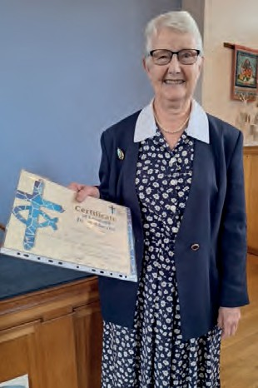
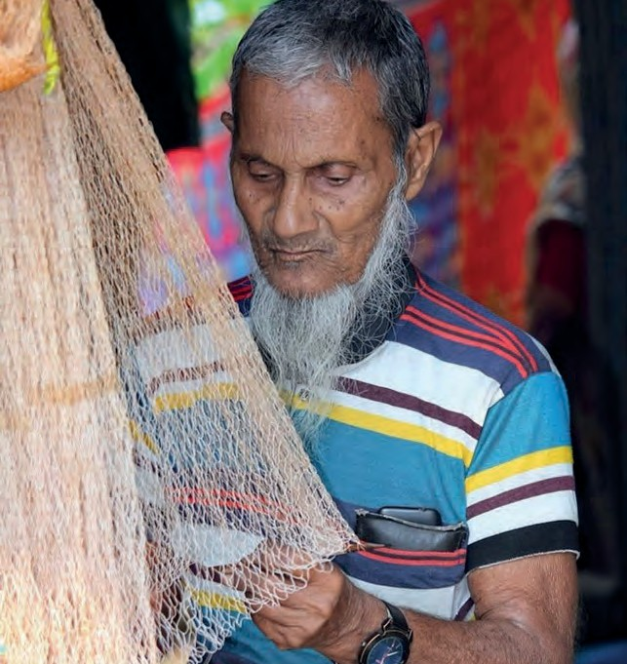

Commitment for Life wishes to thank Audrey Turner for her years of selfless service to the poorest in the world through Commitment for Life. Audrey is pictured here with her Certificate of Loyal and Devoted Service, which was
given to her at the Chesterfield URC Church Meeting on Sunday 8 September.

In her response, Audrey said how much she had enjoyed promoting Commitment for Life and the programmes supported by Christian Aid in our partner country,
Zimbabwe. She also said how much she valued the support of the church and local community in fundraising for Christian Aid over many years.
Photo credit: Abdullah Al Masud, Pixabay

ommitment for Life partners continue to support our Christian Aid Bangladesh programmes. These include programmes on gender justice, climate justice and responding
to the needs of Rohingya refugees in Cox’s Bazar.

In 2024-2025 the priorities remain to advocate for marginalised communities, equipping them to be independent agents of change and good governance. The focus is on the empowerment of women and capacity building. We continue to challenge harmful practices. We are equipping girls and women with more opportunities to gain skills and education for better economic independence.

The update this Autumn will feature a case study about Suhali, a man with physical and speech disabilities who did not let his limitations deter him from his dreams. Through our Empowering
Left Behind Minority Communities programme, they were able to advocate for him and support him to attain a job in IT. People like Suhali are grateful for your support.
commitmentforlife@urc.org.uk www.bit.ly/URCFL

