



United Reformed Church Commitment for Life Nov/Dec 2024
Storie
S

Moving

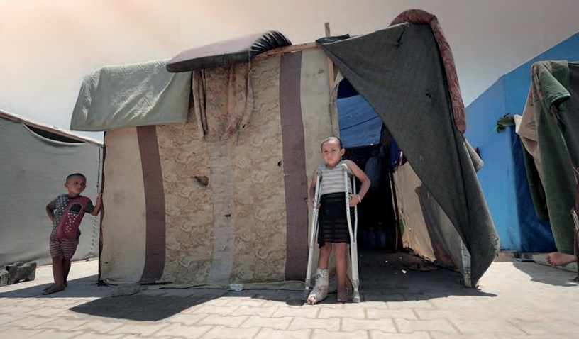
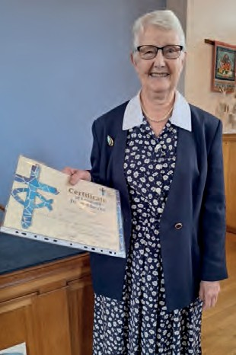
Committed to supporting our global partners IOPT

Commitment for Life wishes to thank Audrey Turner for her years of selfless service to the poorest in the world through Commitment for Life. Audrey is pictured here with her Certificate of Loyal and Devoted Service, which was
given to her at the Chesterfield URC Church Meeting on Sunday 8 September.

In her response, Audrey said how much she had enjoyed promoting Commitment for Life and the programmes supported by Christian Aid in our partner country,
Zimbabwe. She also said how much she valued the support of the church and local community in fundraising for Christian Aid over many years.

he situation in Gaza continues to be one of heartrending agony, with
Photo credit: Helen Lidgett
T
increasing loss of lives and livelihoods, and many injured or forced to relocate by the policies and actions of Israel.

As the one-year mark approaches since October 7th, Commitment for Life sends heartfelt condolences to the Israeli families who have been, and continue to be, deeply affected by the Hamas terror attacks. We believe that resorting to violence is always wrong, though we of course include in this the use of structural violence to oppress people and steal
land. The URC joins with its partners to lobby the government for an unconditional ceasefire.
Nov / Dec 2024

Photo credit: hosnysalah, Pixabay
Commitment for Life remains determined to support our partners even in a difficult and evolving situation.

Our Christian Aid partners have asked us to extend CA’s heartfelt gratitude to the URC for the generous response to the Gaza Appeal. The support received was directed to our partner,
the Palestinian Agricultural Relief Committee (PARC), who identified a need for a more accessible camp for internally displaced persons. With an increasing number of casualties of war, many are left injured or amputees, not to mention being displaced from their homes.
PARC has been working on co- designing the accessibility points for such families.

commitmentforlife@urc.org.uk www.bit.ly/URCFL

