



United Reformed Church Commitment for Life Nov/Dec 2024
Storie
S

Moving

Committed to supporting our global partners ZIMBABWE
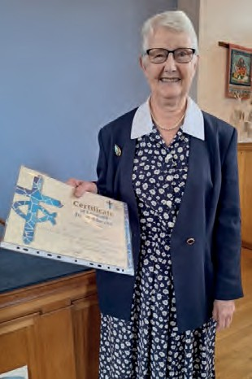
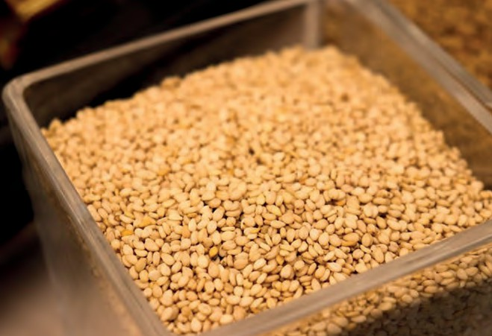

Commitment for Life wishes to thank Audrey Turner for her years of selfless service to the poorest in the world through Commitment for Life. Audrey is pictured here with her Certificate of Loyal and Devoted Service, which was
given to her at the Chesterfield URC Church Meeting on Sunday 8 September.

In her response, Audrey said how much she had enjoyed promoting Commitment for Life and the programmes supported by Christian Aid
in our partner country, Zimbabwe. She also said how much she valued the support of the church and local community in fundraising for Christian Aid over many years.
Sesame seeds. Photo credit: allybally4b, Pixabay
Photo credit: Helen Lidgett

imbabwe continues to battle a climate crisis, with drought causing
Z
emergency food insecurity for thousands of citizens this year.

The Christian Aid team has worked with communities to build capacity and enhance resilience methods for planting to ensure a good crop yield.
There has been an emphasis on advocating for debt relief as Zimbabwe faces international financial pressure. Additionally, efforts to promote gender inclusion and advocate for good governance have continued, with a focus on empowering
faith leaders to engage in meaningful dialogue and advocate for their rights.

Keep watch for Vhaina’s story, a single mother of six who has been trained as a sesame seed farmer by our partners, Sustainable Agriculture
Technology (SAT). Zimbabwe has been facing a severe drought, and SAT has been working with over 3,800 farmers to develop weather-resilient crops and create infrastructure to support
e-commerce, enabling financial freedom and improving livelihoods. Thanks to this support, Vhaina now has more opportunities and can better provide for her family.

commitmentforlife@urc.org.uk www.bit.ly/URCFL

