News Update October 2024

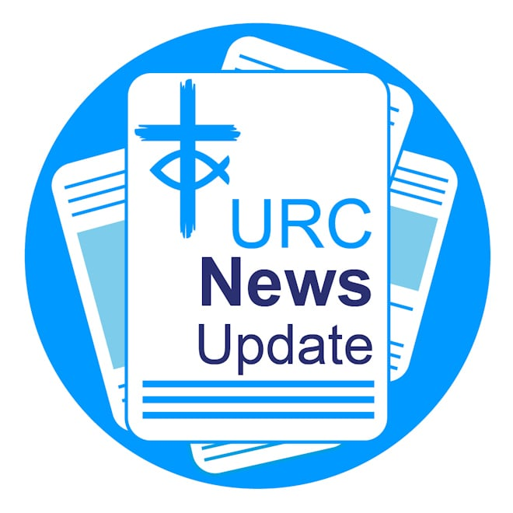

Keeping you informed with the latest news from around the URC

Brian's 30 years of service in Shanklin

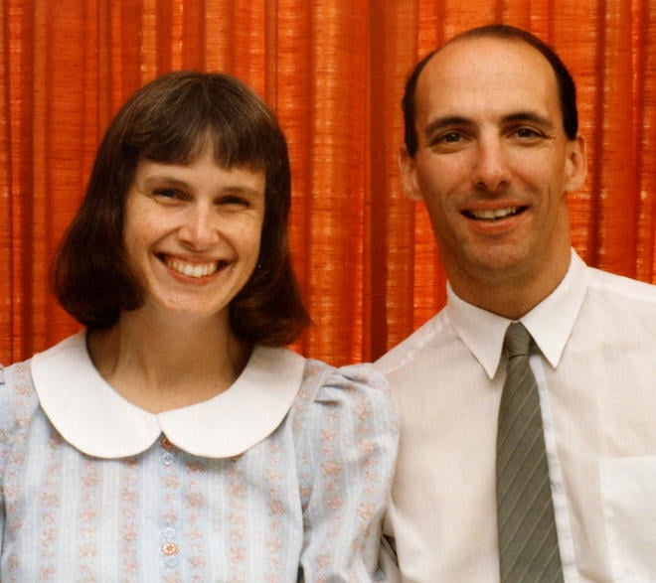

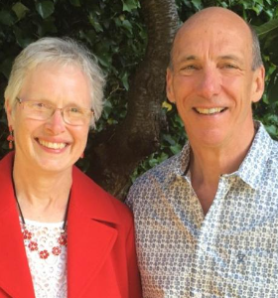

Congratulations to the Revd Brian Harley who has clocked up an impressive milestone, celebrating 30 years of service at Shanklin United Reformed Church on the Isle of Wight. He began his ministry in September 1994 after relocating from Cambridge with his wife Janet and their three children. Before entering the ministry, Brian spent time working in commercial fire insurance in the City of London. Brian has also served as Chair of the GEAR (Group for Evangelism and Renewal in the URC) Committee and has seen many changes within the church. Reflecting on his ministry, Brian shared that while he had hoped for many years of service when he started, he could not have predicted such a long and fulfilling journey.

Help charity boost donations

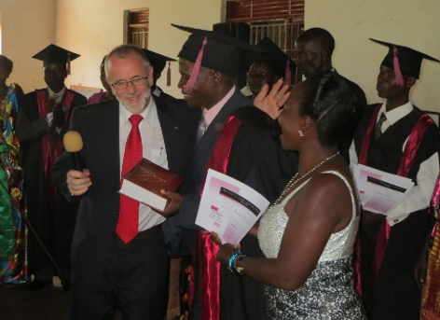

Romans 1.11 Trust, a charity, set up in 1992 by the Revd Dr John Hall, a retired URC Minister, exists to build the Kingdom of God through support for African pastors and their churches. The charity is seeking donations to help fund its work through its Boost 100 initiative, where they hope 100 individuals, congregations or organisations will each make a three-year commitment of £10 per month. Learn more about the Romans 1.11 Trust.

Dedicated teenagers gains a Lundie

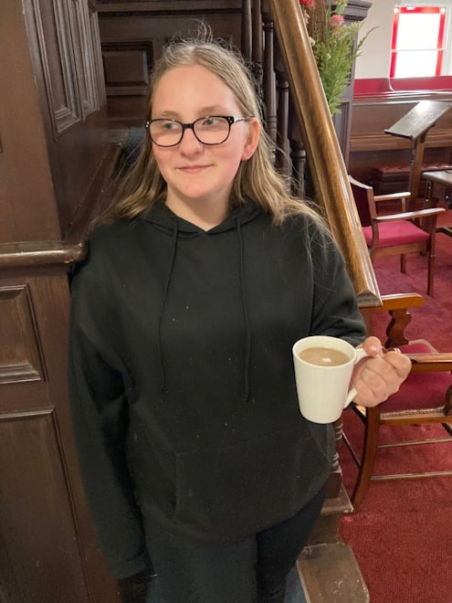

Fourteen-year-old Imogen Illingworth from Yorkshire Synod is the recipient of August’s Lundie Memorial Award, recognising her dedication and role in her church community at Westfield URC. The Lundie Memorial Award celebrates the efforts of young people like Imogen, who embody faith, service, and community. Learn more about Imogen and how to make a nomination: https://urc.org.uk/your-church/family-friendly-church/lundie-memorial-awards/

Share Jesus this Hallowe'en

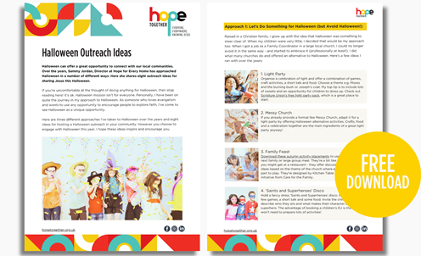

Hallowe'en can offer a great opportunity to connect with our local communities. Over the years, Sammy Jordan, Director at Hope for Every Home, has approached Hallowe'en in a number of different ways. In this free resource, Sammy shares eight outreach ideas for sharing Jesus this All Hallows' Eve: Hallowe,'en outreach ideas.

Black History Month

October is Black History Month and an opportunity for everyone to share, celebrate and understand the impact of Black heritage and culture on these shores. Churches Together in Britain and Ireland (CTBI) has produced resources that will enable all Christians to engage with this monthly celebration in ways that are meaningful and transformative. Access CTBI's free Black History Month resources.

CWM mission partners wanted

Are you a professional, looking for a break in work, a change of scene, or a new opportunity following retirement? The Council for World Mission (CWM) is looking for committed people willing to serve a CWM partner church for six-12 months. Positions are open to all regardless of age and stage in life. Learn more about becoming a CWM Short-Term Mission Partner.

New Free Churches chaplaincy hub

The Free Churches' Group has launched a new chaplaincy hub. The hub will be resourced with information, articles, podcasts, reports, events and support for existing chaplains. It is also a great place to go if you or your church wants to support chaplains in prayer and other ways. Learn more about the chaplaincy hub.

New heritage fund for churches

The National Lottery Heritage Fund has announced a new strategic initiative to address the challenges facing the UK’s beloved places of worship and build a brighter and more sustainable future for them at the heart of communities. Around £15 million is available. Learn more about the new initiative and apply.

Lay preachers design creative Commitment for Life service

Twelve lay preachers from across the URC gathered at Luther King House last month to learn how to design and present a Commitment for Life (CFL) service of worship at their local congregations. Northern College tutor Revd Dr Graham Adams provided a theological foundation for the day, and Revd Ana Gobledale provided practical tips on sermon construction. “I came a bit worried that the theology might be a bit over my head,” said Crispin Myerscough from Garstang URC. “But it really wasn’t. It was incredibly inspiring and creative." The CFL team hopes to deliver more training in 2025. Learn more about CFL.

Register for URC Youth Assembly 2025

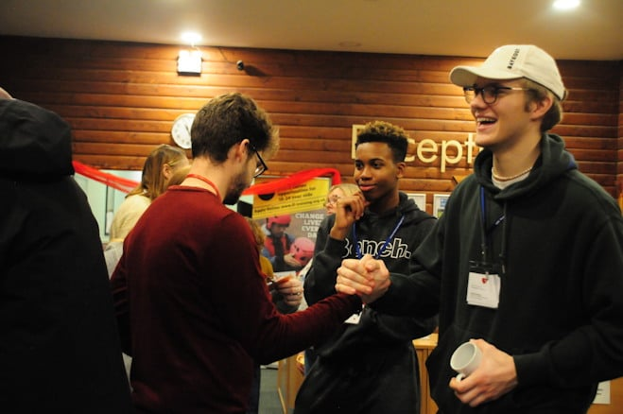

Registration for URC Youth Assembly 2025, themed All Are Welcome, is now open. The date and venue has changed to 7-9 March 2025 at King's Park Conference Centre in Northampton. Learn more about URC Youth Assembly 2025 and book your space.

Download or print News Update

A downloadable version of News Update, formatted for print, and for churches to copy and paste into church newsletters or magazines will be available within a week of this edition being published. Download your printable version of News Update.

Share your good news

If you have a good news story that can inspire, raise hope or show God's work in action then please let URC Communications know. We would love to help share your news across the denomination and in local news outlets. Email the URC Comms Team or call 07976 753 950

This month in Reform magazine



Reform's October was “transcribed by AI and edited by humans”, writes Steve Tomkins, who speaks to anthropologist of artificial intelligence, Beth Singler. They talk about the impact AI is already having, what we should be worrying about and what we shouldn’t, and whether AI is God. Elsewhere, Roy Crowne says God is an entrepreneur (and we should follow suit), while Sian Joyner sees disability differently, regular columnist Sheila Maxey sees the appeal in taking risks, and Roo Stewart sees dreams becoming reality at this year’s Greenbelt festival. We ask questions about hope, put the case for ‘dumb phones’, and share stories from across the UK in ‘Local Digest’. Finally, it gets all cuddly in Reviews as the rabbits of Watership Down make a comeback and Oliver Tomkins embraces the appeal of Colin from Accounts. All this and more in the October Reform, out now. Subscribe to Reform digitally or in print.

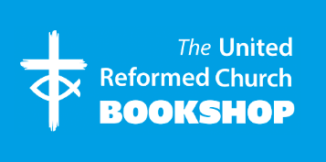

Please order online using the URC Bookshop’s easy-to-use website at
www.urcshop.co.uk or by calling 020 7916 8629

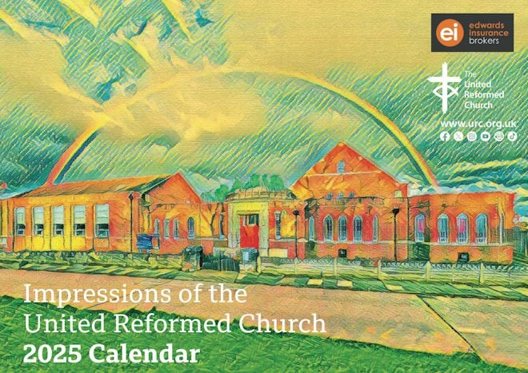

The URC 2025 Calendar – Impressions of the United Reformed Church. The 2025 URC Calendar features images from URCs and LEPs which have been turned into masterpieces using the skills of Senior Graphic Designer Sara Foyle and AI. £1.99 +p&p.

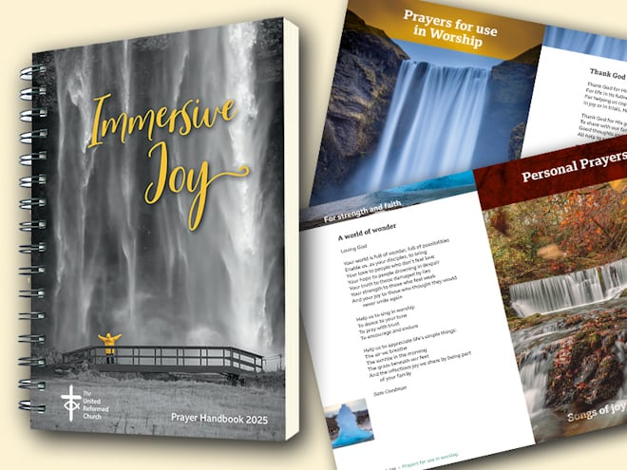

Immersive Joy – The 2025 URC Prayer Handbook is divided into two sections. The first follows the calendar year, with a prayer for each Sunday based on one or more of the lectionary readings, and prayers for other special days. The second subdivided prayers that could be used in public worship and those which seem more suited to personal devotion. Available in A4 and A5 sizes. £6.49-11.49 + p&p.

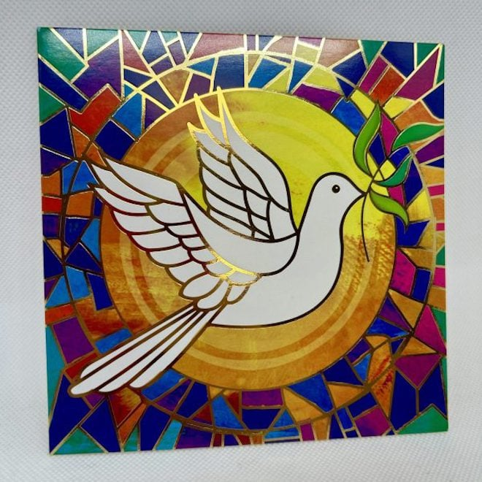

Pack of 10 Shelter Christmas cards – Sunburst Dove. A set of 10 x 10cm x 10cm charity Christmas cards in aid of Shelter and Shelter Scotland, with a stained glass dove of peace design with gold foiling. £3.99 +p&p. Many other designs are available: www.urcshop.co.uk/christmas

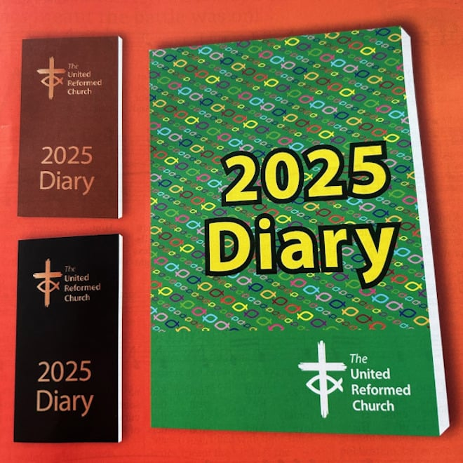

The 2025 Brown or Black Pocket Diary or the A5 Green Diary includes calendars to 2027, year planners to 2027, notable dates for the URC and the wider Church, metric measures, Lectionary readings, Assembly officers and URC staff, useful addresses, Assembly committee details, and more. £9 - £11 +p&p.

Synod news

Yorkshire

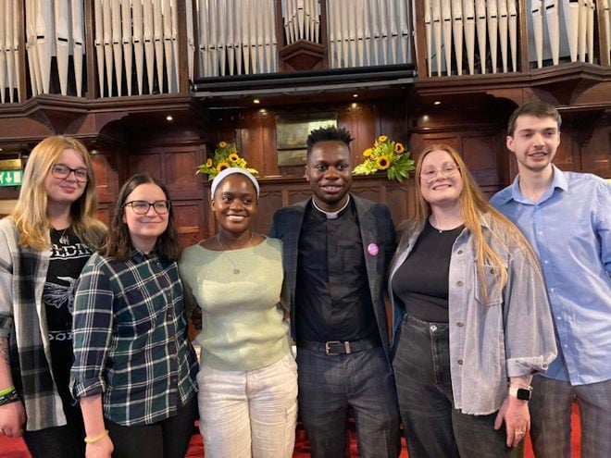

A huge welcome goes to the Revd Joseph Amoah who was inducted as Minister of St Paul’s URC in Harrogate, and the Revd Simon Cross who was inducted to the Hull Team of Churches and Peter’s House. They are wished every success for their ministries.

North Western

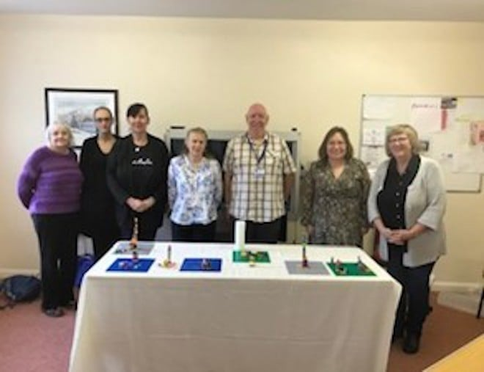

Congratulations to the North Western Synod Faith-Filled Worship group, facilitated by mission mentors Revd Daleen ten Cate and Liz Delafield, which has successfully completed the stream and received certificates of completion. Learn more about Stepwise, the URC's discipleship development course.

West Midlands

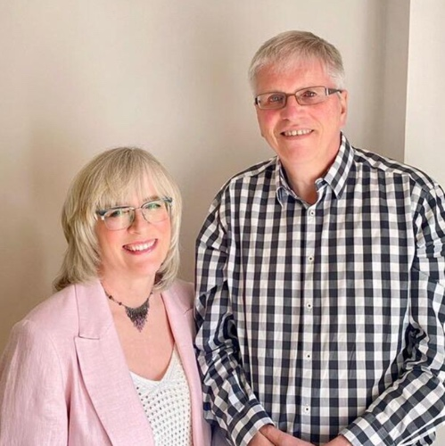

Congratulations to the Revds Sally and Andrew Willett who have recently become the West Midland Synod’s Mission Development Officers. They will be job sharing this role, alongside ministering to six churches in the West Birmingham and Walsall Pastorate. In their new the couple will be assisting churches to grow in their mission and discipleship.

Mersey



The Revd Geoff Felton, Moderator of Mersey Synod, has been named President of the Liverpool and District Free Church Federal Council. The organisation is committed to fostering joint working and creative initiatives across the Mersey region and offers grants for mission and outreach to Free Churches across the region.

What's On

Spiritual abuse webinar

URC Safeguarding is hosting a one-off webinar with Dr Lisa Oakley focusing on Spiritual Abuse on 27 November from 1-3.30pm. Dr Oakley is an Associate Professor at the University of Chester. She is also the Chair of the National working group for abuse linked to accusations of witchcraft and spirit possession and the Church of England Task and Finish Group on Spiritual Abuse. Book your free place.

Young adult residential

Junction 25 is an ecumenical weekend residential for young adults, taking place at Kingswood Dearne Valley Centre in Doncaster from 31 January -2 February 2025. Tickets cost between £10 and £25 and is aimed at 18-25-year-olds. If you'd like to meet others, discuss, worship, chill and laugh together, find more information and book you space by 15 December.

CTBI diversity conference

Churches Together in Britain and Ireland is holding a free one-day conference on 14 November from 11am-4pm on "Dancing with diversity: Revisiting the Scandal of Particularity in the context of inter-religious dialogue". Speakers include the Revd Dr Graham Adams, a tutor at Northern College. Learn more about the conference and book your free ticket.

URC Children's conference

This is your last chance to book your space on URC Children’s Workers Together: The Conference taking place 1-3 November at Cuddesdon College near Oxford. Places cost £150 all-inclusive for the weekend. Activities include worship, keynote, hands-on experiences and workshops on child participation, intergenerational ministry, storytelling, and music in ministry – and so much more! Email Children's & Youth Work for details.

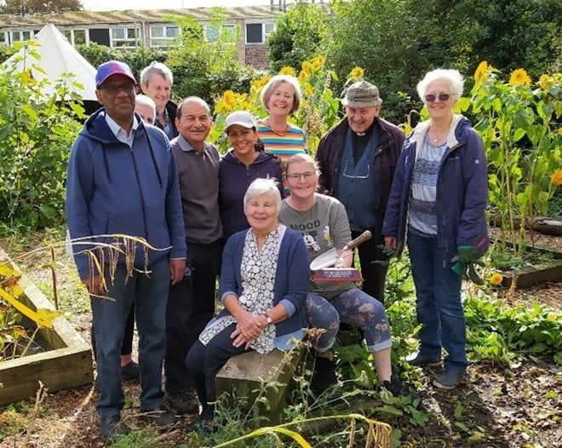

Christmas campaign

A nationwide Christmas campaign called Shine Your Light, will be taking place over the weekend of 13-15 December. Last year saw more than 75,000 Christians from over 700 churches take their Carol services and nativity events into shopping centres, town halls, high streets and public spaces in December 2023. Learn more about Shine Your Light.

URC Buildings Forum

URC Buildings Forum is hosting a webinar on 12 November from 11.30am-1pm themed "Transforming your church building and its land: a close-up of one URC, a wide view of others". During the webinar, guests will hear from a URC minister who has led her church through a major vision-led redevelopment, and from a Synod Green Advocate on some creative ways in which church land is being used for mission. To register or to find out more, email the Mission team.

Church tourism conference

The Churches Visitor and Tourism Association (CVTA) is holding a free conference on 26 October at Castle Street Methodist Church in Cambridge. CVTA is a unique UK-wide inter-denominational charity which encourages churches to be open and welcoming to all visitors. Learn more about CTVA. Book your space at the CTVA free conference.

Single Friendly Church

The Single Friendly Church Network is running a free training webinar to equip churches to welcome single people at every stage of life. The webinar will include lots of practical tips for different areas of church ministry and takes place on 23 November at 11am, all are welcome. Book your free place.

Recruitment

URC vacancies and beyond

Youth, Children and Family Enabler
Location: To serve churches in the Harrogate & Knaresborough Group of the URC in Yorkshire.
Contract: Four years, full-time
Salary: Up to £30,095
Closing date: 8 November
For more information, please contact Megan Tillbrook at 07522 220 213 or email the Synod office.

Commission Secretary – Ministerial Discipline Process
The URC’s Ministerial Discipline Process is looking for a Commission Secretary, effective from July 2025, but with ample shadowing time of the present post-holder built in.
See the URC jobs page for full details.

Assistant Clerk
We are seeking immediate nominations and applications for an Assistant Clerk of General Assembly, which is an opportunity to support the Councils and Committees of the Church in a role which is integral to sound decision making and good process.
See the URC jobs page for full details.

Member of Pensions Committee
We are seeking immediate nominations and applications for a member of Pensions Committee. Have you a financial background? If so, the URC needs you!
See the URC jobs page for full details.

