News Update December 2024/January 2025

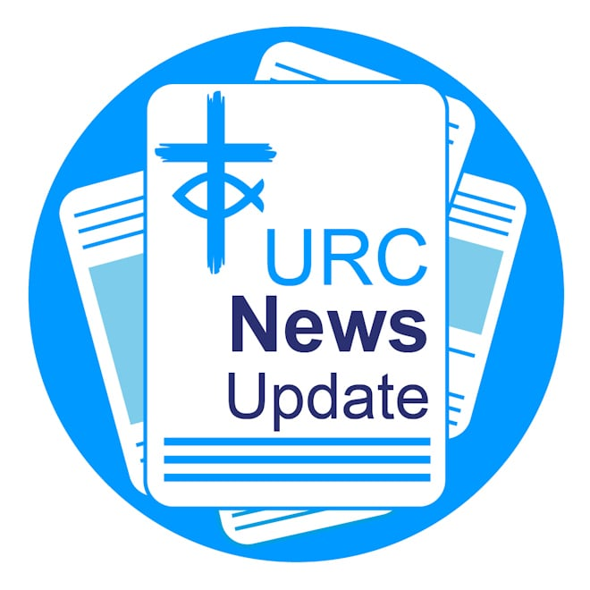

Keeping you informed with the latest news from around the URC.

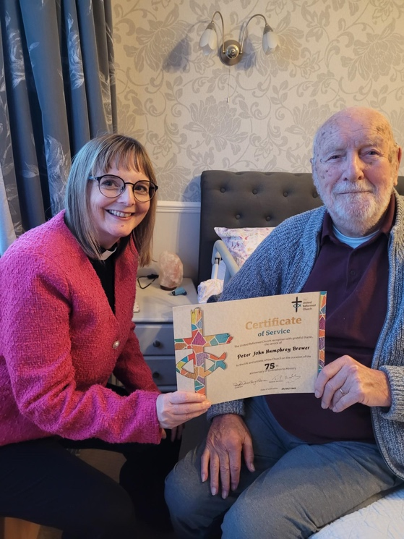
Minister aged 103 celebrates 75th anniversary of ordination

Congratulations to the Revd Peter Brewer, who was presented with a certificate, by the Eastern Synod Moderator the Revd Lythan Nevard on celebrating 75 years since his ordination. Now 103-years-old, Peter is “still bright and interested in life and a man of deep faith. He is exactly 44 years older than me as we share a birthday,” said Lythan.

Church Life Review

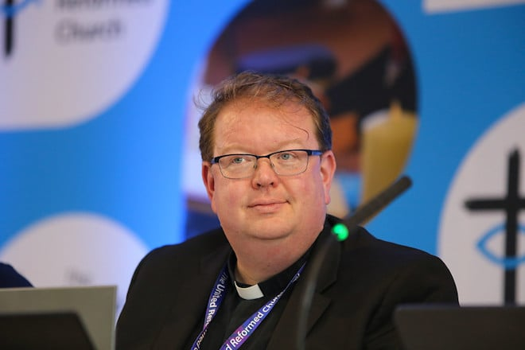

If the URC’s Church Life Review succeeds, things will be different six years from now. John Bradbury looks forward in How We Thrive: A Podcast from 2030. Keep updated with news about the URC's Church Life Review.

2025 Community Project Awards

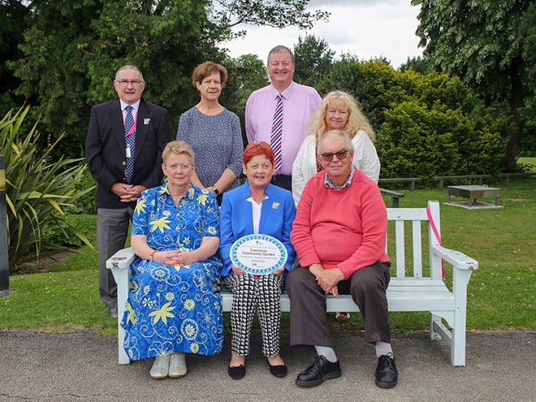

Entry to the 2025 Community Project Awards is now open. There will be six awards again for 2025, three first prizes of £2,000 and three highly commended prizes of £1,000. The closing date will be 21 February 2025. Learn more about the awards and how to enter.

Assembly Executive autumn meeting

The autumn meeting of Assembly Executive was held online on 26 November and convened principally to discuss the URC’s budget for 2025, and to note the target figures for 2026 and 2027. A full roundup of the Assembly Executive budget meeting and decisions made can be found here.

URC comments on assisted dying bill

The URC issued a statement after a debate in the UK Parliament about the Terminally Ill Adults Bill for England and Wales. The URC believes all human life is God-given and precious, and each person, made in the image of God, is of inherent worth and value. Read the URC's statement in full.

Justin Welby resignation

In response to the resignation of the Justin Welby over safeguarding failures as the Archbishop of Canterbury, the URC issued a statement on the need for shared responsibility in fostering safe cultures within all institutions and called on the moment to be used for renewed vigilance in improving safeguarding standards. Read the URC's statement on the resignation of Justin Welby in full.

General Assemblies 2025

In 2025, the URC gathers as Assembly Executive from 3-5 February at The Hayes Conference Centre in Swanwick. General Assembly will meet twice: from 4–7 July at The Hayes and an Extraordinary General Assembly will meet from 14-16 November at Kents Hill Park in Milton Keynes. Keep up-to-date on the Assemblies.

CWM issues statement on Middle East



The Council for World Mission has issued a statement on the humanitarian crisis in the Middle East and announced a Solidarity and Action Grant to provide humanitarian aid for war victims in Gaza. In its statement, CWM expressed deep concern over the escalating conflict’s tragic toll and urged Israel, Hamas, Hezbollah, and other parties to prioritise life by enabling essential aid and committing to dialogue for peace. Read CWM’s statement in full. Image: Palestinian News & Information Agency (Wafa) in contract with APAimages/ CC BY-SA 3.0.

Blessed are the peacemakers

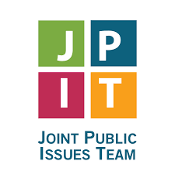

The Joint Public Issues Team's new resource, The Future of Arms (FOA), is now available. As conversations around national security and the arms trade intensify, it’s essential for churches to engage with these pressing issues from a foundation of peace and justice. Explore blogs, prayer guides, and reflection opportunities that encourage thoughtful dialogue and inspire action within your community. Learn more about and access the FOA resources.

Wishing you a Merry Christmas

The URC Communications Team would like to wish each and every one of our readers a very Merry Christmas and a Happy New Year! We look forward to sharing news, resources and information with you in 2025.

Christian Aid Christmas appeal

Christmas is a time for reflection and unity. It’s an opportunity for your church to come together in celebration, while making a meaningful impact. This season, Christian Aid invites you to pray for families who’ve left everything behind to escape conflict, and to find ways to support them through its Christmas Appeal. Learn about Christian Aid's Christmas Appeal and access free resources.

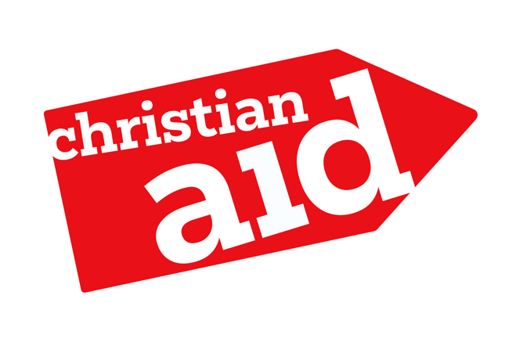

URC/Pfalz Advent service

The annual online Advent service with the URC’s partner churches in the Pfalz region of Germany takes place on 15 December from 6-7pm. The service will be in English and in German (with subtitles). This year will also include a French element, recognising the valuable partnership with the French Reformed Church through Wessex Synod. The opportunity to meet with the URC's German and French friends for conversation will be provided during the service in breakout rooms. The service will be hosted by yoURChurch. Join using the meeting ID 965 1457 5443 and the passcode YoURChurch, or use this link.

EcoCongregation Scotland video Advent calendar


The Revd Tim Meadows, General Assembly Moderator, is one of a selection of contributors to EcoCongregation Scotland's video Advent calendar, produced by the Revd David Coleman, EcoChaplain. While recording the video, David noticed a robin was singing throughout Tim’s uplifting reflection. Tim's reflection has been recorded for day 12 of Advent, following the Rt Revd Shaw Paterson, Moderator of the Church of Scotland, on Day 11. Follow the EcoCongregation video Advent calendar on Facebook.

Free worship resources



Did you know the URC produce Worship Notes for every Sunday of the year, and for other special services? These provide all the resources you might need to prepare a service and include a wide range of hymns from the four hymn books most often
used in congregations. Worship Notes is free to download. Learn more about Worship Notes.

The Scottish College

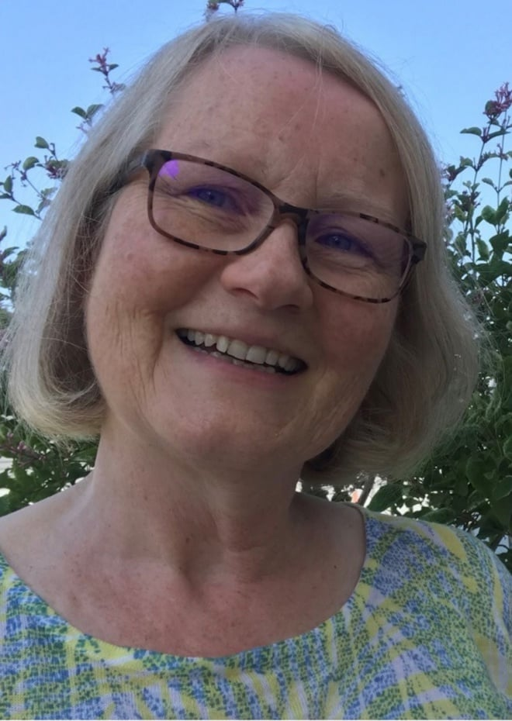

The Scottish College has announced that Linda Harrison will be joining the team as College Manager on a part-time basis. Starting in the New Year, Linda recently worked with partners at the Scottish Episcopal Institute and is the Church Secretary of Augustine United Church, Edinburgh.

The great Gospel giveaway


In 2025, HOPE Together has a bold vision: to help place 30,000 Gospels in the hands of people across the UK, through their local church. In the UK, 24% of practising Christians came to faith through reading the Bible. That’s why they’re on a mission to train and equip churches to share God’s word with people who don’t yet know Jesus. Can your church be part of this extraordinary mission? Learn more about the great Gospel giveaway.

Download or print News Update

A downloadable version of News Update, formatted for print, and for churches to copy and paste into church newsletters or magazines will be available within a week of this edition being published. Download your printable version of News Update.

Share your good news

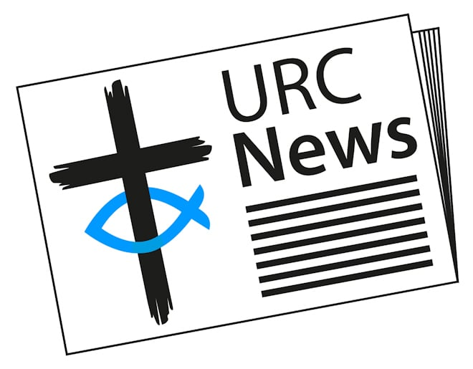

If you have a good news story that can inspire, raise hope or show God's work in action then please let URC Communications know. We would love to help share your news across the denomination and in local news outlets. Email the URC Comms Team or call 07976 753 950.

One-off paper featuring real life stories of hardship unveiled at Parliament Square

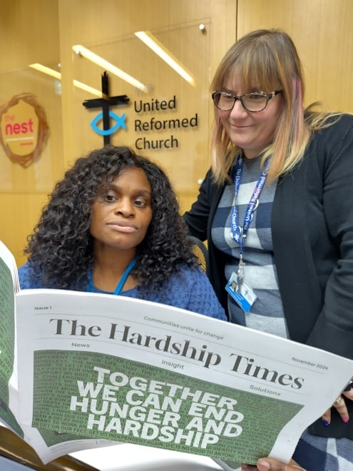

"A choice between heating and eating isn't really a choice at all," says Roo Stewart, URC Head of Public Issues. Last month, food banks, anti-poverty charities and people with lived experience of hardship, alongside Ambassadors Mark Hoyle, from Christmas music act LadBaby, and Levi Roots, a Jamaican-British celebrity chef who was on Dragons' Den, gathered at Parliament Square to unveil a bold new newspaper, The Hardship Times, a one-off publication filled with stories of hope and hardship gathered from across the UK by food banks, charities, faith groups and businesses. Read the Hardship Times.

This month in Reform magazine

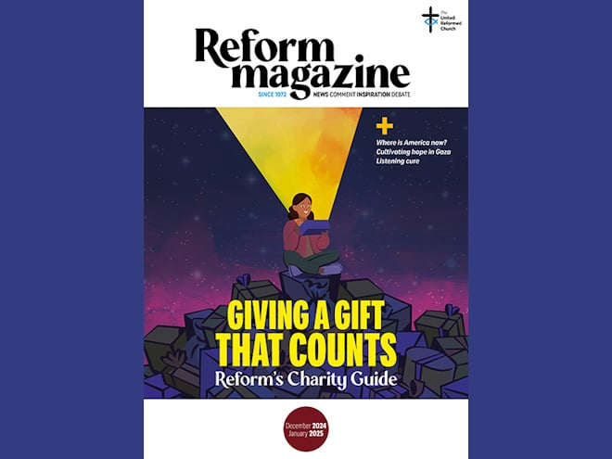

The December 2024/January 2025 edition of Reform magazine has America on its mind. Four American contributors reflect on the outcome of the recent US presidential election and, in a Reform exclusive, leading US health expert Francis Collins says finding a “listening cure” will offer the best way forward. Looking to the Middle East, the team interviews Mahmoud Muna, ‘the bookseller of Jerusalem’, and Matthew Teller about their new book, Daybreak in Gaza. With their collection of firsthand accounts and memories of Gaza and Palestine, they say they are aiming to reveal a ‘normal society’ with an often-overlooked rich, multi-cultural history, while Mahmoud also explains what he believes makes a Holy Land. As we enter the Christmas season, Reform editor Stephen Tomkins and United Church of Christ minister Leah Robberts-Mosser consider different aspects of the nativity stories. All this and more in the December 2024/January2025 of Reform out now! Subscribe to Reform digitally or in print from £18 for 12 months – makes an ideal Christmas gift.

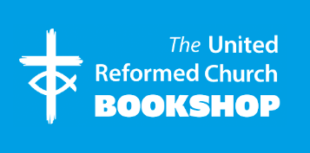

Please order online using the URC Bookshop’s easy-to-use website www.urcshop.co.uk or by calling 020 7916 8629.



Christmas giveaway booklets (25 x A5 16-page booklets)
from £3.99

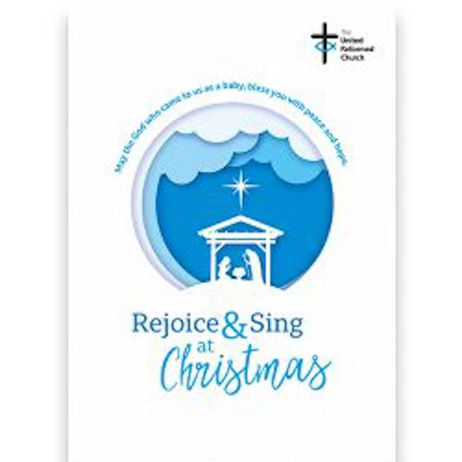

Rejoice and Sing at Christmas
(a large print A5 booklet)
99p



Christmas posters and service sheets
£1.99

To order your church Christmas resources or explore our full range of church resources, see https://urcshop.co.uk/church-resources/



Porcelain hanging cross
£3.99



Make your own Nativity Scene Craft Kit
£5.99



Wooden Nativity Jigsaw
£4.99

To explore our full range of Christmas cards, gifts, baubles and nativity sets, see https://urcshop.co.uk/christmas/

Synod news

North Western

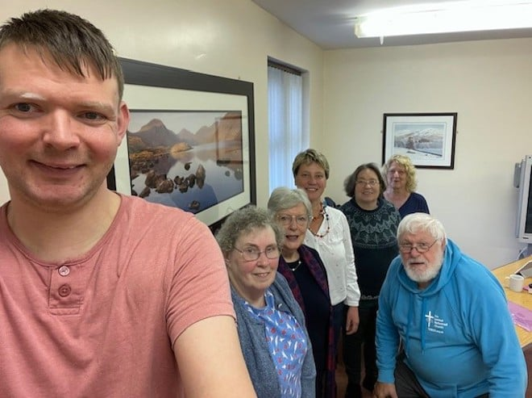

A group from North Western Synod has completed the Faith-Filled Life stream of Stepwise with a memorable away day at North Blackburn URC. Learn all about their Faith-Filled Life Stepwise journey.

Northern

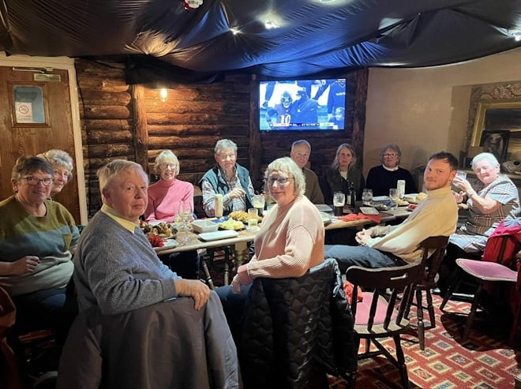

What Would You Ask Jesus is a new group from Wooler URC that has been meeting in a local pub since June. Once a month, the group meets to share testimony, chat to locals and share experiences of faith. Learn more.

Thames North

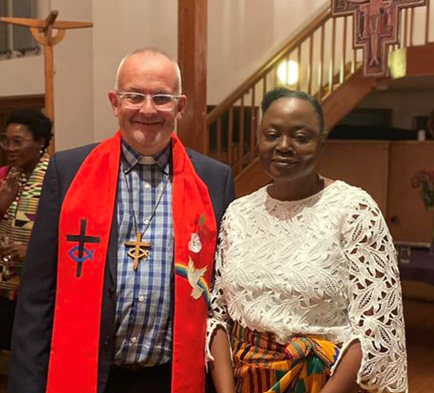

Congratulations to Sue Agyakwa who was commissioned by the Revd George Watt as Elder in pastoral charge at Bromley-by-Bow URC last month.

East Midlands

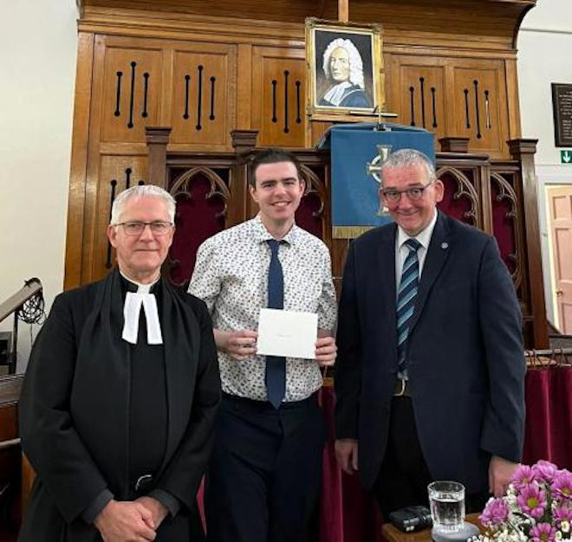

The 350th anniversary of the birth of Isaac Watt was celebrated at Melton Mowbray URC. The service included the Revd Dr Robert Pope, Interim Principal of Westminster College, as the keynote speaker. You can watch the service on the URC's YouTube page, see www.youtube.com/URCUK.

What's On

GEAR prayer and share

Coming Soon! GEAR Zoom Prayer and Share taking place on the first Thursday of each month from 8-9pm is an opportunity to build up, encourage and support each other, in the calling to be "Christ's ambassadors of the Good News" (2 Cor 5:20). Starting on 6 February 2025, more information, including Zoom details, are available from Clare Davison at prayer@gear.org.uk.

Nominations webinar

The new Nominations Committee invites you to a webinar, being held on 20 January 2025 at 7.30pm, to learn about the new processes; how committees appoint new members; what the safer recruitment process looks like; and time for questions. The invitation is open to all interested parties, especially Synod Clerks, Moderators and Committee Convenors. To register your interest please email mission@urc.org.uk. You will be sent the Zoom link nearer the time.

Recruitment

URC vacancies and beyond

Administrator (Church Life Review)
Based: London
Term: Fixed-term contract until March 2026, Contract: Full-time 35 hours pw
Salary: £36,103 pa
Closing date for applications: 3 January 2025

Assistant Clerk
The URC is seeking immediate nominations and applications for an Assistant Clerk of General Assembly, which is an opportunity to support the Councils and Committees of the Church in a role which is integral to sound decision making and good process. For full details, see URC Jobs.

Commission Secretary – Ministerial Discipline Process
The URC’s Ministerial Discipline Process is looking for a Commission Secretary, from July 2025, but with ample shadowing time of the present post-holder built in. For full details, see URC Jobs.

Chair of Retired Minister’s Housing Society
The URC is seeking immediate applications for Chair of the Board of the Retired Ministers Housing Society, which is an opportunity to provide a leadership role in a Christian housing environment seeking to provide quality housing to retired United Reformed Church Ministers.
For full details, see URC Jobs.

