



United Reformed Church Commitment for Life March/April 2025
Storie
S

Moving

Committed to supporting our global partners BANGLADESH


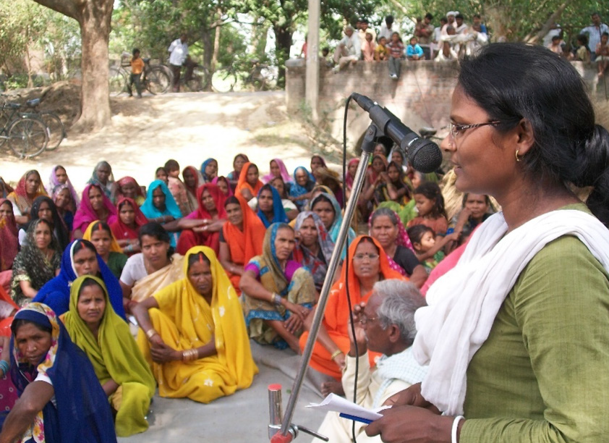
hristian Aid reports that there are around 6.5 million Dalits in Bangladesh. Many are descendants of migrant labourers from India under colonial rule. This history, their caste, and their
Facing the conflict
in Ukraine
Commitment for Life is pleased to be supporting the work of our URC partner churches in Hungary and
in Transcarpathia, Western Ukraine.

NATO expansion into Ukraine has been met by a
devastatingly bloody, Russian special military operation.
The conflict has led to the mass dislocation of ordinary Ukrainians. People have fled to the safer, western parts of Ukraine and into neighbouring countries like Hungary.

Our partner churches are doing brilliant work to support these refugees. Watch our CFL video:
https://youtu.be/lK9s_v4ebPU
and support our appeal here:
https://gofund.me/d99524e8
Photo credit: Christian Aid
C
ethnicity are all causes of discrimination. Little is known about these Dalits, who have come to be known as the ‘missing poor’.

Women and girls among ethnic minorities in Bangladesh face intersecting challenges. These include restricted access to decent work opportunities. Older women and women with disabilities are especially denied access to public services. Christian Aid works to promote inclusive societies in Bangladesh and India.

Usha (pictured) was born into a family of Dalit farm labourers in Uttar Pradesh. She gradually emerged as a leader within her community. She organised Dalit agricultural labourers to oppose caste domination and negotiate for better wages. Some in her family and community rejected her new-found voice. This led to family violence and Usha was forced to leave her marital home. But the backlash has not dampened her resolve to fight for oppressed communities and Dalit women, and she now leads the women’s collective supported by Dynamic Action Group.
commitmentforlife@urc.org.uk www.bit.ly/URCFL

