News Update January 2025

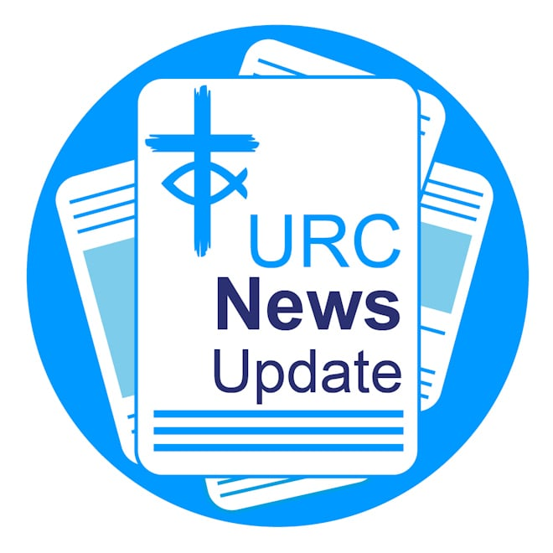

Keeping you informed with the latest news from around the URC.

Enter your prayer for the 2026 Prayer Handbook

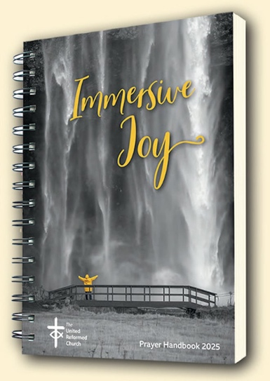

The deadline for submissions for the 2026 URC Prayer Handbook – Touching God is fast approaching. Under the new editorship of the Revd Dr Susan Durber and the Revd Jonnie Hill, prayers are invited which express gratitude for, or a yearning to experience, the touch of God in our lives — moments when the sacred mystery of God breaks into the everyday, filling it with awe and wonder. Prayers that celebrate the sacramental nature of all life, affirming the presence of the divine throughout the world we share. Please make your submission by the deadline of 21 February. You can email your prayers for the 2026 Prayer Handbook to phb@urc.org.uk.

Community Project Awards 2025

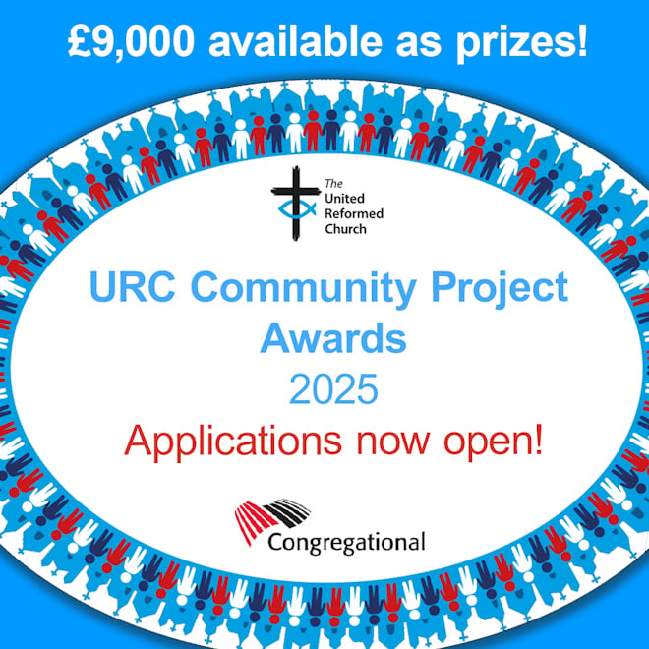

Applications for the 2025 URC Community Project Awards are closing soon. There will be six awards again for 2025, three first prizes of £2,000 and three highly commended prizes of £1,000. The closing date is 21 February. Find all you need to know about the awards and how to make your submission.

Conversations at the Crossroads

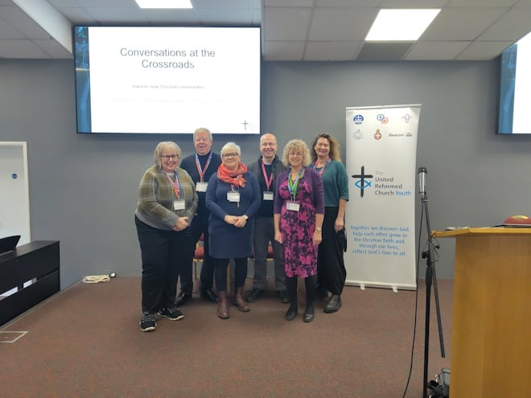

Last month, an inspiring conference brought together 100 passionate individuals dedicated to mission, ministry, discipleship, and evangelism within the URC. As part of the Church Life Review and challenged by the Theos report into the life, identity, and flourishing of the URC, “Conversations at the Crossroads” took place at High Leigh Conference Centre in Hoddesdon to discern where God is guiding the URC in the months and years ahead. Read a round-up of each day of the event.

Reform Live: A Celebration of Rejoice and Sing

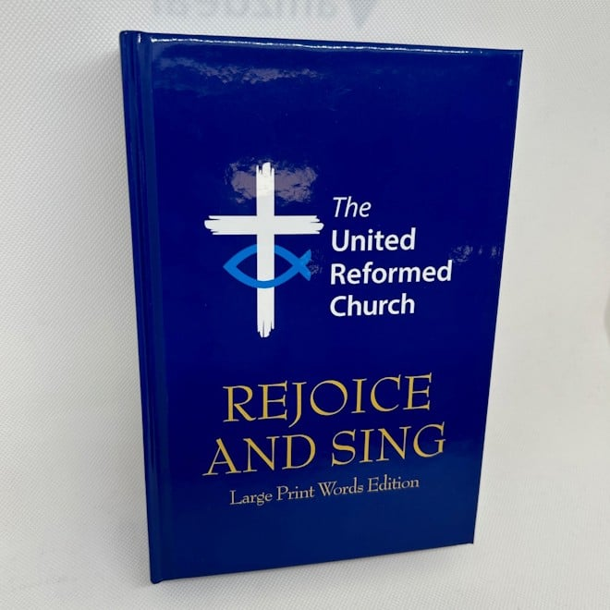
With lots of singing, talks, panel discussions and an exhibition, Reform is hosting a live version of its magazine to celebrate the 35th anniversary of the URC hymnbook, Rejoice and Sing. The event takes place at Coventry Central Hall on 3 May from 12-5pm. Special guests: David Thompson, Stephen Orchard, Anne Sardeson, Dominic Grant and Roo Stewart. Plus, the opportunity to take part in a scratch choir. A drink is included in the ticket price of £5 per ticket (plus booking fee). To book tickets please visit bit.ly/reform-live.

Tim Meadows on UCB Radio



Tune into United Christian Broadcasters Radio to listen to the Revd Tim Meadows, URC General Assembly Moderator, tell his story on This Is My Story with Matt Brown. Visit UCB On Demand to scroll to the episode broadcast on 7 January. Tim's interview appears at 26:06 minutes into the broadcast.

Jenny Mills on UCB Radio



How are your New Year's resolutions going? For 2025, the Revd Jenny Mills, Deputy General Secretary (Discipleship) chose not to make any this year. She spoke on UCB Radio's Talking Point with Vicky Gibbens about why. Visit UCB On Demand to listen to Jenny's interview appears at 2:16:59 minutes into the broadcast.

Helping you share Jesus in 2025

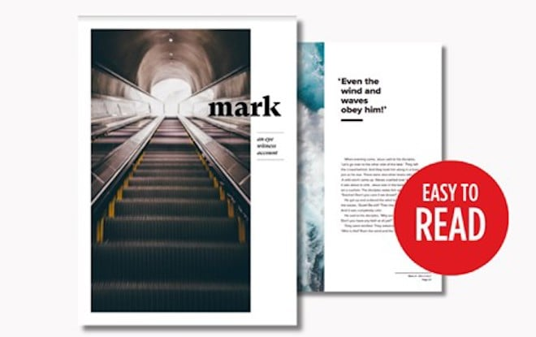
Hope Together, of which the URC is a partner, is offering a beautifully illustrated NIrV Gospel, published in partnership with Biblica, designed in a magazine style and printed on quality paper. Available from £1.25 each. For more details of this and other publications, visit the Hope Together store

.

Search is on for Britain's best church magazine

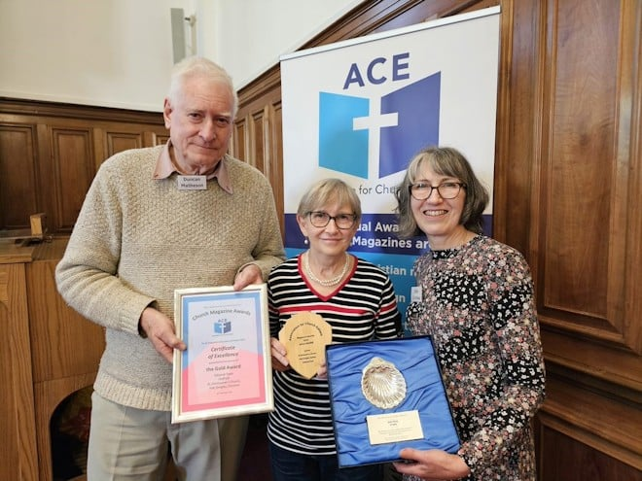

Entries are now invited for the Association for Church Editors (ACE), annual church magazine competition. Sally Churchus, Chair of the national organisation, said: "We are keen to encourage church editors everywhere." For the 2025 competition, which closes on 8 April, awards will be made for any size of magazine using black and white printing (coloured paper is allowed). The prize-giving will take place at ACE's annual meeting in September which is open to everyone and includes talks about how to improve your magazine. Learn more about the competition and how to enter your magazine.
Image: Gold Winner 2024: from left Duncan Matheson (husband) of Kath Matheson, Editor of Ho†Pott magazine from Cheshire, with Sally Churchus/ACE.

Newbigin pioneering conference

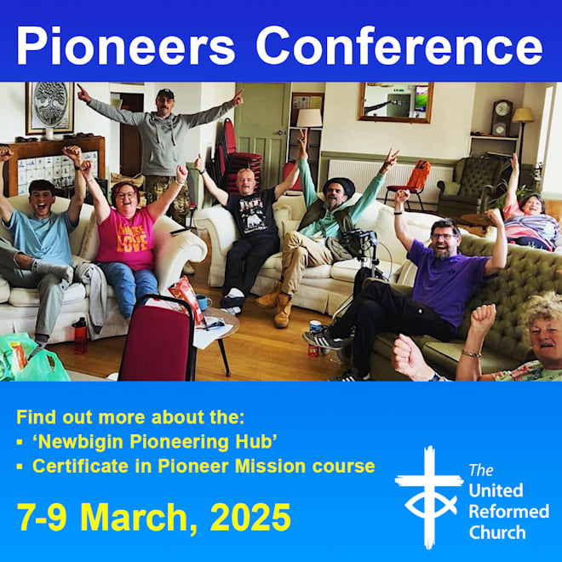
If you are passionate about making a positive difference and want to learn more about how you can become better equipped, then join the Newbigin Pioneering Hub's Pioneering Conference themed "Discovering what’s strong to address what’s wrong". The conference takes place at Lodge Road Community Church in Birmingham from 7-9 March and costs £87.38. Contact your synod for possible funding, including the Discipleship Development Small Grant. Learn more about the Newbigin Hub. Book your place at the conference.

New Nominations resources page

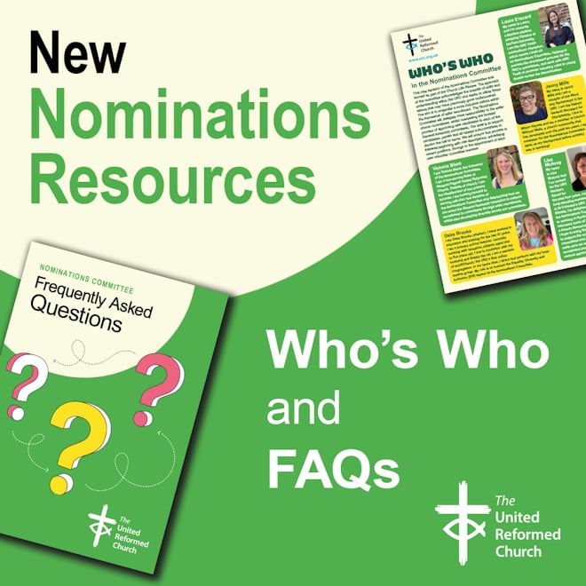
The Nominations Committee exists to support candidates, panels and all related subcommittees of the URC to discern the call to serve. This new iteration of the Nominations Committee was formed following decisions made at the General Assembly of 2023 as part of the Church Life Review. To find out who's who on the commitee and read the answers to frequently asked questions, visit the new Nominations Committee resources page.

Download or print News Update

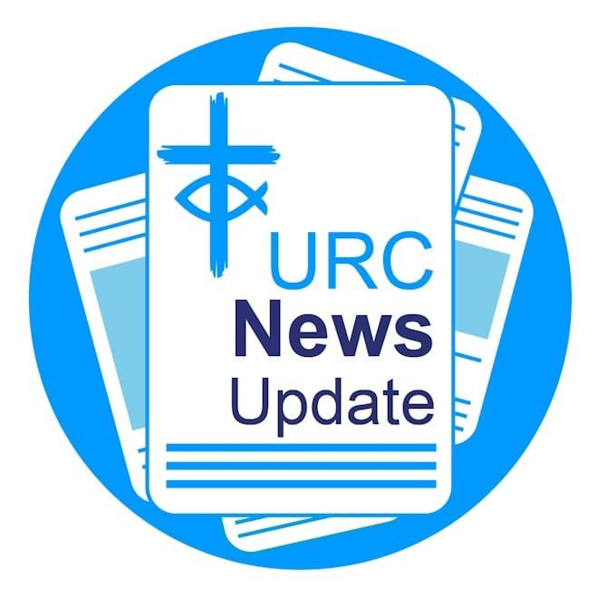

A downloadable version of News Update, formatted for print, and for churches to copy and paste into church newsletters or magazines will be available within a week of this edition being published. Download your printable version of News Update.

Share your good news

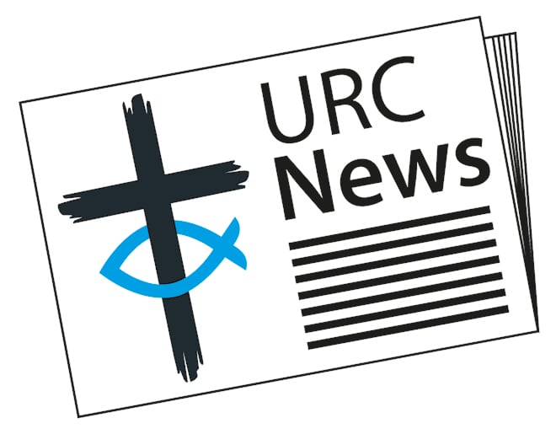

If you have a good news story that can inspire, raise hope or show God's work in action then please let URC Communications know. We would love to help share your news across the denomination and in local news outlets. Email the URC Comms Team or call 07976 753 950.

Volunteer with the URC at Greenbelt Festival 2025

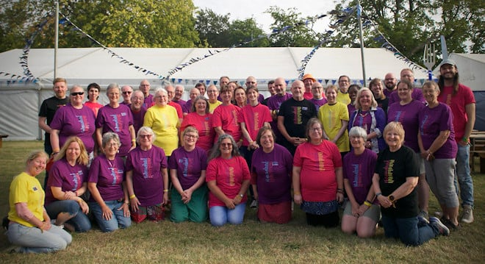

Planning has already started for the URC’s presence at Greenbelt 2025, taking place 21-24 August at Boughton House near Kettering. The team is busy working behind the scenes developing themes and volunteering opportunities. If you would like to know more about becoming a ‘festival friend’, volunteering with the URC at Greenbelt festival at the URC's cafe, yoURCafé venue, please contact Samara Andrews for more information or to register your interest. As a URC festival friend, you will receive free weekend entry to the festival, a parking and caravan pass (if required), food vouchers, discounted shower passes and a complimentary t-shirt. We will also offer a supportive and fun team environment For more information, email samara.andrews@urc.org.uk, or visit the URC's Greenbelt page.

Holiday club materials

Free, new materials and resources to run holiday clubs will be released by the URC Children’s and Youth Work team by the end of January. Based on the "All Are Welcome" theme, the resources will explore five New Testament stories through song and story, craft and discussion, eating, praying and playing together. As always, they will include appendices to help you adapt the materials for under fives, 11 to 14s, vintage holiday clubs or for an intergenerational event. Access the 2025 resources. Grants to help run holiday clubs are available. Learn about grant and funding opportunities.

URC congratulates Zambian church

The URC has sent greetings to the United Church of Zambia (UCZ) on its 60th anniversary. The greeting, sent by the Revd Dr John Bradbury on behalf of the denomination, said: "As brothers and sisters in Christ, we rejoice with thanksgiving on the anniversary of your union, a communion that created a community with many different languages, peoples and cultures, all bonded together by a deep Christian faith." The UCZ was formed on 16 January 1965 when four separate missions – the Paris Evangelical Missionary Society, The London Missionary Society, the Methodists and the Church of Scotland – came into union. Read the greeting in full.

This month in Reform magazine

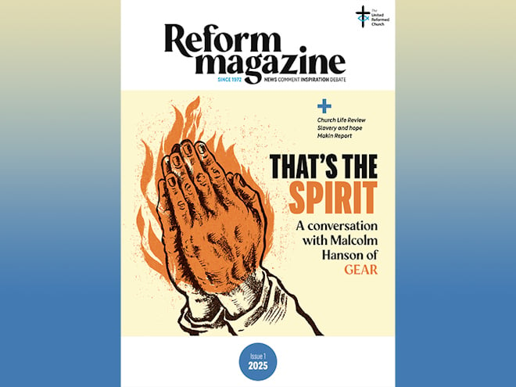

Inside the first issue of 2025: A Buddhist chaplain is among those who ask whether values are more important than beliefs in the latest issue of Reform, and Heather Moore reflects on her year as URC Youth President. We remember John Tinniswood, a former URC Elder who became the world’s oldest man, and report on a global consultation on modern-day slavery attended by the Geoff Felton, along with his reflection more broadly on slavery, past and present, and describes what he has learnt about justice, hope and humanity from recent encounters and studies. Addressing another pressing public issue, in the first of two Reform articles a survivor of church-based abuse responds to The Makin Report, which detailed abuse within the Church of England. Malcolm Hanson talks to Stephen Tomkins about baptism in the Spirit, holding together diverse opinions in one Church, and what he believes the Group for Evangelism and Renewal (GEAR) offers into the United Reformed Church. As well as Top Gear, other TV favourites have also been smuggled into Reform this month – the first dramatised life of Jesus in the UK and even one or two Traitors. Will you be able to spot them? Subscribe to Reform digitally or in print from £18 for 12 months.

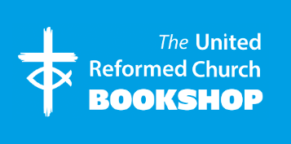

Please order online using the URC Bookshop’s easy-to-use website www.urcshop.co.uk or by calling 020 7916 8629.

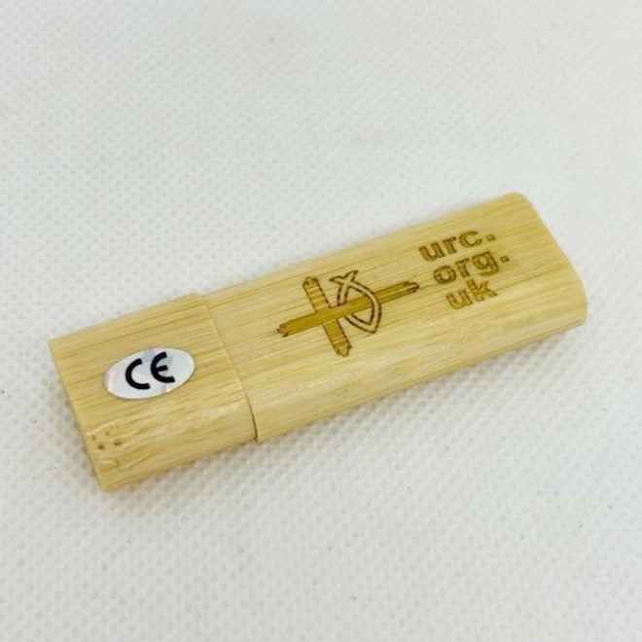

NEW: URC logo 32Gb Wooden USB Stick – A USB stick made from eco-friendly wood with a magnetic lid. The URC logo and web address on one side, the new Reform magazine logo on the other. Laser engraved and varnished. 32Gb capacity with red indicator light which illuminates when plugged in. £5.99 +p&p.

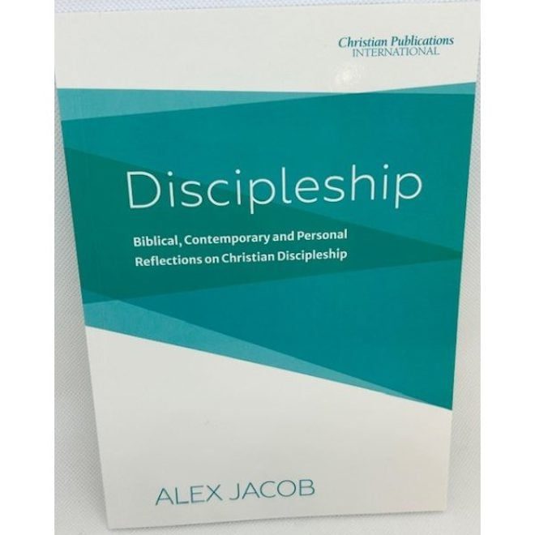

NEW: Discipleship: Biblical, Contemporary and Personal Reflections on Christian Discipleship – Alex Jacob places Christian discipleship into its clear Biblical context and shares many contemporary and practical insights based on ten key steps. £6.99 +p&p.



Pack of five hot cross bun giveaway leaflet Designed to be given away at rail stations, churches, schools or shopping centres, or to be put through letterboxes, the leaflets, that come in packs of 5, have a space on the reverse for a label for churches to add their contact and location details. 10cm x 10cm. 75p +p&p.

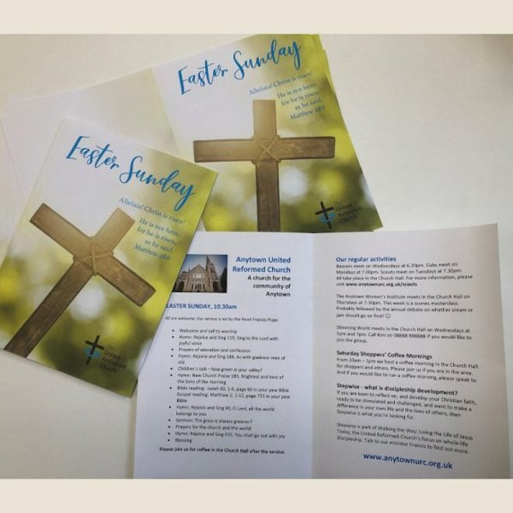

Easter Sunday service sheets, pack of 10. Designed for you to use with your photocopier or printer. Use these service sheets on Easter Sunday. Supplied as A4 sheets for you to print and fold. £1.25 +p&p. Other Easter and Lent resources are available.

Synod news

Mersey



When the waters rose so did Christ Church Haydock URC which opened its doors as a donation hub to support flood-affected residents over New Year's. With hot drinks, food parcels, and essential supplies, the church showed what it means to live out faith through action. Neil Fairhurst, Secretary of Christ Church Haydock, said: “The Christian faith is about being there for our community, and we’re happy to do just that.”

East Midlands

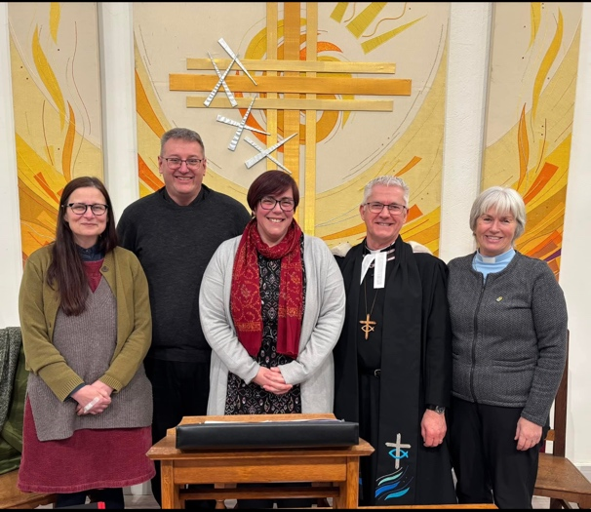

A warm celebration was held at Fountain Square Church in Tideswell last month for the induction of the Revd Carole Marsden. Alongside her full-time role as Community Warden at Cliff College, Carole will serve as Non-Stipendiary Minister in North & West Derbyshire Resource Area (NWDRA), focussing on Fountain Square Church, in team ministry with Revd Caroline Andrews as Area Minister.

North Western

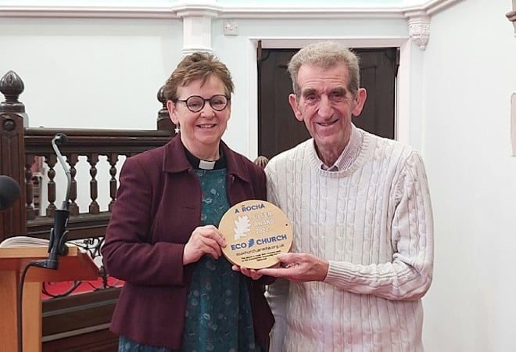

After first gaining the Bronze Eco Church Award in 2022, Grange-over-Sands URC has now achieved the silver award. To mark the achievement, the Revd Kate Hunt presented David Lamb, Grange-over-Sands Eco Church rep, a plaque. The church is now planning to work towards the gold award. Find out how you can gain an A Rocha UK Eco Church Award.

National Synod of Scotland

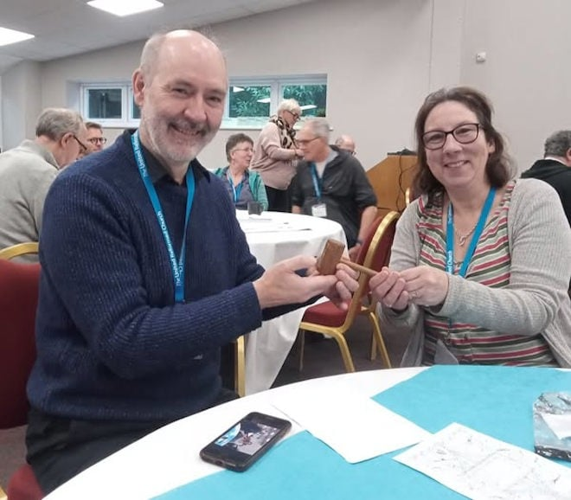

A ceremonial gavel which turned up at Giffnock URC is heading home to Idle Upper Chapel URC in Yorkshire. The gavels were given to local children to mark the laying of the foundation stone of a new church building for Idle Congregational Church in 1956. How the gavel ended up in Giffnock is a bit of a mystery, but the Scotland and Yorkshire Synod Moderators (pictured) were happy to help the gavel return home.

What's On

Faith into action webinars

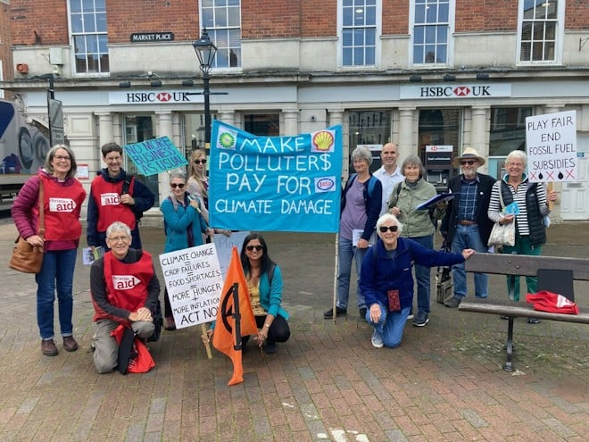

Christian Aid is hosting a series of monthly online sessions to help people understand more about the causes of global poverty and how they can speak up in way which helps create change. The series which launched earlier this month, continues on 10 February from 7-8pm. For full details visit Christian Aid.
Image: Christian Aid.

Connect with your MP



The Joint Public Issues Team is hosting monthly webinars to grow its Constituency Action Network (CAN) – a network of churches across the UK who are committed to building meaningful relationships with their MP and working with them to speak and act for peace and justice. The next webinar is on 26 February which you can join at either 12.30-1.30pm or 7-8pm. Learn more about CAN and the webinars.

Northern College

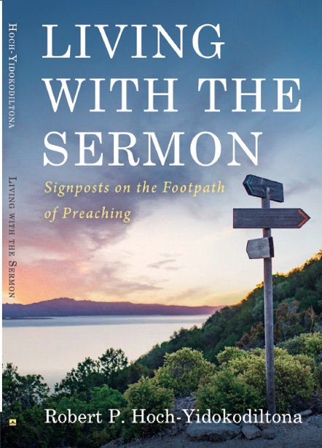

Please join Rob Hoch-Yidokodiltona, Associate Tutor for Northern College’s lay preacher programme, and Training and Learning Mentor for North Western Synod, and the Luther King Centre community, on 25 February for the launch of his new book Living with the Sermon for an exploration into the footpath of preaching. The launch takes place at Luther King House's chapel at 7pm, and the programme will start at 7:30pm.

Lay Preacher training

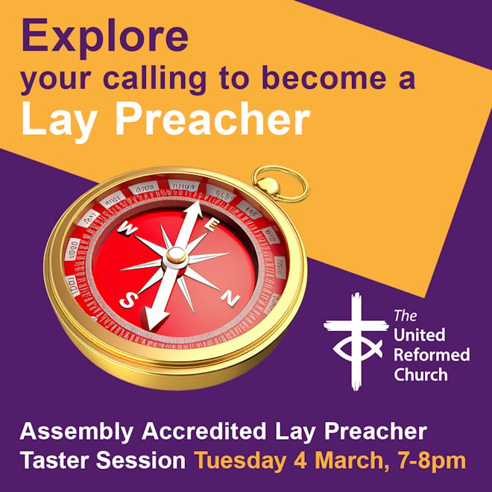

Northern College is running an Assembly Accredited Lay Preacher taster session on 4 March from 7-8pm, via Zoom, ahead of the Assembly Accredited Lay Preaching course which begins every September. Those who believe God may be calling them to become a lay preacher are invited to attend this taster session. For further details visit Northern College's website. Alternatively, please email christine.hufton@lutherking.ac.uk.

Recruitment

URC vacancies and beyond

Head of Governance Services
London
Permanent contract, full-time
Salary: £78,000 – £86,000 per annum
Closing date for applications: 3 February

Ministries Support Officer
London
Permanent contract, full-time
Salary: Circa £43,000 per annum
Closing date for applications: 3 March

