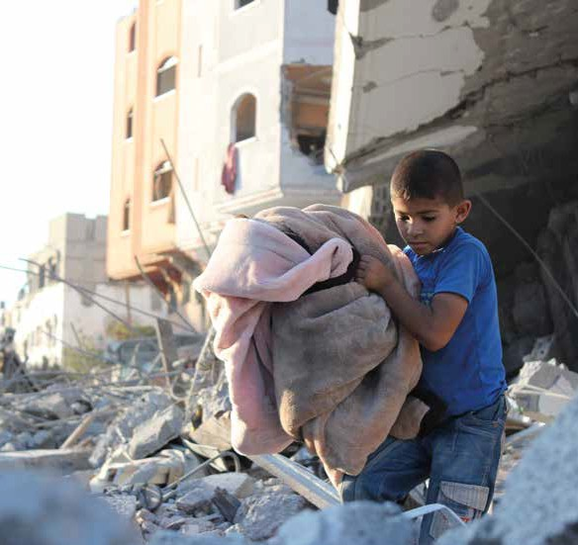




2025

Prayer Partners
We offer these prayers and images to use in your services of worship, church magazines, etc to encourage and guide your prayers for global justice. We suggest using one per month, but feel free to mix things up.

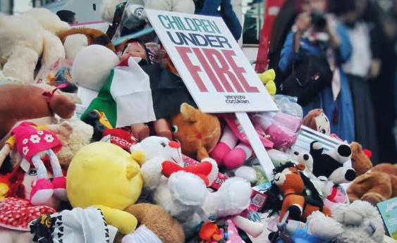
Prayer Partners 2025 • page 2

Prayer for activists
By Global Justice Now

Dear God, we at Global Justice Now come to you with heavy hearts, seeking peace in a world overwhelmed by conflict and violence. We pray for an end to war and the suffering it brings, and for the courage to stand against the forces of oppression and injustice.
We ask for your guidance in our efforts to address the root causes of conflict, including the unchecked power of corporations that fuel climate change and perpetuate inequality.
Help us to challenge their greed and exploitation, and to create a world where all people can live with dignity and respect.
We pray for the people of Gaza, and all those who suffer daily under the weight of state violence and oppression. Give them strength and resilience in the face of adversity and help us to stand in solidarity with them as they struggle for freedom and justice.
We thank you for the work of activists across the world, who tirelessly advocate for a more just and peaceful world. Bless their efforts and multiply their impact, so that together we may build a world where peace reigns and all people can thrive. Amen.

Credit: image by Şeyma D, Pexels

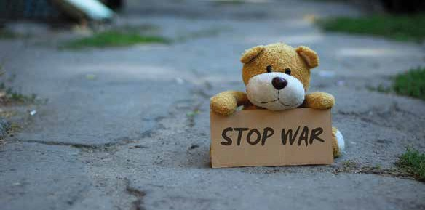
Prayer Partners 2025 • page 3

Credit: image by Marina Shatskikh, Pexels

Prayer for peace
By Maurice Omorojie, URC
Eternal loving God, full of justice and peace,
We pray that your justice become more visible in our communities and in the wider world, to dismantle wars and the powers that fan its flames.
We pray that your Holy Spirit will possess our human governments and fallible justice systems and transform it into your perfect reign that caters for peace and extends loving kindness to all Your creation.
We remember students and pupils, in places like Gaza, Northern Nigeria, Ukraine, Myanmar, Syria, and so on, who are caught up in the evil of war and terror and have had their learning disrupted.
God of the weak, may Your power propel and take charge of every peace talk and agreement, and continue to empower programmes like Commitment for Life, Christian Aid, and Global Justice Now
to constantly be your hands and legs in our world, showing your benevolence and bringing hope to many. Especially, we pray Your comfort, restore, and illuminate the state of mind of these students and pupils to cope and be able to carry-on with their learning, as we continue to trust in Your work of justice and peace in our world. Through Jesus Christ we pray. Amen.

Prayer Partners 2025 • page 3

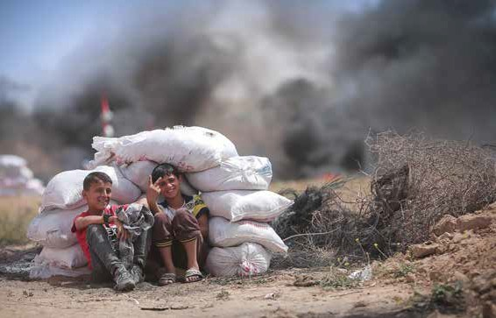
Prayer for Palestine
By Omar Haramy, Sabeel

Heavenly Father, we come before You with heavy hearts, seeking Your divine intervention in a world marred by conflict and sorrow.
Open the eyes and hearts of those in power, those who hold the capacity to end bloodshed and halt the cycles of violence. Grant them the wisdom and the will to act justly and to foster peace where there is strife.
Lord, empower each of us who feel helpless, who believe we cannot make a difference. Instil in us the courage to be peacemakers,
to stand firm in the face of adversity, and to continue the work of reconciliation and love. Let Your Spirit inspire and guide us in these efforts.
We pray for those who have lost family, friends, and neighbours to violence. Comfort them in their sorrow, envelop them in Your love, and heal their wounded spirits. In their grief, help them find the peace that only You can provide.

Credit: image by Hosney Salah, Palestinian photographer currently living in Palestine Gaza Strip, from Pixabay

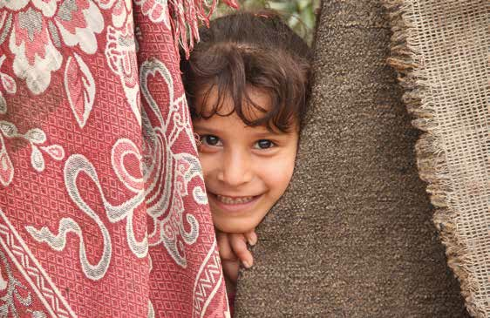

Credit: girl in Gaza, by Hosney Salah, Pixabay

We lift up the Palestinian refugees, longing for a home and a future. Facilitate their journey towards safe return, and foster conditions where all people may live in dignity and peace.
We also pray for justice to touch the lives of those who have committed war crimes. Let them face the consequences of their actions, and through Your profound mercy, lead them towards repentance and change of heart.
Lord, we ask for healing for the broken-hearted, that they may find the strength to forgive those who have caused them pain. Nurture within us all an enduring spirit of forgiveness, compassion, and love.
We trust in Your goodness and mercy, Lord. Guide us all towards a future where harmony and love prevail over discord and hatred.
In Jesus’ name, we pray, Amen.

Prayer Partners 2025 • page 5

Prayer for Zimbabwe
By Wilbert Sayimani, URC
Heavenly Father, we come before You with heavy hearts, lifting Zimbabwe in prayer. We pray for restoration and healing in every aspect of the nation’s life. Lord, we ask for the elimination of corruption that has plagued Zimbabwe, hindering progress and causing suffering among its people. Bring forth leaders who are filled with integrity and a heart for the well-being of their fellow citizens.
Grant wisdom and guidance to those in authority, that they may govern with justice and compassion, prioritising the needs of the people above all else. We pray for an improved economic situation, where all citizens have access to opportunities for prosperity and growth.
Lord, send abundant rains to nourish the land and alleviate the drought that has brought hardship to many. Ease the scarcity of electricity and provide sustainable solutions to meet the energy needs of the nation.
We lift up the education system, asking for resources and support to ensure every child receives a quality education, empowering them for a brighter future. Strengthen the healthcare system, Lord, so that all Zimbabweans can receive the care they need to thrive.
Finally, we pray for unity and peace to prevail, and for the burdens caused by the introduction of the Zig currency to be lifted.
May justice prevail and may the leaders prioritise the well-being of their people above all else. Grant Zimbabwe the strength to overcome its challenges and emerge stronger, guided by your grace and love.
In Jesus’ name, we pray. Amen.

Credit: ‘Woman’ by Fietz Fotos, Pixabay

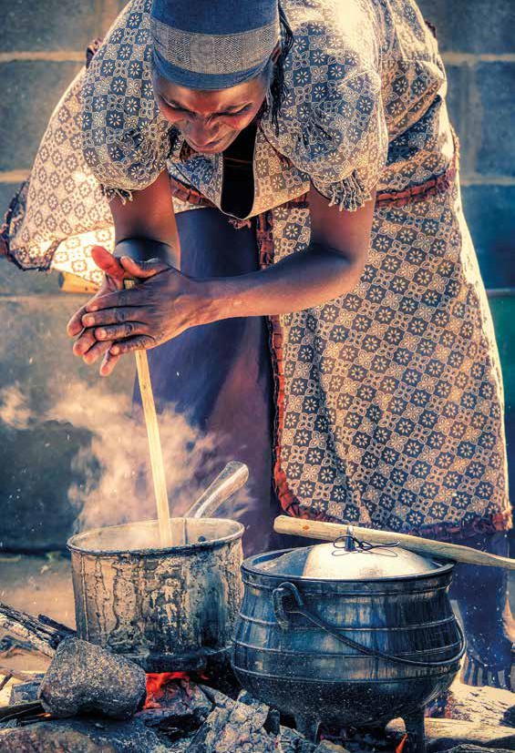

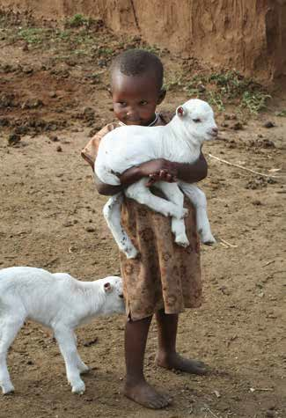
Praying about debt, prosperity, and peace
By Sue Richardson, Just Money Movement
Life-giving God, we are held by you between gift and obligation. We thank you for your abundant gifts in our lives. These we do not deserve and cannot repay except by loving others as you have taught us.
We live in your world, however, between loan and debt.
Our lending to others seeks a material return which is not always faithful to the needs of our borrowers and heedless of their security as we seek our profit. The bond of mutual obligation becomes the chain of indebtedness.
Teach us to live in interdependence, building links of peace and prosperity for all through the breaking of the fetters of debt.
Help us to see that the most valuable return on our giving is a world of mutual enrichment, that we can know our own security most fully when peace is enjoyed by the most vulnerable among us. Amen.

Credit: ‘Kid’ by Yasmin00,
Pixabay

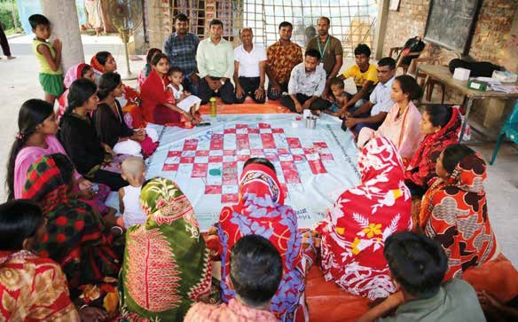

Interactive Ludo Game orientation for community awareness on minority rights and discrimination through a courtyard session in Khulna.
Credit: Christian Aid

Prayer for Bangladesh
By Nuzhat Jabin, Christian Aid
We pray for justice for communities who have been historically neglected due to religion, caste, profession or gender and deprived of basic rights. Across the region we see how this deprivation has played out – children have no or very limited access to education, limited access to decent work and little or no access to healthcare – leaving them in a vicious cycle of poverty. We pray for their
well-being, for their children to grow up with access to education and opportunities, to choose livelihood options instead of those that have been decided for them before their birth, and for their community members to thrive without fear of persecution based on their religion, caste, profession or gender. We pray in general for societies to embrace diversity and value the human capital each individual brings, regardless of their orientation. Amen.

Prayer Partners 2025 • page 9

Action Prayer with Greta – Israel and the occupied Palestinian territory
Dove of Peace Prayer
Equipment – paper plate, scissors, marker pen, glue, or stapler.

Make a Dove of Peace. A dove has been used

Supporting
Israel
and the occupied Palestinian territories

for thousands of years as the universal sign for peace, reconciliation, and forgiveness. Need: paper plate, template, scissors, marker pen, glue, or stapler. Using the scissors, cut out the body of the dove while making sure the tail is lined up against the edge of the plate. When cutting out the wings ensure they are lined up with the rimmed edge for texture.
Stick or staple the wings on to the body. Using coloured pens add a beak and eye. Write on the dove ‘Peace is ’
now finish the sentence with your prayer
for peace. (Christian Aid)
Prayer
Dear God, we know that you are a God of peace and love. We pray for wisdom for a lasting peaceful solution for all involved in
the war in Gaza. We pray for families that have lost loved ones, for those whose homes that have been damaged and for those that have become refugees. We pray that aid will be allowed in to help all people affected by the devastation. We pray that a great wave of Your love for one another will flow through this whole area and overcome the fear and hatred that is currently present, bringing reconciliation and peace. Amen.

Action Prayer with Greta – Bangladesh
Clothes
Equipment – clothes.

Bangladesh is a country where many clothes are made and are sold in the UK. As you look through your cupboards and
Supporting
Bangladesh

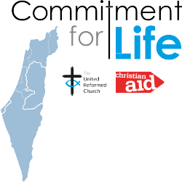
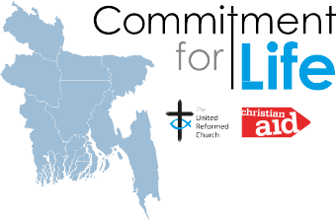

drawers, see how many of them are made in Bangladesh. (It should say on the label) and ask God that the clothes we wear will be ethically made. Pray that factory owners will create safe working places and be compelled to pay their workers well.

Prayer Partners 2025 • page 10

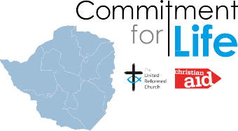
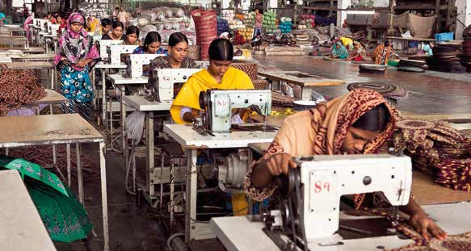

Clothing factory workers, Bangladesh. Credit: Pixabay
Supporting
Zimbabwe
Prayer
Dear God, we thank you for our clothes. We pray for the women in Bangladesh that work in poor conditions and for very little pay to make the clothes we wear. We pray that you may hear their cries for better working conditions and pay, and bless them. Amen.

Action Prayer with Greta – Zimbabwe
Pebble Prayers
Equipment – pebbles and a bowl of water.

Zimbabwe is famous for one of the largest waterfalls in the world – Victoria Falls. It forms the largest sheet of falling water in the world. In the Bible, water is a powerful symbol representing life, cleansing and renewal. Yet despite the huge waterfall with its thundering waters, Zimbabwe suffers from much drought.
Take a small pebble and drop it gently into the bowl of water. Watch the ripples go out.
Prayer

Dear God, we know that a huge river starts from a small spring of water. Each tiny drop of rain that falls into it makes it bigger and stronger. We pray for farmers in Zimbabwe that struggle with their crops due to a lack of rain. We pray for the provision of water through bore holes and the constructions of water harvesting pits. Amen.
Prayer Partners 2025 • page 11

Prayer for Justice
By Grace Kariuki, Christian Aid
Dear Loving God and Father, Creator of the universe, who recognises each of us as your image bearers, we pray that you would convict our hearts to treat and value each other as your image. May we pursue justice and dignity for all.
Help us be conscious of the impact of our actions and inactions toward those marginalised and oppressed. Give us courage to challenge the systems that continue to bring division instead of unity and love.
God of peace, may you bring an end to war and violence across the world. God of love may compassion and mercy flow in our streets and communities. God with us, may those in difficult and unbearable situations experience your presence with them.
God of creation, may you cause us to look after and treasure the world you have given us and work together to address climate change. God of heaven, may we know that in eternity we will experience the perfect shalom. In Jesus’ precious name. Amen.

- Prayer for Israel and the Occupied Palestinian Territory By Nathan Eddy, CCJ
God of peace, we pray for peace in the land you love, the land we call holy: we pray that Palestinians and Israelis can find a just and lasting peace and security for all. We pray that violence might be rejected, and practical solutions found.
We pray for our United Reformed Church and our ecumenical partners, that in the name of the Prince of Peace we can be agents of goodwill in the region.
We pray that here in these islands we can promote understanding between Jews, Muslims, and Christians, and between people of all faiths and none, about the Holy Land – the land that is ‘competitively loved’.
We pray that we can stand together courageously in the face of all intolerance and hate, including Islamophobia and antisemitism, so that we, too, can live in peace and mutual flourishing.
In Jesus name, Amen.

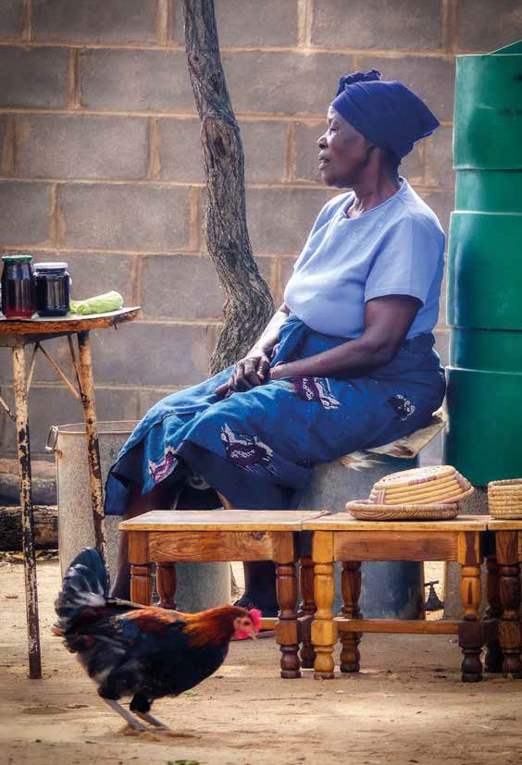

Credit: ‘Woman’ by Fietz Fotos, Pixabay

A prayer for Palestine
By Ana Gobledale, URC – ‘Like the olive tree’. Originally published in ‘Together in Prayer: Palestine’, World Day of Prayer 2024
Allah, Eternal One, God of Christians, Jews, and Muslims, Holy One in this place, in Palestine and in Israel, may our faith lead us to bear with all in love, despite differences in faith traditions. Strengthen
us to stand with all who are being harmed, even to bear with the occupiers in love, speaking the truth in loving resistance, calling the oppressor back to their humanity. May the legacy of those who have died in the Palestinian occupation live on to nourish the earth from which will arise renewed strength to continue telling the story and demanding justice, like the branches of the olive tree, resisting the strong winds that threaten to erase the truth of Palestinian
experience. May the voice of truth, your truth, speak bold and strong bringing hope. Amen.

Shared stories on the URC Commitment for Life web pages

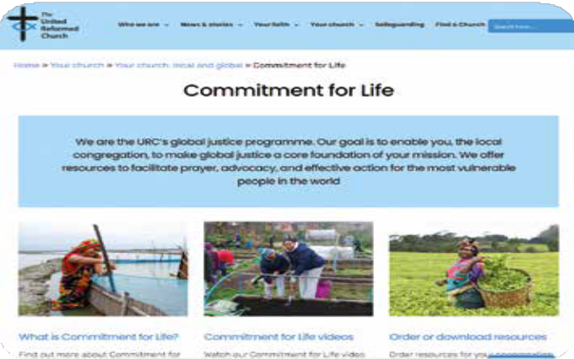

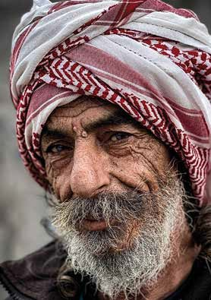
Prayer Partners 2025 • page 15

Prayer for divine direction
By Ana Gobledale, URC
Originally published in ‘Together in Prayer: Palestine’, World Day of Prayer 2024
Unite us to be peace makers building peace among people promoting human rights churning arms into ploughshares

Empower us to be justice workers speaking truth to evil
dismantling oppression liberating the occupied

Peace perfect peace Justice perfect justice

Show us how to walk your path Guide us in the ways of peace And justice. Amen.

Credit: man in Gaza, by Hosney Salah, Pixabay

Front page image credit: child in Gaza, by Hosney Salah, Pixabay

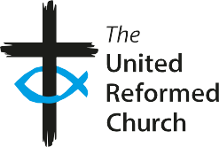





Further resources
More ‘Go with Greta’ material can be found at the URC’s children and youth work pages: urc.org.uk/go-with-greta-and-connect

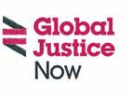
These prayers and photos can be reproduced for non-commercial use

www.urc.org.uk/cfl

Working with Christian Aid and Global Justice Now
The United Reformed Church, 86 Tavistock Place, London WC1H 9RT www.urc.org.uk

The United Reformed Church Trust (URC Trust) is a limited company in England and Wales (Registered Number 135934) and a charity (1133373).
Christian Aid is a charity in England and Wales (1105851) and company (5171525) and in Scotland number (SC039150) and company (5171525).
Global Justice Now is a charity (1064066) and company (2098198).

