News Update February 2025

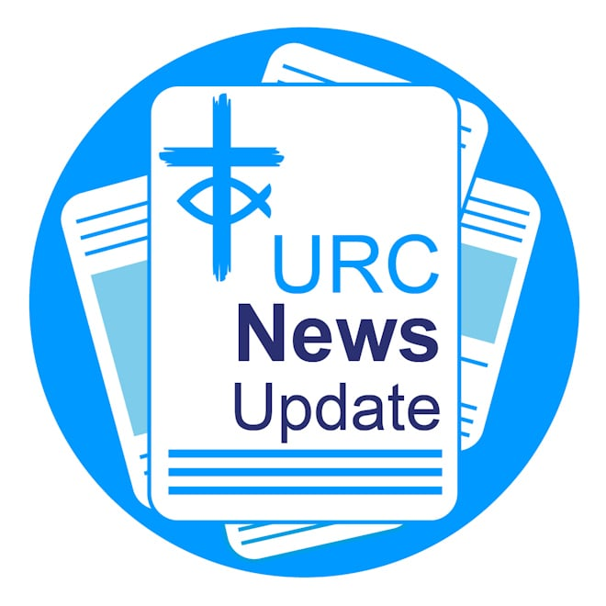

Keeping you informed with the latest news from around the URC

Cuts to international aid condemned


Leaders from the Baptist, Methodist, Church of Scotland
and the United Reformed Church responded to the Prime
Minister’s announcement concerning further cuts to the
international development budget saying: "This would
break a manifesto promise made to people in the world’s
poorest communities, and have a devastating impact on
lives and livelihoods across the globe."
Read the statement in full. Image: Number 10/Wikimedia/CC by 2.0.

Third anniversary of Ukraine conflict


The third anniversary of Russia’s full-scale attack on Ukraine, the
largest war in Europe since 1945, was marked on 24 February.
According to the United Nations, around 12,500 civilians, including
650 children, have died. Around 46,000 Ukrainian soldiers have also
been killed in action. The URC marked the event through prayers
are written by church leaders in Transcarpathia, Ukraine.
Read the prayers.

The 2026 URC Calendar: Seeds of hope

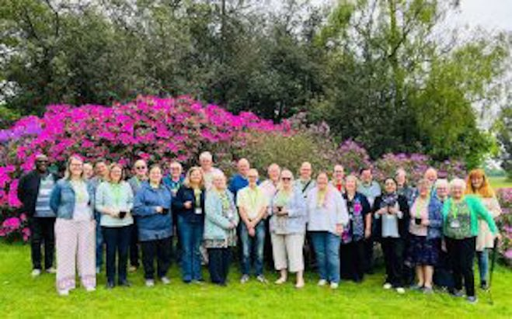

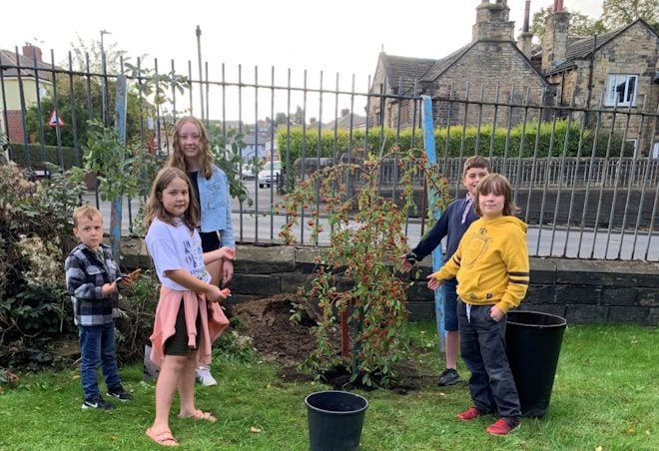

Based on "I am the vine, you are the branches", the 2026 URC Calendar will feature images of people and plants connected to the URC. We have beautiful people and picturesque gardens in and around our churches, and we invite you to send in your photos of them all. Show your seeds of hope – from people of all ages (and please get permission for their photo to be taken and used by the URC), to established or new plants and gardens. Landscape photos are preferred, and square and portrait images are also invited, by the end of June. JPG or PNG file format. Please include the name of the church and the photographer. No bigger than 3600 pixels wide (which should be around 3Mb) please. Please email them to pressoffice@urc.org.uk. If photos are sent, the photographer is granting the URC permission to use the photographs in print and digitally.
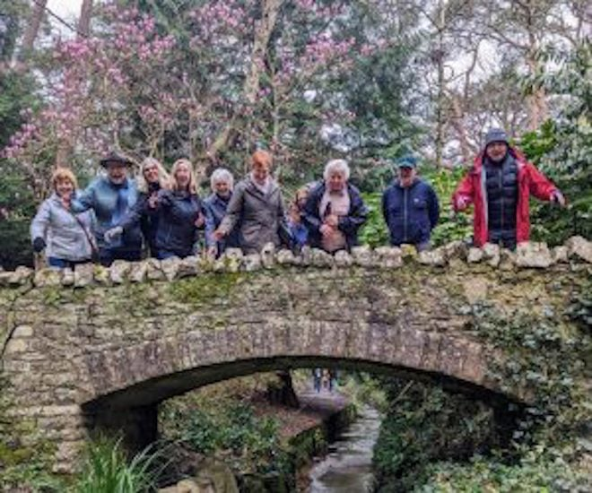
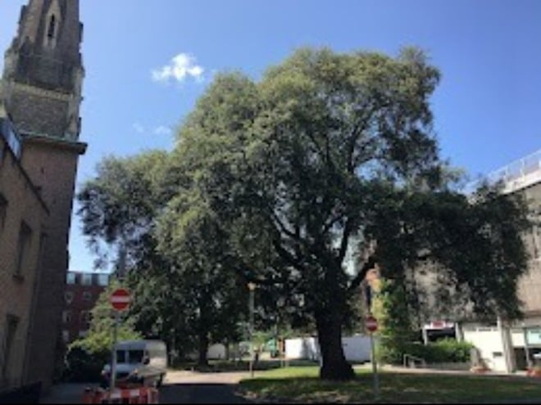

Rejoice & Sing Live: What's your favourite hymn and why?

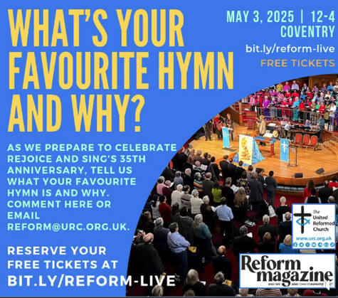
We're asking what your favourite hymn is and why ahead of
the 35th anniversary celebration of our hymn book, Rejoice
and Sing on 3 May in Coventry. Email reform@urc.org.uk
with your answers. Rejoice and Sing LIVE is a celebration of
35 years of the URC's hymn book. The event takes place on
3 May from 12-4pm at The Methodist Central Hall in Warwick
Lane Coventry. To get your free tickets for the event, visit
bit.ly/reform-live.

CTBI Lent resources

Each year Churches Together in Britain and Ireland produces a Lent course often in conjunction with a partner organisation. "Christian Unity in a Fragmenting World" follows on from this year's Week of Prayer for Christian Unity theme which invites us to explore together the enduring relevance of the first ecumenical council of the Church which took place in Nicaea 1700 years ago. Download the resource for free.

JPIT worship resources for Lent

JPIT was invited by the Church of Scotland to write some worship resources for the first Sunday in Lent, 9 March. Based on the lectionary readings, they reflect on power and change. Download JPIT's Lent resources for free.

Free pack for local churches

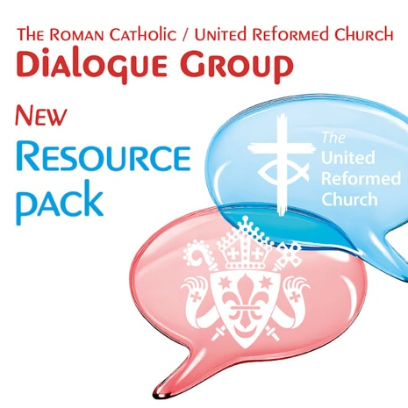
The Roman Catholic/URC Dialogue Group is completing its
third quinquennial with the publication of a free, practical
resource pack for local churches. It includes reflections on the
journey the group has been on, reflective materials for local
groups and lots of ideas for further things to do together.
The Mission Team hopes that the pack will enable journeys of joy and blessing among local churches. Access the resources.

Nominations Committee

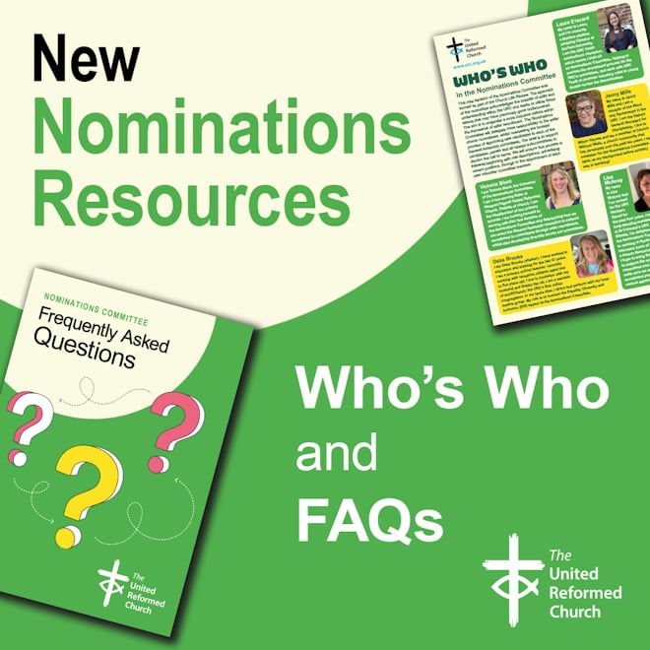
The Nominations Committee exists to support candidates,
panels and all related subcommittees of the URC to discern the
call to serve. This new iteration of the Nominations Committee
was formed following decisions made at the General Assembly
of 2023 as part of the Church Life Review. To find out who's
who on the committee and read the answers to frequently
asked questions, visit the Nominations page on the
URC website.

URC representatives talk mission at CWM forum

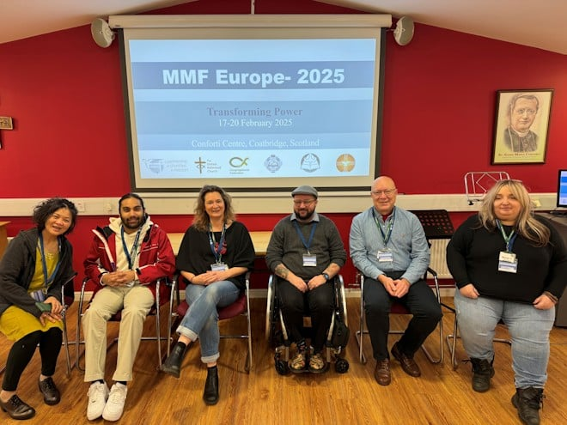
URC representatives recently came together at
the Council for World Mission's Europe Members'
Mission Forum, held at the Conforti Centre in
Coatbridge, Scotland earlier this month.
This inspiring gathering served as both a
mission-focused forum and a space for meaningful
fellowship. Key discussions centred on Palestine
and the challenges posed by Christian Zionism.
The event also explored themes that emerged
from the 2024 CWM Assembly, themed "Rise to
Life: Together in Transformation", encouraging
participants to reflect on collective growth and change. Lindsay Brown, Evangelism and Ecumenical Officer, said: "The URC has been muscular in its response to the situation in the Palestinian territories for several years, and it was encouraging to hear much of the action recommended by General Assemblies affirmed, as well as to learn of further ways we can tackle the deeply shocking daily dehumanisation of the Palestinian people."

How good is your church magazine?

The search is on for Britain's best church magazine. Entries are now invited for the annual competition run by the Association for Church Editors, an independent, not for profit organisation. For the coming 2025 competition, which closes on Saturday 31 May 2025, awards will be made for any size of magazine using just black and white printing. (Coloured paper is allowed). For full details, visit the Association for Church Editors.

Explore life-changing encounters with the risen Jesus this Easter


ALIVE is a video-based course that explores the life-changing meetings people had with Jesus after he rose from the dead, and what relevance they have for us today. Almost one in three people (29%) in the UK say they believe in the resurrection of Jesus to some extent but still have questions (Talking Jesus Research 2022). The ALIVE series, in partnership with Kingsgate, Hope Together and the Bible Society, is designed specifically for this group of people. It offers your church a unique opportunity to connect with those open to exploring faith. Learn more about ALIVE and how to run a course at your church this Easter season.

Download or print News Update

A downloadable version of News Update, formatted for print, and for churches to copy and paste into church newsletters or magazines will be available within a week of this edition being published. Download your printable version of News Update.

Share your good news

If you have a good news story that can inspire, raise hope or show God's work in action then please let URC Communications know. We would love to help share your news across the denomination and in local news outlets. Email the URC Comms Team or call 07976 753 950.

Volunteer with the URC at Greenbelt

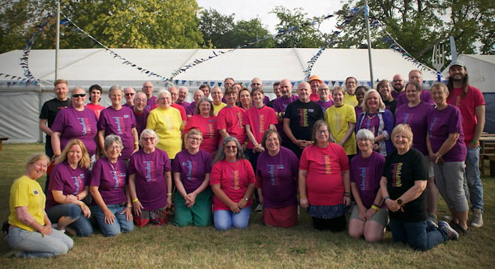
Thinking about your plans for this summer? Why not consider volunteering with the URC at Greenbelt team at the Greenbelt festival taking place 21–24 August at Boughton House in Kettering. There's a variety of volunteering opportunities on offer which come with a variety of perks. Learn how you can get involved.

This month in Reform magazine

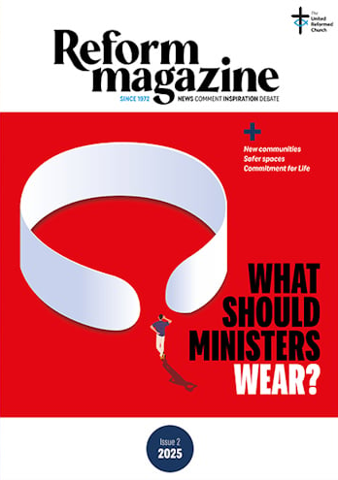
"How do you make the world a better place?" is just one big
question being asked in Reform this issue. We are looking for
stories about local actions, projects, campaigns and passions
that make their own contribution to the United Nations’
international Sustainable Development Goals. How are we, in
our local areas, part of the big picture? In this month’s interview,
Kevin Snyman asks another big question: how can we design a
world that doesn’t depend on money? Money creates divide and
poverty and is counter to the Gospel of Jesus, he says. And a
third question. What should ministers wear? Four contributors
debate the dos and don’ts of “dog collars” and other clerical
garb – it’s more complicated than you might think. Elsewhere,
the URC’s Safeguarding Lead says biblical values have their place in the Church’s safeguarding policy. We also hear reports from two inspiring conferences: Junction 25, a unique space for 18-25-year-olds to discuss how faith works itself out in their lives; and Conversations at the Crossroads, which looked at how the URC builds new communities. This and all the regular columns and reviews. The Issue 2/2025 edition of Reform is available from 9 March. Subscribe to Reform digitally or in print. For any queries, please email the Reform team.

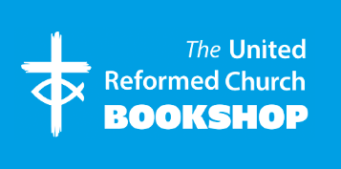

Please order online using the URC Bookshop’s easy-to-use website www.urcshop.co.uk or by calling 020 7916 8629.

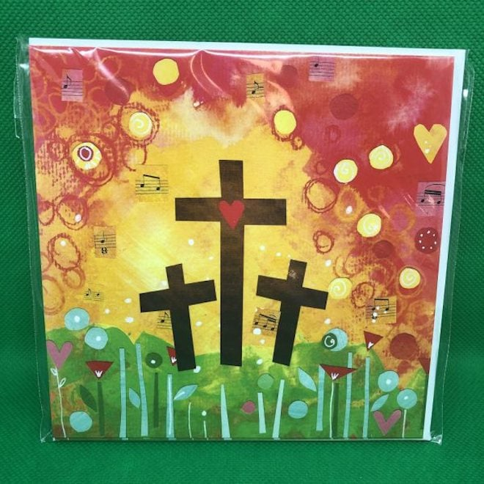
Three Crosses and Heart – pack of 5 x 12.5cm square
Easter cards. A pack of 5 x 12.5cm square Easter cards with
three crosses and a heart design. Can be posted using a
standard first or second-class stamp – no large letter stamp
needed. £3.49 +p&p. Explore the range.

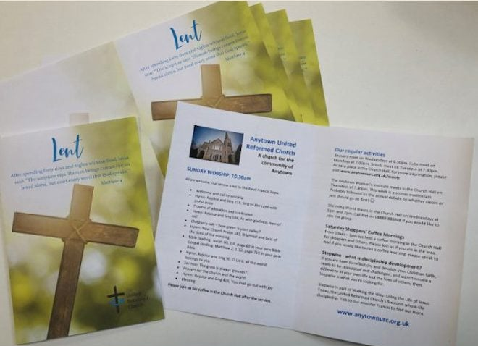
Lent service sheets, pack of 10. Designed for you to use
with your photocopier or printer. Use these service sheets for
all services throughout Lent. Supplied as A4 sheets for
you to print and fold. £1.25 +p&p.

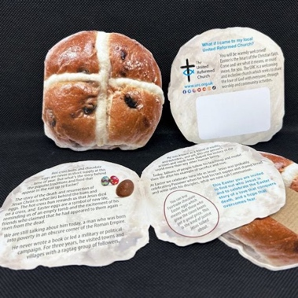
Hot cross bun giveaway leaflet – pack of five Hot cross buns
seem to be in the shops all year round. But what do they mean and
how is it related to Easter? This hot cross bun-shaped leaflet
explains the relationship between the buns and chocolate eggs to
Easter, with an invitation to worship at your local URC. 75p +p&p.

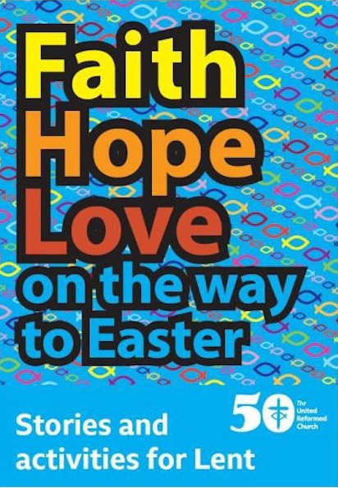
Faith Hope and Love on the way to Easter is a packed with stories
about people and churches and their faith in everyday life, along with
activities, prayers, reflections, things to do and Bible readings. Ideal to
give to others, 48 pages, A5. 50p +p&p.

Synod news

Mersey

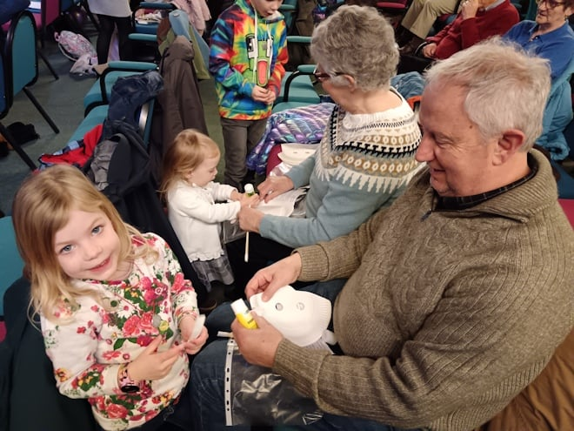

West Kirby URC celebrated three decades of its beloved toddler group with a special event at the end of January. Families past and present joined the festivities, which included a joyful service, birthday cake, and bouncy castles. The church has been running two toddler group sessions every Friday, along with a monthly dads’ group since 1995, creating a welcoming space for countless families to connect, play, and grow.

Eastern

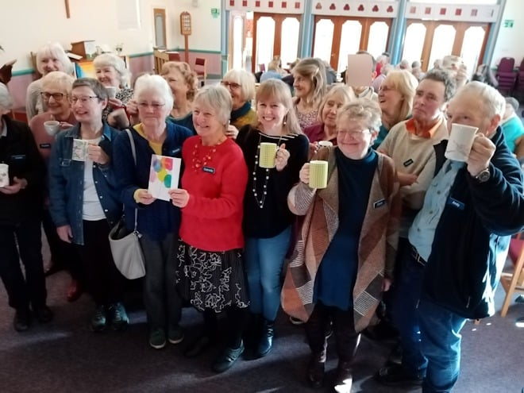

Diss United Reformed Church celebrated the 10th anniversary of its popular Dove Dementia Café this month. The café first opened its doors in January 2015 to just one person with dementia. But over the years more and more have attended with the church now regularly seating between 50 and 60 people for lunch, all supported by a team of 20 volunteers.

Yorkshire

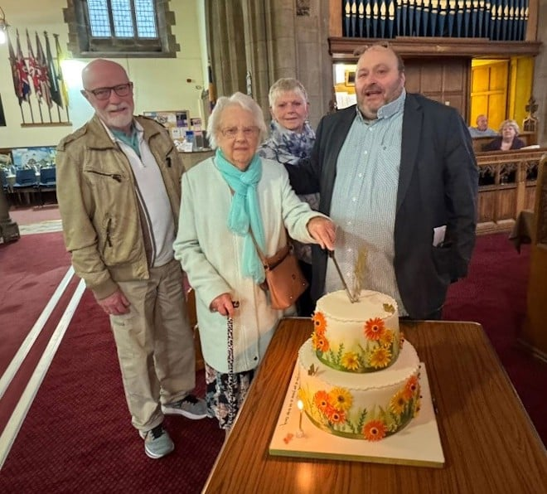

The Bridge Church in Otley, West Yorkshire, recently celebrated two incredible milestones for longtime member Joan Wiseman. In October, Joan turned 100, marking the occasion with a cake and a signed card from the congregation. Then, at a service held on 23 February, she celebrated 80 years of church membership. Minister the Revd Jason McCullagh presented her with a certificate to honour the achievement.

North Western



Exciting times lie ahead for the congregation of Revidge Fold Church as it merges with Trinity United Reformed Church, Brownhill, to create the North Blackburn United Reformed Church. At a special service on 22 February, 100 years of Christian witness was celebrated including an exhibition of the history of the church, followed by a buffet lunch.
Image: Google Maps.

What's On

Christian Aid turns 80

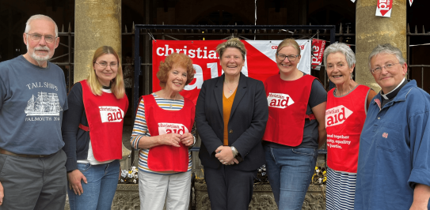

As Christian Aid marks its 80th anniversary, supporters from up and down the country will be gathering for the annual Changemakers’ Conference – Changing the world together. The event is an opportunity to hear the results from Christian Aid Week 2024, find out about the stories behind this year’s appeal and meet up with other supporters and Christian Aid staff and partners. It takes place on 8 March from 10.30am-1pm, at St John’s Church Waterloo in London. Register for the event.
Image: Christian Aid.

Christian Action Network



To help resource Constituency Action Network (CAN) churches, JPIT is holding webinars towards the end of each month (with a break in July). The next session takes place on 26 March at two times: 12.30pm and 7pm with a focus on refugees. The one-hour sessions provide a chance to reflect and listen to guest speakers and also to learn from each other. If your church isn’t a member of CAN yet, you are still very welcome to join. Book here.

GEAR: Refreshing your ministry

Refreshing Your Ministry 2025 takes place 7–9 October at the Hayes Conference Centre, Swanwick. This gathering builds on the previous successful events in recent years and includes teaching input, Bible studies and worship, space for prayer plus available down-time with colleagues away from regular responsibilities. This is for serving URC ministers and CRCWs, and also includes Synod-appointed Local Leaders, and retired Ministers who are in pastoral charge. Total cost is £270. This includes a £50 booking fee, with the balance of £220 due by 1st September. Learn more about the event and book your space.

IOPT in Focus webinar

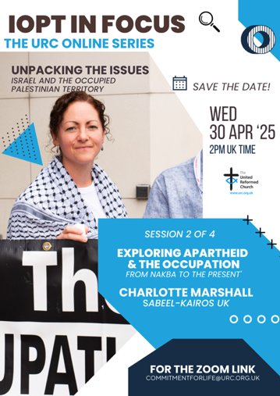
The Interfaith Enabling Group and Commitment for Life are hosting an
online series to help URC members and groups deepen their
understanding of some of the fundamental issues as to why the conflict
in Israel and the occupied Palestinian territory seems so intractable.
Coming up on 30 April at 2pm, is a webinar - Exploring Apartheid and
the Occupation with Charlotte Marshall, Director, Sabeel Kairos UK.
For more information and a link to the webinars please contact commitmentforlife@urc.org.uk.

URC Buildings Forum

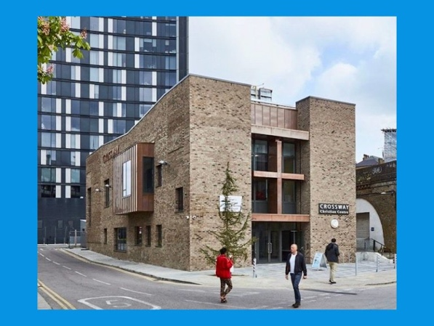
Upcoming webinars in the URC Buildings for Mission
Forum series takes place on 20 May at 7.30pm and
Thursday 20 November at 11.30am. The URC Buildings
Forum is primarily focused on developing and linking
to resources that can help churches to have a
mission-based focus on buildings and has identified
online networking as one important way of bringing
churches into contact with one another.
Learn more about URC Buildings Forum.

Recruitment

URC vacancies and beyond

Ministries Support Officer
Based: London
Term: Permanent contract, full-time
Salary: Circa £43,000 per annum
Closing date for applications: 3 March

Centre Manager at Brighthelm Centre
Term: Part-time, three 3 days a week, onsite
Salary: £35,000.00 pro rata (£20,800 actual)
Closing date: 7 March
For more information, please email katie@brighthelm.org.uk

Commission Secretary – Ministerial Discipline Process
The URC’s Ministerial Discipline Process is looking for a Commission Secretary, effective from July 2025, but with ample shadowing time of the present post-holder built in.

Business Committee Convenor
The URC is seeking immediate nominations and applications for the convenor of the Business Committee, as the current convenor will complete their term in the role at the July 2025 General Assembly.

