
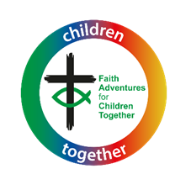
Faith Adventures:

Children Together

and Youth Resource sample
(Free weekly resource available online at bit.ly/FACT_resources)

Enabling everyone to grow more like Jesus  together in the home, church and beyond. | For guidance on the purpose of the resource and how to use it as a launch pad for your engagement with children and families, please use this link: https://urc.org.uk/wp-content/uploads/2023/01/FACT-how-to-sheet.pdf

Galatians 3:27-29 – ‘Putting on Christ’
Theme: We are all unique but equal in God’s eyes
Introduction: What would be helpful to know in my planning?
Paul had founded the churches in Galatia and so wrote this letter to them as someone who knew them well. He was travelling off on his first missionary journey to Asia Minor. He had heard that the congregations in Galatia were falling into bad ways and that they were split. Some followed leaders who taught that the law of Moses meant God’s grace was just for the Jewish people and only those who obeyed the law. Other leaders recognised that Jesus had brought a new promise of grace that was for Jews and Gentiles (non-Jews) alike – all who accepted God’s grace would receive it, they did not have to earn it or be a certain type of person.
Paul compared accepting God’s grace as being like ‘putting on Jesus’ like we put on our clothes. Just like when we put on our school uniform we can be identified as belonging to our school and even representing our school. This can raise the question “if we can put on Jesus like clothing, can we take that clothing off?” This could be a good starting point for discussion in your group and some interesting ideas may emerge. It may also lead to discussion about whether ‘putting on Christ’ changes what we look like on the outside or whether it’s just an internal change, and whether it’s important to wear particular things to show we’re a Christian like wearing a cross etc. Be careful not to impose your thoughts on the children but to allow them to explore what the message of this passage means to them. The important part of this passage is to realise that it’s OK to be different – you don’t have to be the same as everyone else or as they expect you to be – you are equal in Christ. And so is everyone else.
Remember that different children may have different experience and understanding of baptism. They may have been baptised or not. Some families and congregations will practice infant baptism and some will practice adult baptism. Some may use dedication or thanksgiving services in the place of infant baptism. You may want to read this https://urc.org.uk/who-we-are/what-we-believe/ to find a concise explanation of the difference if you are not sure. The important thing is not to impose your beliefs on the children and to respect both, both being practised within the United Reformed Church.

Together
How do I help my group to come together and get started with the theme?
Gathering prayer
Jesus, our friend
(use alternate index fingers to point and tap the middle of opposite palms)
Be with us today
(two hands, palms up in front of you, move up and down twice)
As we share together,
(two hands, palms up in front of you, move one forward and one back and alternate twice)
Pray together,
(hands together, palm against palm, as though praying)
Play together,
(hands to each side, palms up, make two small circles outwards)
And get to know you better,
(point up with one hand)
As children together in your family
(one hand out, palm down in front of you, move it sideways and up in three ‘steps’ as though to indicate children of three different heights)
AMEN (Two thumbs up, and bring fists slowly together to meet in front of you)
OR
Thank you, God, for bringing us together today.
Help us to grow closer to you in all we do.
Help us to speak and to listen, to learn and to grow together,
Adventuring together with you wherever we may go.
Amen
Youth resource gathering prayer

All mighty God,
Be with us as we learn more about you through stories and people in the Bible.
Help us to walk in your way and follow your path.
Be with us as we make decisions that affect our lives, and the lives of those around us. Amen

In-person game – Clothed with….

You will need:
A bag of assorted dressing up clothes (e.g. hats, silly glasses, scarfs etc)
A source of music that can be stopped at random and restarted
What you do: Just as with ‘Pass the parcel’, everyone sits in a circle and passes the bag of dressing up clothes from person to person while the music plays. When the music stops, the person holding the bag pulls out one item without looking and has to put that item on. When the music starts again, pass the bag one again. No winner, but everyone should have lots of fun!
Experience

For this story we recommend using the New Century Version https://www.biblegateway.com/passage/?search=Galatians+3%3A27-29&version=NCV

Where can I find the story online? God’s Story: Galatians https://youtu.be/LrzbssH-cBU

Songs to support the story: Big Family of God: Remix with Actions & Lyrics (by Nick & Becky Drake) https://youtu.be/Rawq3usrzsE

Youth Resource: Watch and Listen
Song: Something Inside So Strong
Labi Siffre version: https://youtu.be/7B-4Lsrx8IA?si=4NfZcUW0Foi8veH_
Flying Pickets version: https://youtu.be/XHCziDaioxc?si=Z-2MlH30DIV_LsaB

Explore
Ideas and activities to explore this week’s Bible passage together
A way to explore the story
Starter Task: Begin by asking the group to draw a self-portrait showing all the things that make them them – their individual identity.
Spot the similarities – Before the session, encourage everyone to bring one thing in, anything at all. The more random the better and put all the items on the group table. Gather round and have a look at the items. Explain that it’s obvious that all these things are different, but in what way are they all the same? Encourage the group to come up with as many different ways the items are the same, where is the commonality?
Once you have had some time doing this task, lay the self-portraits onto the table and ask the group to consider what God sees – the passage tells us that the gender, age and background of each person is not important, that we are all equal (the same) to God. Ask the group to offer suggestions of how we are all the same.
This is a good opportunity to ask the group whether they believe they, as a group and as individuals, are equal in church - if so, how? If not, why not? What would our church look like if we did see us all as equal? You could share these ideas with the wider church.
Youth Resource alternative - Fast Fashion
How ethical are the clothes we buy? Watch and discuss the short video clips below.

Can fashion be sustainable? BBC Earth – https://youtu.be/ZoiU8sprXpQ?si=4Ox-fFA2VfJCyImh
Stacey Dooley Investigates fast fashion – https://youtu.be/zOe_M3GutdY?si=ygARj_5wftOJz-Ut

Research – Use the website https://goodonyou.eco/ to find out more about how ethical different shops and brands are. Search different brands using the “brand rating” tool near the top right of the sight. How do the brands that you normally purchase rank? Which brands are ranked most ethical?

Exploring further – Check out the free “Justice X Together” resource pack from Tearfund. Session 2 focusses on the topic of “Fast Fashion.” Download the resource at https://wearetearfund.org/justicextogether/

In your opinion, should the clothes we choose to wear be linked to our faith in any way? What do the clothes we wear tell others about us, and does it matter? Is it anyone’s business what we choose to wear?

Modern parables
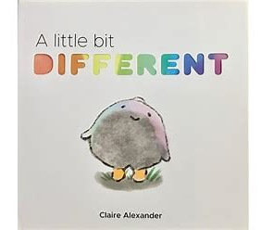
Jesus used stories to help people understand the things of God, even though they weren’t necessarily overtly Christian stories. Lots of children’s books can be used in a similar way as a conversation starter on the week’s theme. Examples are shared here but you may think of others too.
‘A little bit different’ by Claire Alexander, Read by Petway Elementary school https://youtu.be/x9xSUu0ldQI?si=U64ogsrVZKfXTN4Y
Talking together: How might we talk about the story together?
- I wonder what it means to be clothed in Christ? How would people see a difference?
- Can you think of a time when you feel equal? What is that like? What about a time when you don’t feel equal?
- Where do you see inequality around the world? Is there anything we can do in response to that?
Wondering together: suggested questions to use during activities

- I wonder what your favourite outfit is and why?
- I wonder what it’s like being the favourite? Or not the favourite?
- I wonder if you’ve ever gone somewhere wearing the wrong thing – e.g. forgotten PE kit, slightly different uniform, fancy dress, forgot about non-uniform day ….. ?
What’s in the box (for under fives)
Use the special box or bag and sing “what’s in the box/bag? What’s in the box/bag? Let’s see, let’s see, what’s in the box/bag” (to the tune of The Farmer’s in the Dell). You could tap the top of the box twice after the word ‘box’. Pull out the things one by one and then let the children play with them, talking about the theme or the story in simple terms.
This week’s box could include:
- A selection of uniform hats (what we wear gives people an idea about what we do and who we are)
- Some costume jewellery – including a cross (we can choose to wear accessories/symbols that tell people something about us – what do you like to wear?)
- Pictures of rainbows (we are told that being part of Jesus’ family means we are included in God’s promise – what promise?)
- A selection of baptism gifts (baptism shawl, baptism spoon, etc. – what does it mean to be baptised?)
- A mirror (we are all unique but loved equally by God – what is unique about you?)
- A set of play people to act out the story or random shapes/bits you can move around to make pictures from the story as you tell it (e.g. stones, felt, twigs etc)
Youth Resource alternatives
Video: What Is Equality? (3’39”) https://youtu.be/V7gX1PRgDRA?si=jpHNBILEYPWYBfng
Trailer for Mitchells vs the Machines https://youtu.be/_ak5dFt8Ar0?si=AIcSdVWRD7lrM4vu
Talking together: Going deeper
- If you’ve not been baptised in church, does that mean you’re not baptised in Christ – are they linked?
- The differences in the Bible passage are set in time and context – what differences do we have in current context that divides people?
- What does “protected characteristics” mean? If you look at this passage, what is missing from the list of protected characteristics we recognize today? How might you re-write this passage?
- If we’re clothed with Christ, how should we view others?
Conversation starters
- What do we wear that identifies us as Christians? Do we need anything? Is it the reason we wear something that’s important?
- What is the difference between equality and equity?

Express
Praying together: how can you involve the children actively in prayer?
‘All of you are one in Christ Jesus’ Galatians 3:28
It is good to talk to God about everything that we are feeling, our concerns for the world, for others and for ourselves, and to give praise and thanks to God for all the good things in our lives.
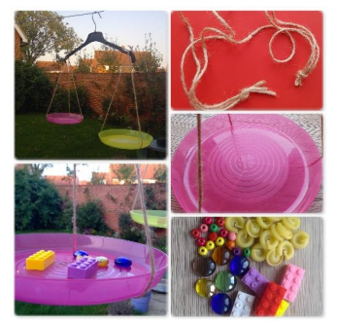
You will need: String, two paper/plastic plates or cups, a coat hanger and some objects to act as weights
Cut six pieces of string each the same length. Tie three pieces together with a knot at both ends. Attach one end of the string to the coat hanger and, at the other end, spread the string to support the plate or cup. Repeat for the other side of the hanger. Make sure that the knot is in the middle of the cup or plate and spread the string evenly. You can hang the balance scales from a washing line outside or someone can hold the hanger over their finger to allow the scales to balance. Take it in turns to add a ‘weight’ to the scales as you pray. Try to always keep the scales balanced. Holding your ‘weight’, talk to God about the things that do not see fair or equal in the world. Add your weight prayer to the scale and the next person adds their prayer to the scale the other side at the same time to keep the scales balanced.
As an alternative, take a weight and say prayers of thanks, praise and blessing and add it to one side of the scales. On the other side, add your prayers of things that worry and concern you and things you are sorry for.
Spoken prayer - St Patrick’s Breastplate
Use actions with this Celtic prayer of protection, remembering the words of Galatians… ‘we are clothed with Christ’. Encourage the children to come up with the actions.
Christ be with me,
Christ within me.
Christ behind me,
Christ before me.
Christ beside me,
Christ to win me.
Christ to comfort and restore me.
Christ beneath me,
Christ above me,
Christ in quiet,
Christ in danger.
Christ in hearts of all that love me.
Christ in mouth of friend and stranger.

Responding together
Here are some suggested crafts and activities, and there is a colouring sheet at the end of this resource. You could also use small play toys and/or have a basket of resources available so children can choose their own way to respond. See here for more suggestions.
With an online group, plan whether to deliver any resources in advance or how you will encourage them to use what they’ve got to hand in their response.
However you do it, it is good for the adults to engage in the response too, and all chat together.
Making activity – Craftivism
Craftivism is when you use craft to create something to encourage people to think about injustice or motivate others to look for effecting change in society.
You can find out more here: https://bit.ly/craftivism-pins
Encourage your group to create something that will motivate thought and action in others around the issues of inequality. What has got your group going…… what would they like to address and encourage others to think about? Then get creative, you could make a poster or an installation that makes your point to others.

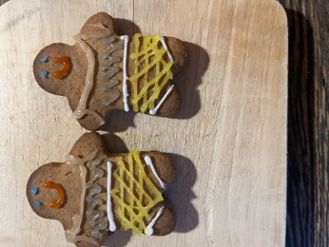
Gingerbread people

You will need:
Some pre-made Gingerbread shapes – you can buy or make these in advance. Here is a recipe to help you:
https://www.bbcgoodfood.com/recipes/ultimate-easy-gingerbread

Icing pens and icing sugar and any decorations you wish.

What you do:
You need to either make or buy pre-made gingerbread people.

Ask the children to all create an identical gingerbread person using the writing icing and decorations (they will have to work hard as a team to achieve this) and then create one completely unique gingerbread person that is unlike anyone else’s in the group. You will end up with lots of gingerbread people who look the same (in Christ) and lots who are the same inside but look different on the outside.

When we put on Christ, we all become like Christ. We are all unique and its ok and actually important to be different, but with Jesus we all have something which is the same in us.

Youth Resource alternative : Equality versus equity

Take a look at the words below taken from the introduction to the American Declaration of Independence:

We hold these truths to be self-evident, that all men are created equal, that they are endowed by their Creator with certain unalienable Rights, that among these are Life, Liberty and the pursuit of Happiness.

Preamble to the Declaration of Independence

- How equal do you think past and current society is in the USA? How do you think this compares to society in the UK and elsewhere?

Show the picture below. (Available to download from https://interactioninstitute.org/illustrating-equality-vs-equity/
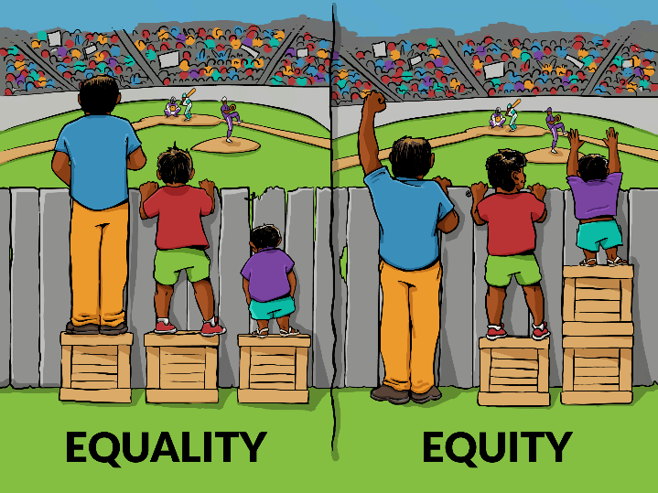

Image credit: Interaction Institute for Social Change interactioninstitute.org | Artist: Angus Maguire. Madewithangus.com

- What are your thoughts on this image?
- What do you think is the meaning of this metaphor?
  - What could the boxes represent?
  - What could the fence represent?
- What might be some of the limits or challenges within this metaphor?

Exploring further – The team at “centre for story based strategy” have produced resources to further explore the equality and equity model, creating discussions by expanding the image to include a 3rd and 4th box. Images, workshop resources and a mobile game can be downloaded at https://www.storybasedstrategy.org/the4thbox

The UN Convention on the rights of the child

Take a look at this poster from UNICEF which uses child friendly language to introduce the main articles of the rights of the child. bit.ly/rights-of-child-poster
- Which of the numbered articles stand out to you? Why?
- Can you think of examples of positive steps that have been taken to help meet specific rights?
- Can you think of examples of where we may fail to meet specific rights? What could be done about this?

Everyday with Jesus – Walking the Way
What could we do this week to carry on what we’ve learned? Maybe members of the group could come up with a suggestion. If not, get them to choose from these two challenges:
- You’ve heard of rose-tinted spectacles, where you try to see everything in a positive light? Try to look at people around you this week with ‘God-tinted spectacles’, seeing not their differences but the fact that they are valued by God. Does it change the way you treat them?
- As you go about your daily life, notice what things you find easy and what things you find difficult. Compare this list with a friend. In what ways do you complement each other and how could you support each other?
Illustration from https://www.supercoloring.com/coloring-pages/diversity Creative Commons 0.4 License

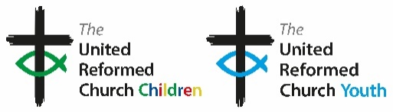
Youth Resource Challenge
Discipleship doesn’t stop when you walk out of the church door – it is a part of everyday life. Take a challenge with you and try to make it part of your week.
You may think of your own suggestion of what you as an individual or a group might do in the coming week in response to what you have explored today? If not here are some suggestions:

- Use one of the “conversation starter” questions or the question below to talk with someone of a different generation or from a different setting and share your questions, thoughts, insights together: How would the world be different if everyone was treated equally?
- Research something suggested by JPIT, Resources (jpit.uk) Commitment For Life cforl.co.uk
- Create a vision/ mood board for the week ahead, fill it with things that help to motivate and shape who you are.
Free weekly resource available online at https://bit.ly/FACT_resources.
Join our Facebook group on
https://bit.ly/FACT_URC

