



United Reformed Church Commitment for Life May/June 2025
Storie
S

Moving

Committed to supporting our global partners ZIMBABWE



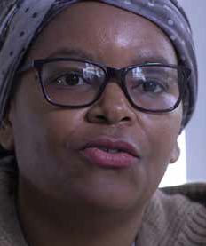
hen Commitment for Life went to Zimbabwe recently,
Two opportunities to get involved

Christian Aid Week 11 to 17 May, 2025
This year the focus is on Guatemala. Please go to www.bit.ly/4co1Apj

The Great Big Green Week – ‘Together for good’ 7 and 15 June, 2025
Do you have a passion to tackle climate change and protect nature?
Commitment for Life is a member of The Climate Coalition that brings people together to demand action on the climate. The Great Big Green Week will take place between 7 and 15 June.

Get your resource pack here
www.bit.ly/42qxg8R
Photo credit: Sostina Takure: ACT Alliance, Zimbabwe, by Kevin Snyman
W
we met up with Sostina Takure, who coordinates the Zimbabwe ACT Alliance Forum.

Sostina told us about just how much she loves working with the ACT Alliance. ACT Alliance is faith based and, as a pastor’s
wife, Sostina feels right at home. She coordinates the efforts to assist people who are most at risk in Zimbabwe.

When Hurricane Idai struck Zimbabwe several years ago, Christian Aid, in collaboration with ACT Alliance, was one of the first to have “boots on the ground”. They helped people to safety, rescued personal property and livestock, and helped people re-build over 500 houses.

Sostina told us that she is passionate about empowering women, whether this is in relation to economics or to family life. She helps women set up markets that empower them to get good prices for their

produce. Sometimes, women need assistance to get out of abusive situations. Sostina is there to help, with the assistance of the church. You can watch our interview with Sostina in this video. As a bonus, you get to see Wilbert throw a drone into the African sky! www.bit.ly/C4LSostina

With your continued support for Commitment for Life, Incredible people like Sostina can function and do what they do best – care for people. Please continue in your prayers for Zimbabwe, especially given how attention is being diverted by local and global crises.

