News Update April 2025

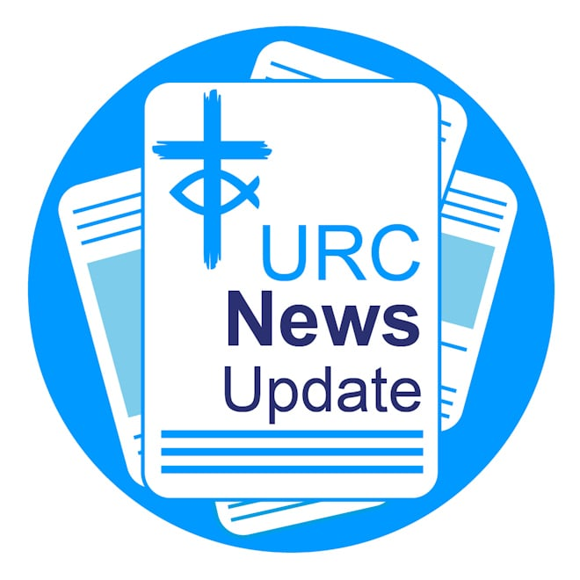

Keeping you informed with the latest news from around the URC.


Christian Aid launches Myanmar Earthquake Appeal
Christian Aid has launched an urgent fundraising appeal in the wake of the 7.7 magnitude earthquake which struck central Myanmar today (March 28). The charity’s partners are reporting people have been severely impacted by the disaster, including many who saw their homes destroyed or badly damaged. Access to vital services such as water, power and basic foods have been critically disrupted.
Immediate emergency support is now urgently needed, including food parcels, water kits, shelters, and cash for essential supplies. And – with the generous help of its supporters – Christian Aid is mobilising to assist its partners and quake-affected communities with
essential aid and recovery over the coming weeks and months. If you can, please donate to the Myanmar Earthquake Appeal.
Image: Christian Aid.

Faith leaders call for bold action on child poverty


Leaders from the URC have joined other senior faith leaders from across the country to issue an urgent call for the government to be ‘bold and ambitious’ in its forthcoming Child Poverty Strategy. The call comes in an open letter to the co-chairs of the Ministerial Child Poverty Taskforce, Bridget Philipson, Secretary of State for Education, and Liz Kendall, Secretary of State for Work and Pensions. The letter is signed by 35 senior faith leaders from Christian, Muslim, Jewish, Hindu, Sikh and Buddhist traditions, including the Revd Tim Meadows, Moderator of the URC General Assembly, and Maya Withall, Youth Assembly Moderator. The letter was coordinated by the Joint Public Issues Team, in which the URC is a partner. Read more about the action.
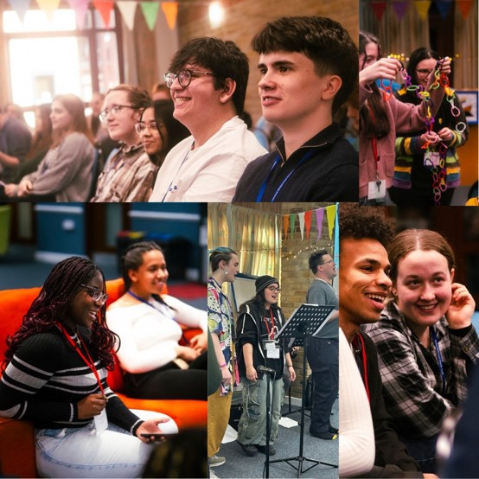
URC Youth Assembly 2025

Ninety-five young people gathered for a weekend of fun, faith and fellowship at URC Youth Assembly 2025. Held from 7-9 March at Kings Park Conference Centre in Northampton, members of the denomination held a robust debate on steps to encourage local churches to sign up to the Welcome Directory, which supports prison leavers with rejoining faith communities. This proposal, with the help of Mission Committee, will be brought as a resolution to General Assembly. Maya Withall was inducted as the Youth Assembly Moderator for 2025-26 and Kacie Hodgson was elected as Moderator-Elect. Catch up on the highlights from Youth Assembly 2025.

Brian Wren among contributors for Rejoice and Sing LIVE
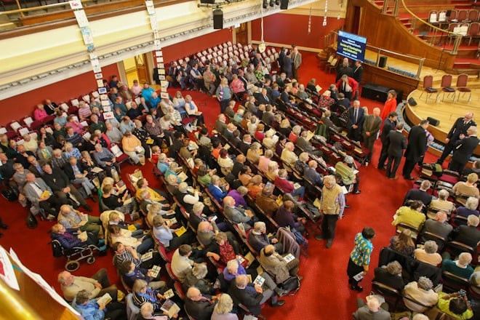

Hymn writer and poet Brian Wren is among many contributors at the Rejoice and Sing Live service and celebration, taking place at Methodist Central Hall, Coventry, on May 3.
Celebrating 35 years of the URC's hymn book, the service, open to all, will include the singing of many classic hymns, plus a new hymn written for the occasion by the Revd Dominic Grant, short talks by Anne Sardeson, David Thompson and Stephen Orchard, and a panel discussion with those who helped to create the hymn book, chaired by Stephen Tomkins, Editor of Reform magazine. A message from Brian, who lives in the US, will be shared during the service. An exhibition about the creation of the hymn book and cafe for lunch and drinks will be available from 12 noon, and the service starts at 2pm. Tickets are free and can be reserved
from www.bit.ly/reform-live. (If you, or your choir, would like to take part in the scratch choir, please email roo.stewart@urc.org.uk for further details.)

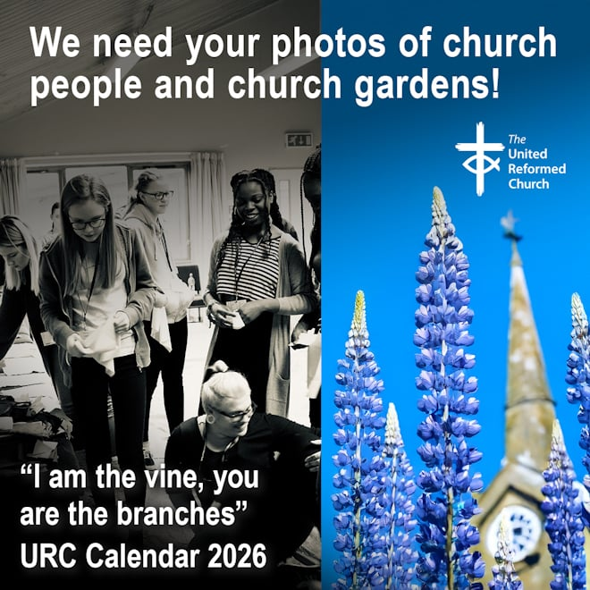

Photos needed for
URC calendar

Photos are needed for the URC 2026 Calendar - Seeds of Hope, Based on ‘I am the vine, you are the branches", the 2026 URC Calendar will feature images of people and plants connected to the URC. Learn all you need to know, including submission guidelines.
The calendar has been generously supported by Edwards Insurance.
New Eco Church survey

A Rocha UK has launched a new version of its Eco Church Survey, a framework for action to help us respond faithfully to the climate and nature crises. The Eco Church survey is a self-assessment tool for churches to connect environmental issues with their Christian faith and mission and respond with practically. Take the Eco Church Survey.
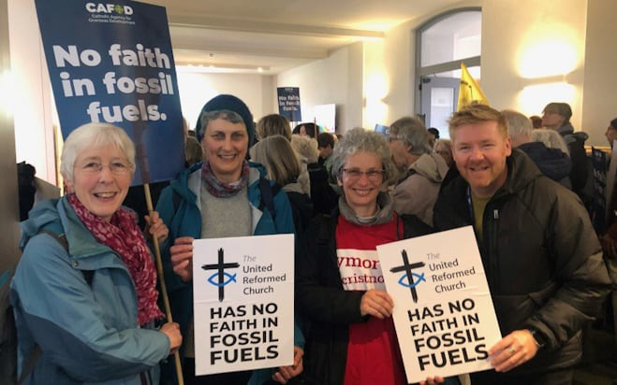
Become a greener church
In the light of the climate emergency, "we need to act urgently to reduce carbon emissions across the whole of church life". Read the URC Environmental Policy. Help is available for URC congregations wanting to deepen and strengthen their care for God’s creation.
Learn more about how you can
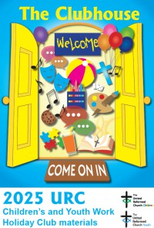
become a greener church.


Safeguarding training
Free holiday club resources

New, free holiday club resources are available to download. "The Clubhouse" explores five New Testament stories through song and story, craft and discussion, eating, praying and playing together and much more. Download the holiday club resources.

Safeguarding training continues on
with Spiritual Abuse, taking place on
24 April from 1.30pm – 3.30pm, and Online Safety taking place on 13 May
from 7pm - 9pm. If you are interested in attending, please email Emma Pearce, Safeguarding Administrative Assistant, at emma.pearce@urc.org.uk to register your interest.

Christian Aid: Restore Debt campaign

Christian Aid and its supporters are urging the UK government to tackle the twin issues of global debt and the climate crisis which are trapping millions of people in poverty. A series of workshops and webinars have been organised to give people more information on the issues and on how they can join the Jubilee 2000 international movement which won $130bn of debt cancellation owed by 35 of the poorest countries.
To register for the online sessions, please visit
the Christian Aid website and click on "Get Involved and Campaigns".

New video about the Hollinshead Centre and Chorley URC

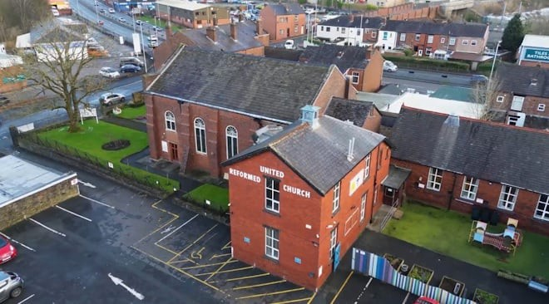
Watch a new film about the importance of Chorley United Reformed Church and the Hollinshead Centre for the people and communities of Chorley, Lancashire. The video features interviews with Minister the Revd Martin Whiffen, and Community Minister, Andy Littlejohns, a URC Church Related Community Worker. One person commented: "Amazing people carrying out amazing work. The Hollinshead Centre is truly a remarkable place and is, in my own opinion, the heart of Chorley; the Community of Chorley is truly blessed to have this on their doorstep. Truly wonderful." Watch the video on the URC’s YouTube channel:
www.youtube.com/URCUK
Download or print News Update
A downloadable version of News Update, formatted for print, and for churches to copy and a downloadable version of News Update, formatted for print, and for churches to copy and paste into newsletters, service sheets or magazines, will be available within a few days of this edition. Download your printable version of News Update.

Share your good news
If you have a good news story that can inspire, raise hope or show God's work in action then please let URC Communications know. We would love to help share your news across the denomination and in local news outlets. Email the URC Comms Team or call 07976 753 950.


Free books with Reform magazine

Subscribe to Reform magazine, the magazine of The United Reformed Church, or give a gift subscription, and receive three free books from the URC Bookshop. A subscription starts at £18 for the digital edition (with free access to all digital back issues), £29.50 for the printed and posted edition, £35.50 for both. Find out more about subscribing to Reform.


Please order online using the URC Bookshop’s easy-to-use website www.urcshop.co.uk or by calling 020 7916 8629.
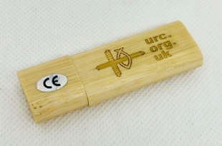


URC logo lightweight eco-friendly reusable raincoat - available in URC blue, purple, yellow or pink, the new URC lightweight, branded, waterproof raincoat comes with a drawstring hood, elasticated sleeves and popper fastenings. One size, fits all older children and adults (tested on an XXL male!).

Happy Easter – A pack of 5 x 12.5cm square Easter cards with a Happy Easter daffodils design. Can be posted using a standard first or second-class stamp. No Large Letter stamp needed. Printed on FSC paper. Inside is a greeting and Bible verse. Other cards available. £3.49 +p&p.

URC logo 32Gb Wooden USB Stick - a USB stick made from eco-friendly wood with a magnetic lid.
The URC logo and web address on
one side, the Reform magazine logo
on the other. Laser engraved and varnished. 32Gb capacity with red indicator light which illuminates when plugged in. £5.99 +p&p.



Hot cross bun giveaway leaflet - Designed to be given away at rail stations, churches, schools or shopping centres, or to be put through letterboxes, the leaflets, that come in packs of 5, have a space on the reverse for a label for churches to add their contact and location details. 10cm x 10cm, 75p per pack of 5 +p&p.


A5 Celebration card with envelope
- An A5 card with envelope featuring
the URC logo on the front and the logo
with URC on the reverse. Blank inside
for your own message. Can be used for many occasions including Easter
baptisms. 99p +p&p.

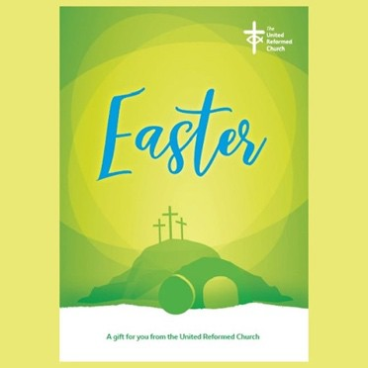
Easter giveaway leaflets
– A pack of 25 booklets explaining the meaning of Easter, written by the Revd Susan Durber. A5 in size, the booklet has been designed to be given away at your church, at schools, bus or rail stations, shopping centres, care homes, to be posted through letterboxes or used anywhere to tell people that Christ is Risen. £4.99 for 25.

Synod news
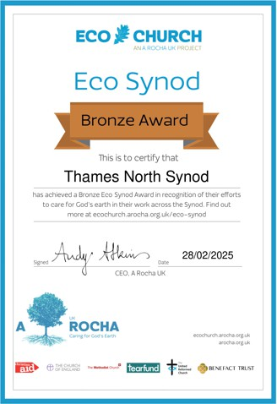


North Western

Solidarity between groups in North Western Synod shone last month. Groups such as DARE, Barrow URC Primary School, Meeting Places at Chorley URC, and local citizens —came together to agree on a Citizens Statement. This declaration champions community involvement in shaping local services,
a true example of grassroots action.
The event was supported by Moderator, the Revd Clare Downing. And within one day, the team of community leaders had secured commitments from northern mayors, MP's, council leaders and decision makers.
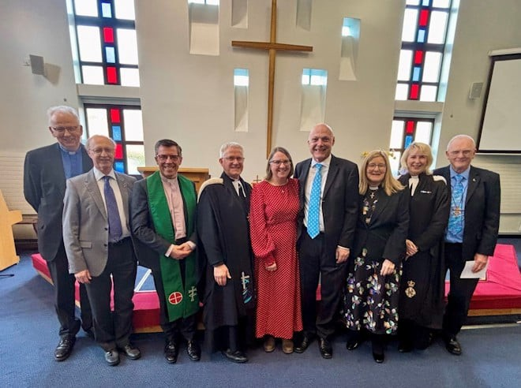

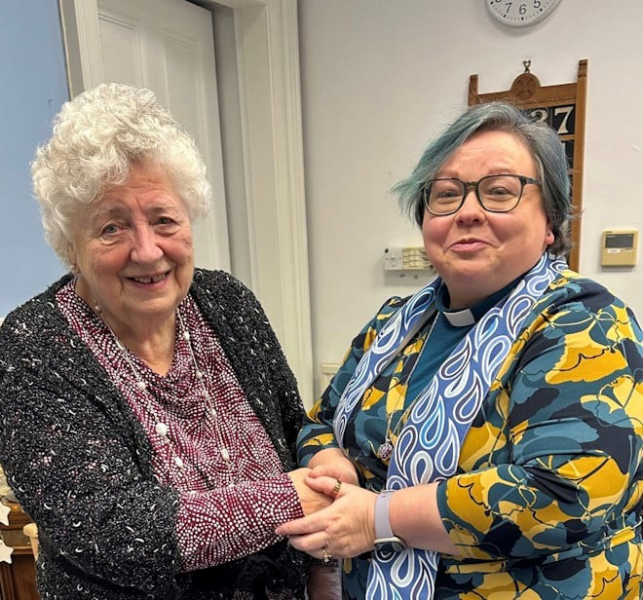

East Midlands
National Synod of Scotland

Congratulations to Eileen Millar who was warmly welcomed into the role of Deacon within Stewarton URC in February. Eileen, pictured with Revd Lesley Thomson, is already an active member within the congregation at Stewarton and will be a great addition to the deacons of the congregation.
The Revd Kevin Jones, a former army chaplain, is the first minister inducted to the new South West Derbyshire Area Partnership. Ashbourne Road Church, a Methodist and URC LEP, hosted a special service to mark the occasion on 1 March. Ashbourne Road together with Alvaston, Derby Central, Mackworth and Repton URCs will make up the area partnership.

Thames North

Congratulations to Thames North Synod which has gained a Bronze A Rocha UK Eco Church award. A Rocha UK said that they synod showed lots of good work around championing the environment - from annual Green Days which in 2024 had a nature focus, to a comprehensive environment policy which includes references to net zero, protecting and encouraging biodiversity, and engaging and supporting young people about the climate and nature crises, and an eco-fund to support local churches. Out of the synod's 105 churches, 54 are registered with the scheme and 27 have received an award: 20 bronze and seven silver.

What's On

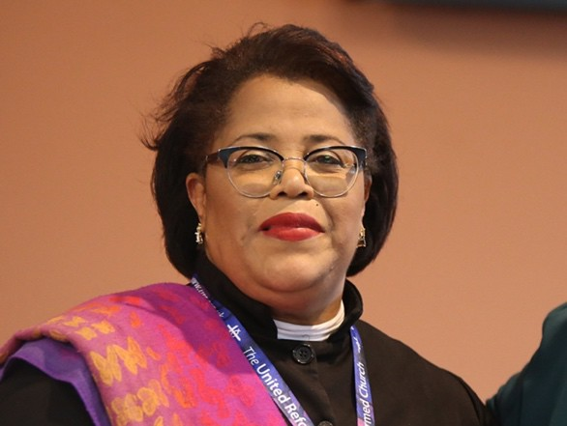

Free Churches’ Moderator

On Palm Sunday (13 April) at 6.30pm, the Revd Dr Tessa Henry-Robinson will be inducted as Moderator of the Free Churches’ Group at the American International Church, Tottenham Court Road, London. Tickets are free but required. Reserve your ticket.


Free To Believe Reading Party

'Holy Anarchy: Dismantling Domination, Embodying Community, Loving Strangeness' is the next Reading Party hosted by Free to Believe, an informal network of liberally-minded Christians striving for an open, inclusive and
thinking church.

The reading party will be lead by the author of Holy Anarchy, Graham Adams, a Tutor in Mission Studies, World Christianity, and Religious Diversity at Northern College within the Luther King Centre, and a member of CTBI’s Inter Faith Theological Advisory Group. The venue is Luther King House, Manchester, and further details and a booking form can be found here.

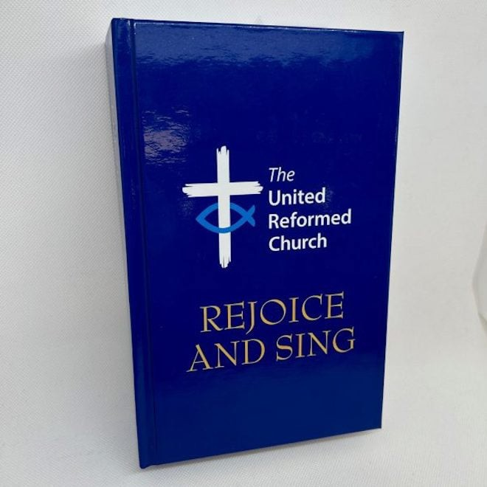

Rejoice and Sing LIVE

On May 3, at Methodist Central Hall, Coventry, a hymn-filled service of celebration for the 35th anniversary of the URC’s hymn book, Rejoice and Sing. Lots of hymn singing, a scratch choir lead by Roo Stewart (all singers and choirs are welcome), special talks, a panel discussion, an exhibition and the chance to gather with many others to sings lots of superb hymns. Reserve your free tickets here.



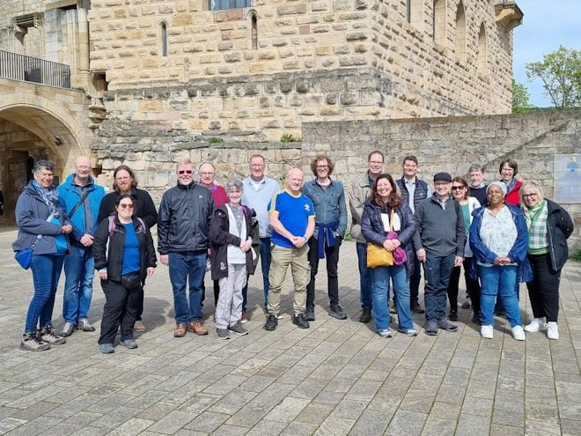

Ecumenical partnerships

Celebrate and nurture the relationships between the URC and its European partners at "Opportunities for Partnerships" on 3 April from
7-8.30pm via Zoom. The URC and the Protestant Churches in the Palatinate region of Germany, the "Evangelische Kirche der Pfalz" shares a long-standing Covenant of Pulpit and Table Fellowship. The URC also has close links with the Waldensian Church in Italy and the United Protestant Church of France, among others. Celebrating and nurturing unity is especially important now in the changing political landscapes. Joining details: Meeting ID: 842 2245 1396 Passcode: 726105. For further information please email the ecumenical team.

150th anniversary of WCRC

The World Council of Reformed Churches is celebrating its 150th anniversary on 12 July at the American International Church in Tottenham Court Road. With roots in the 16th-century Reformation, and particularly in the theology of John Calvin, the World Communion of Reformed Churches (WCRC) dates its organisational history to London in 1875, and has been unifying churches over the course of its existence.
Book your free ticket.

IOPT in Focus webinar

The Interfaith Enabling Group and Commitment for Life are hosting an online series to help URC members and groups deepen their understanding of some of the fundamental issues as to why the conflict in Israel and the occupied Palestinian territory seems so intractable. Coming up on 18 June at 2pm, is a webinar themed Antisemitism: a present-day prejudice with Nathan Eddy, co-director of The Council for Christians and Jews.
For more information and a link to the webinars please contact
commitmentforlife@urc.org.uk.

Churches Together England

Join authors and editors, led by the Revd Dr Ben Aldous, Principal Officer for Mission and Evangelism at Churches together in England on 9 April for a study day looking at some of the key chapters in the new book Lived Mission in 21st Century Britain and be involved in stimulating discussions about what a
new missiology in Britain may look like. Places cost £58. Book your place.

URC vacancies and beyond
Recruitment

Business Committee member
The URC is seeking a member of Business Committee who can represent the diversity of the URC with links to the denomination’s racial justice networks. This is to replace one of our existing members who completes their term on the Committee at the July 2025 General Assembly.

Business Committee Convenor
The URC is seeking immediate nominations and applications for the convenor of the Business Committee, as the current convenor will complete their term in the role at the July 2025 General Assembly.

