News Update May 2025

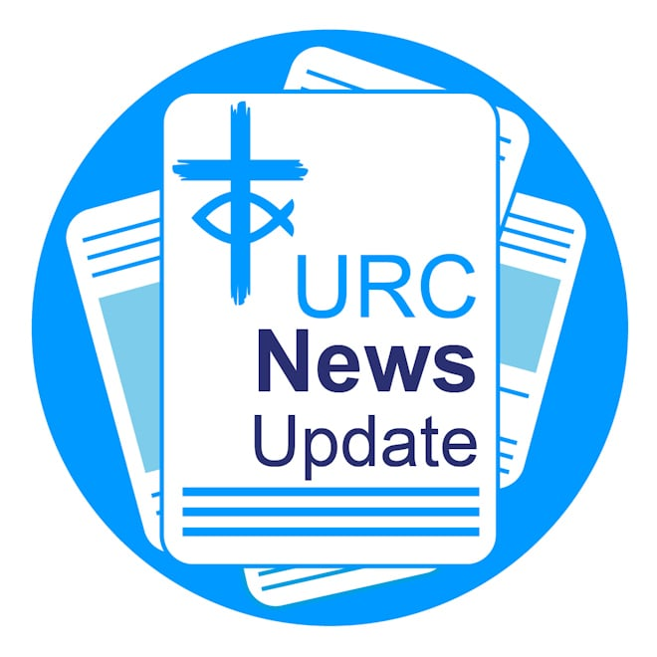

Keeping you informed with the latest news from around the URC

Two Synods gain bronze eco awards
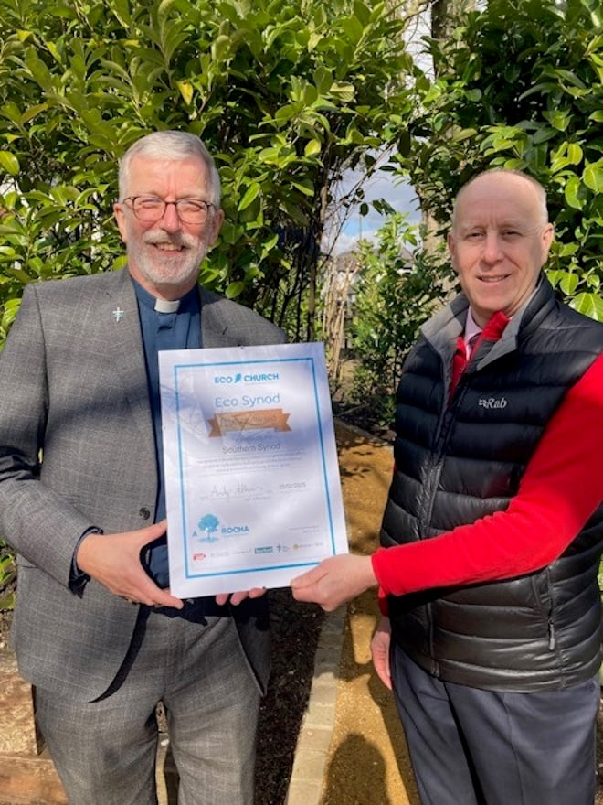

Southern and Thames North Synod's efforts to tackle climate change have each gained a Bronze Eco Synod award from A Rocha UK. Southern is now the sixth Synod in the URC to reach the Bronze status and Thames North is the seventh. Roo Stewart, URC Head of Public Issues, said: “We are hoping that all of our Synods, except the National Synod of Scotland which is part of Eco-Congregation Scotland, will reach Bronze Award level very soon.” Learn how the Synods gained the awards.

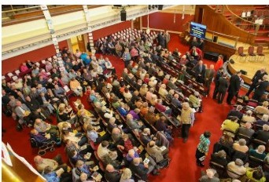
Sing your heart out at Rejoice and Sing LIVE

Rejoice and Sing LIVE is a service celebrating the hymns, hymnwriters and hymnbook of the URC, taking place on Saturday 3 May at Methodist Central Hall, Coventry. 19 hymns will be sung along with talks, a panel discussion by those who curated and created the hymn book, a scratch choir, an exhibition and cafe.
Tickets are free and can be reserved by visiting www.bit.ly/rejoiceandsing or by calling 020 7691 9865. The cafe and exhibition opens at 12 noon and the service starts at 2pm. Contributors include David Thompson, Stephen Orchard, Anne Sardeson, Dominic Grant, Steve Faber, Roo Stewart, Karen Campbell, Brian Wren, Andrew Satchell, Brenda Stephenson, David Jenkins, Steve Tomkins and David Williams.

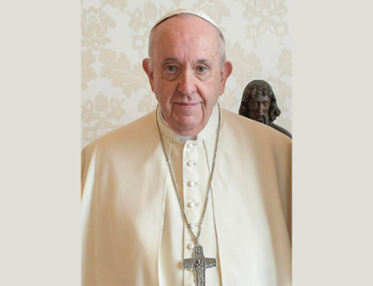
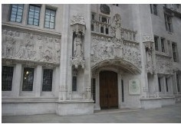

Legal definition of a woman Pope Francis

The URC, with Christians everywhere, mourns the death of His Holiness Pope Francis, and extends its sympathy to Catholics who will grieve this loss most keenly. The Pope, who made his first significant public appearance on Easter Sunday since leaving hospital, died on Easter Monday.
A reflection on the life of Pope Francis is available here.

The URC has expressed its lament at the Supreme Court's legal ruling on the definition of a woman. In a statement, the URC said that the ruling would “have a negative impact on the lives of trans, intersex, non-binary/gender non­conforming people, who already experience significant marginalisation and misunderstanding within our society”.
Read the statement in full.
Image: Tom Morris, CC BY-SA3.0, via Wikimedia Commons.

New climate justice book Myanmar earthquake appeal launched
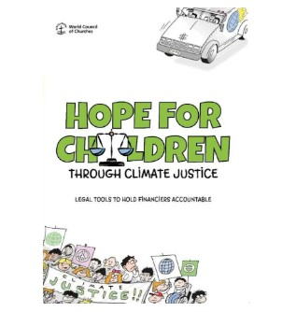

The World Council of Churches (WCC) has published a new climate Justice handbook which sets out practical ways faith organisations can help protect young people and future generations from the climate crisis. Hope for Children Through Climate Justice is available for £15.75.
Order your copy from the WCC.

The Disasters Emergency Committee (DEC) launched an appeal last month to raise funds to help people impacted by the devastating earthquake in Myanmar, which has killed more than 2,800 people, and injured thousands more. Learn about
the appeal and how you can help.
The URC's Commitment for Life partner Christian Aid, also part of the DEC,
also launched an appeal.
Image: Sai Aung Main AFP Getty. Image must be credited and used only in conjunction with this appeal.

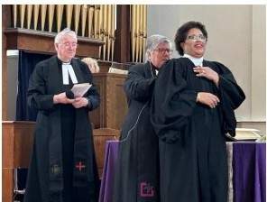
URC minister inducted as new Moderator of Free Churches Group

The Revd Dr Tessa Henry-Robinson is the new Moderator of the Free Churches Group (FCG). Tessa, who made history as the URC’s first Black and ethnically-minoritised woman Moderator of the URC General Assembly, was inducted at a service held at the American International Church, London, on Palm Sunday. The FCG is a group of 29 denominations in England and Wales and works with a particular focus on chaplaincy in prisons, healthcare and education. Read more about Tessa’s induction.

Seeds of Hope • the 2026 URC Calendar
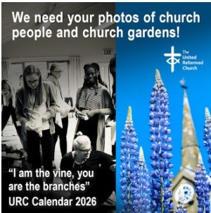

Your photos are needed for the URC 2026 Calendar – Seeds of Hope. Based on the verse from John 15, “I am the vine, you are the branches”, next year's calendar will feature images of people and plants connected to the URC. Learn all you need to know https:1/urc.org.uk/your­ church/church-local-and-global/urc-buildings-calendar/ including submission guidelines. The calendar has again been generously supported by Edwards Insurance.

Creative Connections Get to grips with copyright

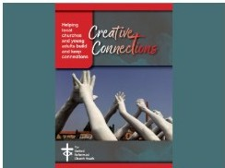
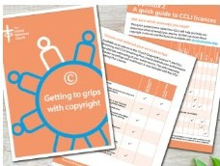

Copyright is complicated! The URC Communications Team hopes this booklet, which, whilst not claiming to be a definitive guide, will help churches navigate through the potential minefield of copyright law and how it affects churches. Download your free copy.
Creative Connections is a free, practical resource to help local churches and young adults build and keep connections. Download your copy of Creative Connections.

Assembly Accredited Lay Preacher course
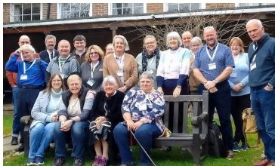

Do you feel called to deepen your ministry and expand your impact as a worship leader? If you have Synod recognition as a local worship leader, or simply have a passion for leading worship and want to grow in your calling, the Assembly Accredited Lay Preacher (AALP) course could be the next step on your journey.
Offered through Northern College in Manchester on behalf of the URC, this two-year, part-time, course blends online learning with enriching residential weekends – three per year – where you’ll connect, learn, and be inspired alongside fellow students.
Applications for this year’s intake (starting in September) closes on 30 June. For more details and an application form, contact your Synod Lay Preaching Advocate. Learn more about becoming a Worship Leader and Lay Preacher.

Download or print News Update Share your good news
If you have a good news story that can inspire, raise hope or show God’s working action then please let URC Communications know. We would love to help share your news across the denomination and in local news outlets. Email the URC Comms Team or call 07976 753 950.

A downloadable version of News Update, formatted for print, and for churches to copy and paste into church newsletters or magazines will be available within a week of this edition being published. Download your printable version of News Update.

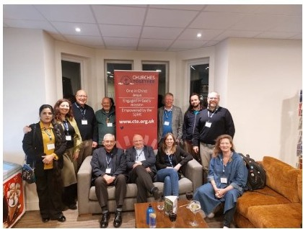
URC members attend CTE triennial forum

A group of URC representatives attended Churches Together in England’s (CTE) triennial forum last month themed “One but not the same: celebrating diversity – living with difference”. The Revd Dr Tessa Henry-Robinson delivered the keynote address. URC representatives connected attended work workshops and experienced a wide variety of worship styles, and connected over coffee and meals with many new and existing friends from the 50+ member churches that belong to CTE.

URC minister gains new JPIT role Improve your disability awareness

The Revd Dr Alex Clare-Young, the URC General Assembly's Deputy Clerk, has been appointed as the Joint Public Issues Team (JPITs) new Campaigns and Church Engagement Officer. Alex will begin the role with a focus on the Constituency Action Network, Politics in the Pulpit, and the preparation for the team’s 2025 conference on 8 November. Alex said: “These are all ways in which I believe that we can dialogue and work together to speak truth to power in the public square.”
Learn more about JPIT.
Conversation Starters exploring Disability Awareness for All are now available on the URC Learning Hub. The material is open access and can be used in worship or cafe church, in an Elders meeting or small group setting, or even just to have deeper conversations with a friend. The main sessions cover the definition of disability, being accepted, being valued, being visible and hidden disabilities. There is material for worship and reflection, a video webinar with Through the Roof, a section on helpful resources, and much more! Learn more.

Spring Statement Submit a publishing proposal

“Poverty and inequality in the UK are on track to increase. Rather than addressing these concerning trends, which cause so much harm to people's lives, the measures announced in the Spring Statement will exacerbate them,” says JPIT’s Paul Morrison.
Read more about Paul’s response to the Spring Statement in this biog.
Have a publishing proposal for a new book, resource or and worship materials? The URC’s Communications Department is keen to consider proposals for new books, resources, worship materials and Synod projects that could be used by the wider Church. We're also interested in updates to existing books and resources.
Learn how you can submit your proposal.

This month in Reform magazine

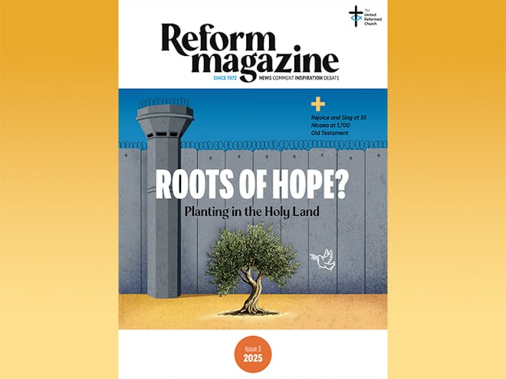

The latest issue of Reform includes reports from members of an ecumenical delegation on a recent visit to Israel and the West Bank. From scenes of physical devastation to centres of reconciliation, it’s out of conversations with individuals, and in the blessing of a single olive tree, that shoots of hope are revealed.
The question of where hope may be found also hovers uncertainly through Stephen Tomkins’ interview with journalist Andrew Graystone, whose book Bleeding for Jesus explores the abuse by John Smyth in the Anglican-led youth organisation Titus Trust. Andrew criticises the Church’s failure to respond and says there has been no improvement in caring for people who have been hurt, “because there is no real understanding”.
Susan Durber goes back 1,700 years to describe the momentous Council of Nicaea and its impact, while David Thompson recalls how the URC’s hymnbook Rejoice and Sing was created 35 years ago. Stephen Tomkins suggests ‘the tide has turned’ for a declining UK Church, thanks to more young people getting involved – young people like Jay Tynan, who writes that the URC Youth Assembly was a place she could express ideas and beliefs without judgement.
Elsewhere, the Old Testament/Torah comes under scrutiny in “A Good Question” and the powerful TV series Adolescence gets an in-depth Reform analysis. The Issue 3/2025 edition of Reform is available from the end of April. Subscribe to Reform digitally or in print.

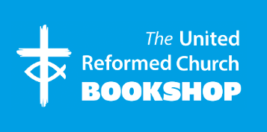

Please order online using the URC Bookshop's easy-to-use website www.urcshop.co.uk
or by calling 020 7916 8629.

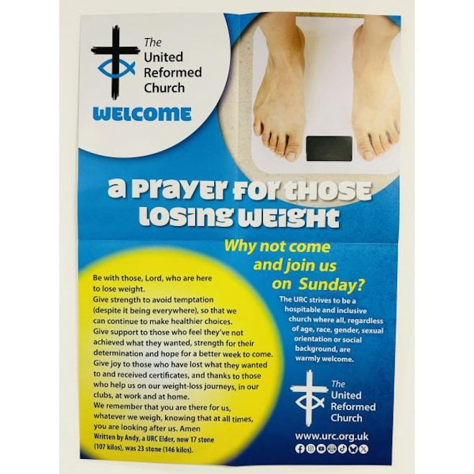

Weight loss group prayer poster – a free poster for you to place in rooms used by weight­loss groups, such as Weight Watchers or Slimming World, aimed at connecting the members of those groups with the church with a prayer and an invitation to Sunday worship. Printed in A2 size with A3 on the reverse to suit your needs. Postage and package applies.

Fair trade photo frame using recycled pencils – a wooden frame with recycled coloured pencil crayon stubs mounted around the edge. Freestanding portrait or landscape with glass glazing. To fit photo 4 x 6" (10 x 15 cm). Overall size: 17 x 22 cm. Please note this is a handmade frame, measurements shown might not be exact. £11.50 +p&

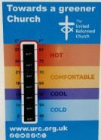

Sing and make music pin badge – A 3cm x 3cm soft enamel metal pin badge with the words from Ephesians 5:19: “Sing and make music from your heart to the Lord.” Supplied with a butterfly clasp. Designed on silver with cyan and royal blue lettering, musical notes and the URC cross and fish logo. £2.99 +p&p.
Temperature gauge card – magnetic or sticker fastening – an A6 temperature gauge card for home or church use, to show the temperature in rooms. Comes with a sticker and magnetic strip on the reverse to attach to walls, your fridge or other metallic surfaces.
£1.75 +p&p.
Synod News
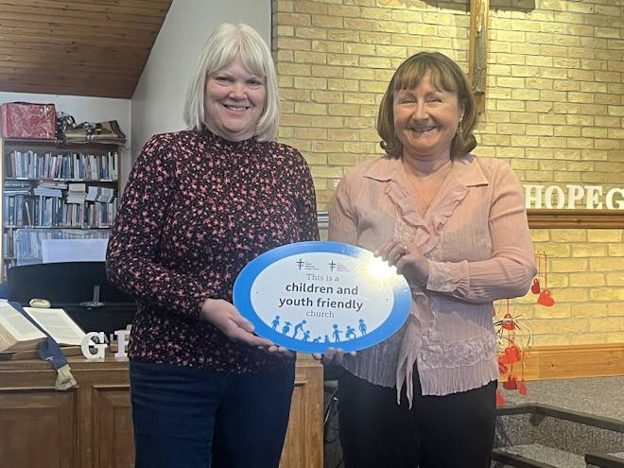
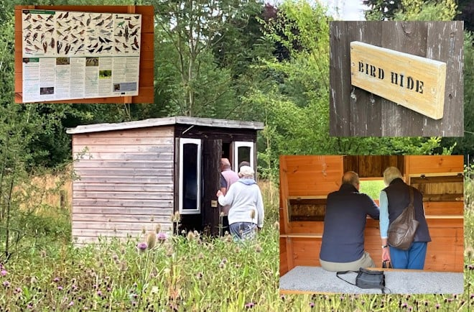
East Midlands West Midlands

Congratulations to Braintree URC which received the Children and Youth Friendly Church Award in April for demonstrating its commitment to welcoming and including children and young people. Learn more about the Children and Youth Friendly Church Scheme.

Church Stretton URC in Shropshire has gained a Silver Eco Church Award from A Rocha UK. Elder Roger Wilson CBE said that the Church Stretton congregation is “genuinely seeking to reduce our environmental impact, take a greener stance in the world and raise awareness of climate and environmental issues”. Learn about the Eco Church awards.

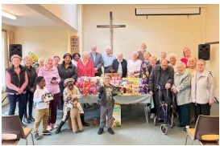
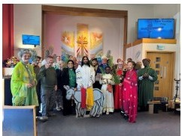
Southern West Midlands

Broadway United Church portrayed the events of Palm Sunday through a church play. Zeerak Shabaz, a Locally Recognised Worship Leader and Youth Executive's Chaplain, led worship and said that all those who took part in the play were delighted to be part of it.

Members of Zion URC in Langley Green in the Black Country used their Palm Sunday service for a special collection. Lots of Easter Eggs were collected by the church which were then donated to a local women’s refuge and to others known in the area who would not otherwise receive or be able to afford one.

What’s On
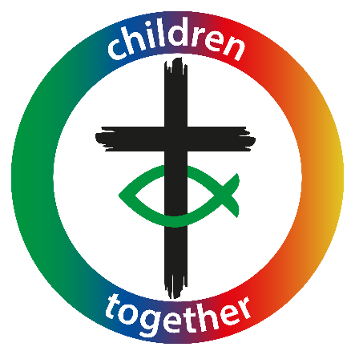
George Floyd anniversary Safeguarding training



St John's Church, Waterloo, London is hosting a special service commemorating the fifth anniversary of George Floyd’s murder on 25 May from 3-4.30pm. The service will feature prayers, talks, reflections, hymns, worship songs and poetry. Please register on Eventbrite to attend.
Free, denomination-wide, safeguarding training continues with Domestic Abuse on 3 June and Supporting Survivors on 12 June. The training will take place on Zoom and will be run by the URC’s Safeguarding Team. To book a space, please email Emma Pearce.

Refreshing your ministry Pray for the URC
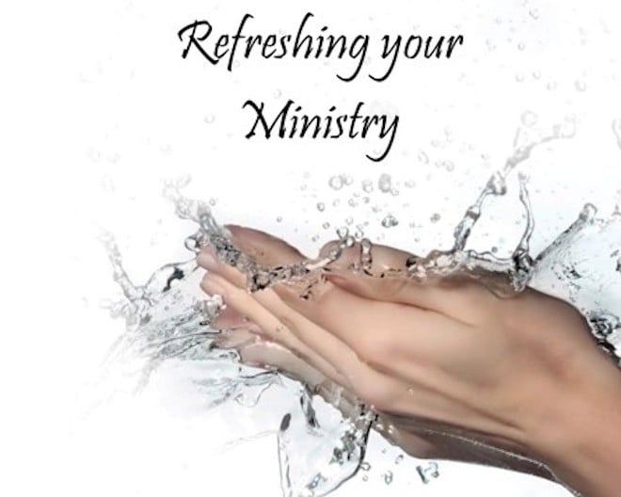
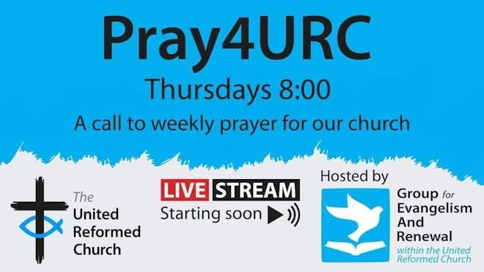

The Group for Evangelism and Renewal in the URC (GEAR) is hosting a “Refreshing Your Ministry” (RYM) gathering at The Hayes Conference Centre in Swanwick from 7-9 October. Main speakers include Phil Knox, Jonathan Conrathe and Sarah Watkins. RYM is for serving URC ministers, ministers of other denominations serving in an LEP, CRCWs, and also Synod-recognised local leaders considered active by their synod and retired ministers who are considered to be active by their synod.
Places cost £270. Visit GEAR’s website to book.
GEAR is hosting a time of prayer on Zoom for the URC taking place on the first Thursday of each month from 8-9pm. For the gathering on 1 May, the group will be thinking of the activity of the Trinity: God, our Father, Jesus, His Son, and the Holy Spirit. All are welcome. Please join with stories ready to be shared about how God is at work in your local situation to give thanks.
For more details, please visit GEAR’s Facebook page.

CWM annual gathering CWM book presentation

CWM is holding its Annual Gathering and Thanksgiving Service of former missionaries of CWM and its predecessor bodies on 2 July. The gathering will be held at the Clapham Welsh Presbyterian Church, 30 Beauchamp Road, Clapham, London, SW11 1PQ. Complete this form to register to attend.
On 28 April, the Council for World Mission (CWM) is hosting an engaging and thought-provoking book presentation on the themes of Empire, Liberation, and Decolonial Practice in Mission, with insights from the Revd Dr Graham Adams, author of Holy Anarchy: Dismantling Domination, Embodying Community, Loving Strangeness. The event
takes place from 3-5pm at CWM, 11 St Georges Circus, London SE1 8EH Sign up to attend.

What’s On
URC vacancies and beyond
Commission Secretary – Ministerial Discipline Process
The URC’s Ministerial Discipline Process is looking for a Commission Secretary, effective from July 2025, but with ample shadowing time of the present post-holder built in.

Trustee – Congregational Fund Board
At the heart of the Congregational Fund Board lies a strong commitment to supporting ministers and students in times of financial need. The Board is currently seeking a trustee to represent the United Reformed Church. Must be a member of the United Reformed Church and commit to a term of four years.

Case Presenting Officer
The URC is seeking immediate nominations and applications for a Case Presenting Officer to be part of the process for dealing with cases of discipline involving Ministers or Church-Related Community Workers. This is a volunteer role that is crucial in ensuring the integrity of the disciplinary process.
Deadline for applications: 2 May.

Children and Families Worker for Norwich Area United Reformed Church Mission Partnership (NAURCMP)
Term: Full-time, 37.5 hours per week, Salary: £28,000-£35,000 pa depending on experience.
Car ownership essential mileage
will be paid.
Closing date: 31 May

